Merchant marine academy of Macedonia- School of Engineers
Course: Maritime English Academic year:2021-22 Exam period: June
Semester: A Date: 14/06/22 Instructors: A. Birbili, E. Xenitidou, M. Tsompanoglou
Student’s name: Student’s number:
Exam paper grade: Instructor’s signature

Fill in the gaps with the following words to make phrases: (10 points)
IMO | Diesel | station | fly | proof
scavenge | winch | stuffing | stroke | call
…………………. box four………………………diesel engine
…………………..wheel water ……………………
…………………..sign pilot ……………………….
Mooring ……………….. ………………………number
……………… oil ………………………….box
Fill in the gaps with the following words: (10 points)
transponder | Lifejacket | stretcher | station | embarkation
distress | apparatus | lifebuoy | muster | extinguisher

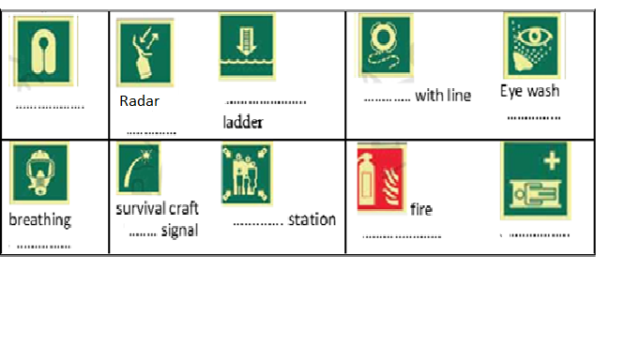

Match the following parts of a diesel engine with their functions. (10 points)
exhaust | push | crosshead | water jacket | crankcase
piston | bedplate | piston rod | gudgeon pin | cylinder head
-- It reciprocates in the stuffing box: ________________
-- All the valves are fitted in it: _________________________________
-- It supports the whole engine: _____________________
-- The crankshaft rotates in it: ______________________
-- The gases go out through this valve: ________________ valve
-- It connects the piston rod to the connecting rod: _____________________
-- It compresses the air: ______________________
--The camshaft opens the valves with the help of this rod: ___________ rod
-- It connects the piston to the connecting rod: _____________________
-- It cools the cylinder externally: ________________

Fill in the gaps with the appropriate word from the list below. (15 points)
funnel | poop | port side | hatches | starboard side
rudder | galley | bulkheads | holds | laundry
messroom | cranes | forecastle | superstructure | bridge

-- Tool for changing course: ___________________
-- The place where food is cooked: _________________
-- You can wash your clothes there: ___________________
-- The anchor windlass is kept on the: ________________
-- All navigational activities take place in it: __________________
-- The raised “house” containing the bridge and the accommodation: _____________
-- They separate the holds from each other: ______________
-- They are used to lift the cargo: ________________
-- The left part of the ship: _________________
-- The place where you can eat: _________________
-- Cargo is stored there: _________________
-- The right part of the ship: ____________________
-- A raised deck aft: ________________ deck
-- The openings on the deck that provide access to the holds: ________________
-- The exhaust gases from the engine room go out into the air from there: __________

Find the kinds of vessels that do the following. (10 points)
lightship | tugboat | container | SAR vessel | clean-product tanker
Ro-Ro | bulk carrier | ferry | icebreaker | crude carrier

-- Carries vehicles: __________________
--Carries any type of cargo in “boxes” of standard dimensions: _______________
-- She breaks a way through ice for other ships to sail: _________________
-- Carries passengers and cars: ______________________
-- Tows other vessels: _____________________
-- Carries crude oil: ___________________
-- Carries dry loose cargo such as grain, iron, ore etc.: __________________
-- Carries refined petroleum products: ___________________
-- Searches and rescues ships in distress: ____________________
-- Serves as a beacon for navigation: ______________________

Fill in the names of the following tools: (15 points)
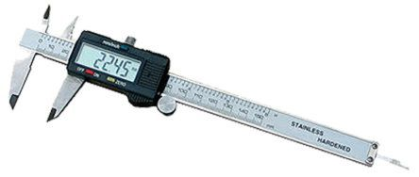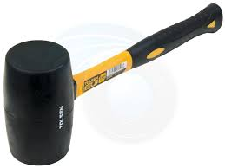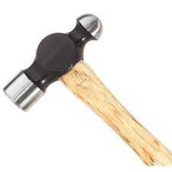
Digital C……………….. M…………………… Ball point h……………..
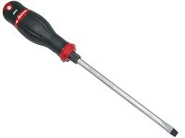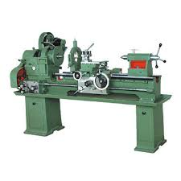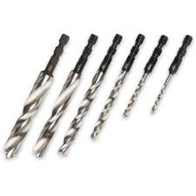
s…………………… L………………… B…………………

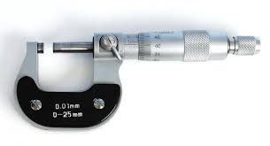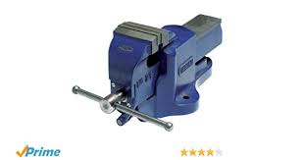 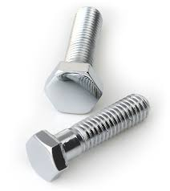 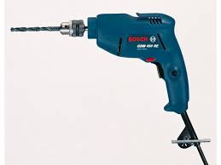 M……………………… V……………… B…………… D…………………

Fill in the gaps with the following words: Captain, Chief Mate, 2nd Mate, Messmate, A/B, Rating, Fitter, Oiler, Chief Engineer, Second Engineer, Engineer Cadet, Bosun, O/S, Wiper, Cook (15 points)
………………………… S/ He is in charge of the ship’s cargo and deck crew.
…………………………. This person works on the ship but is not an officer.
………………………… S/He prepares food.
………………………… S/ He keeps and E/R watch and is in charge of engine room repairs.
………………………… S/ He is in charge of the engine department.
…………………………. S/ He is the representative of the company.
…………………………. S/ He is in charge of all aspects of navigation.
………………………… S/He follows commands of officers in the E/R and assists as required.
………………………….. S/He cleans the galley and keeps all living spaces on board tidy.
………………………… S/He is responsible for cleaning various engine spaces.
…………………………… S/He greases bearings and assists in the engine room.
…………………………… S/He is in charge of all deck ratings.
…………………………… S/He is a fully trained seaman and is in charge of maintenance of the deck. S/ he can also steer the ship.
………………………….. S/He is not a fully trained seaman and concentrates more on cleaning.
………………………….. S/He does sheet metal work, plumbing and welding.

Fill in the gaps: (15 points)
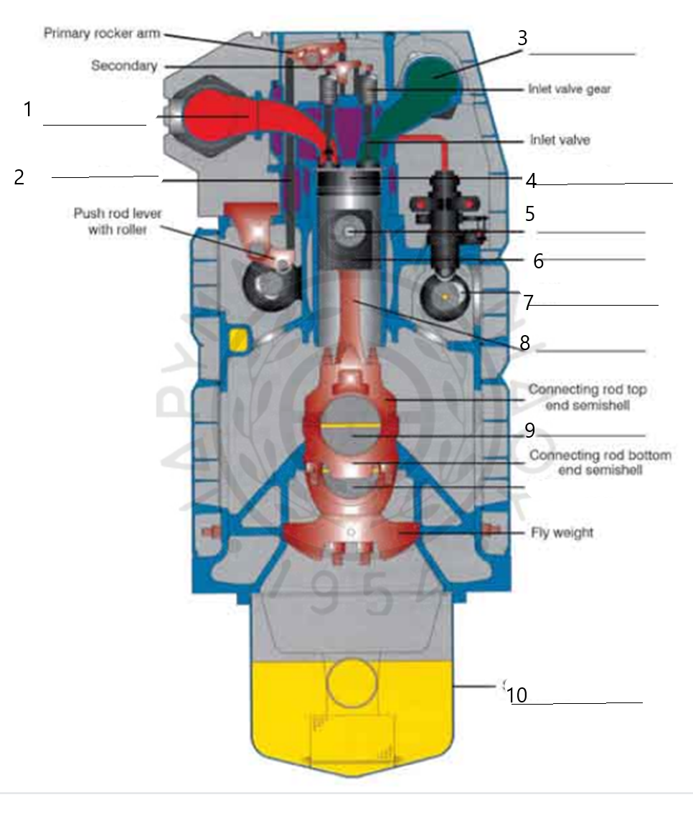

End of the test
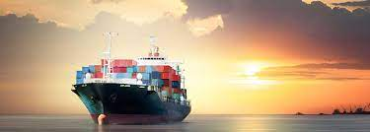
GOOD LUCK!!!

