Merchant marine academy of Macedonia- School of Engineers
Course: Maritime English Academic year:2023-24 Exam period: February
Semester: A Date: 20/02/24 Instructors: A. Birbili, E. Xenitidou
Student’s name: Student’s number:
Exam paper grade: Instructor’s signature

Fill in the gaps with the following words to make phrases: (10 points)
Vessel’s | Cargo | Seaman’s | Pilot | Exhaust
Call | Engineer | Hold | Mooring | Windlass
anchor ………………. .…………….. sign type of …………… ……………… station ………………. winches …………….. capacity ……………… book …………………. cadet cargo …………………. ……………… gases

Fill in the gaps with the word that you see in the picture: (9 points)
L _ _ _ _ _ _ _ with line s_ _ _ _ _ _ _ _ m_ _ _ _ _ station

I _ _ _ _ _ _ _ _ suit E_ _ _ _ _ _ _ _ _ ladder lower l_ _ _ _ _ _ _

Match the tools with the definitions: (10)

scrapers | pliers | reamers | tinsnips | punches
milling | taps | ratchet | cutting torches | rasps
…………………………are used to cut or bend wire.
………………………. are used for cutting sheet metal.
…………………………are tools with which you can shape and enlarge holes with more precision than a drill.
…………………………are coarse files for metal or wood.
……………………are tools used for cutting threads in metal for inserting a screw
…………………… are used to remove paint.
…………………machines remove material from a work piece by rotating a cutting tool and moving it into the work piece.
……………….. wrenches are activated by their handles and rotate in one direction only.
Centre ……………… are used to make a small indentation at the location of the centre of a hole to be drilled.
……………………… use fuel gases and oxygen to cut metals.
Fill in the gaps with the appropriate word. (15 points)
The g _ _ _ _ _ is the kitchen of the ship.
The right part of the ship is called s_ _ _ _ _ _ _ _ side.
C_ _ _ _ _ are used to lift the cargo.
The m_ _ _ _ _ _ _ is where the crew members eat.
The b _ _ _ _ _ _ _ is a kind of wall that separates different compartments of the ship.
The t _ _ _ _ -decks separate the hold into a lower hold and an upper hold to store different kinds of cargoes.
The p _ _ _ deck is at the back of the ship.
P _ _ _ is the left side of the ship.
The crew members sleep in the c _ _ _ _ _ . They can get first aid in the h_ _ _ _ _ _ _.

Fill in the gaps with the following words: (15 points)

Tankers | Lightships | Pax-car ferries | Tugs | Pilot ships
Container ships | Reefer ships | Bulk carriers | Dredgers | Ro-ro vessels
Cruiser ships | Icebreaker ships | General cargo ships | LNG | SAR
.……………………… vessels search and rescue vessels in distress.
………………………. carry refrigerated cargo.
………………………..can be used in Alaska and the Poles.
………………….….….are used in areas which
………………………. dig the bottom of the sea.
…………………………carry “loose” cargo such as grain, coal and iron ore.
…………………………have huge stern doors and are transfer vehicles and trucks.
…………………………carry cargo too large to be in a container or in break bulk form.
…………………………help other ships enter a port safely.
…………………………carry extremely dangerous cargo, explosive gas at freezing temperatures.
…………………………carry any type of cargo in “boxes” of standard dimensions.
…………………………offer luxury and comfort to holiday makers.
………………………… serve as a beacon for navigation.
………………………… escort other vessels or tow other ships.
…………………………carry liquid cargo in tanks.
……………………….. ..carry cars and passengers.

Fill in the names of the following tools: (15 points)
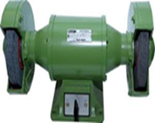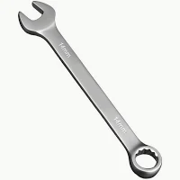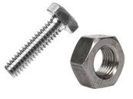
Bench G _ _ _ _ _ _ Combination S _ _ _ _ _ _ _ B _ _ _ and N _ _ Fitter’s V _ _ _
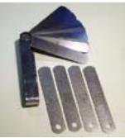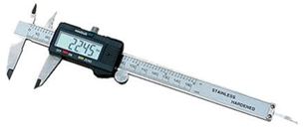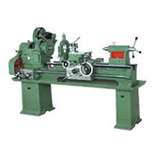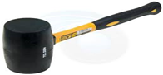
F _ _ _ _ _ gauge Digital C _ _ _ _ _ _ _ L _ _ _ _ S _ _ _ _ _ _ _ _ _ _ M _ _ _ _ _

Fill in the appropriate gaps with the part of the vessel shown: (15)

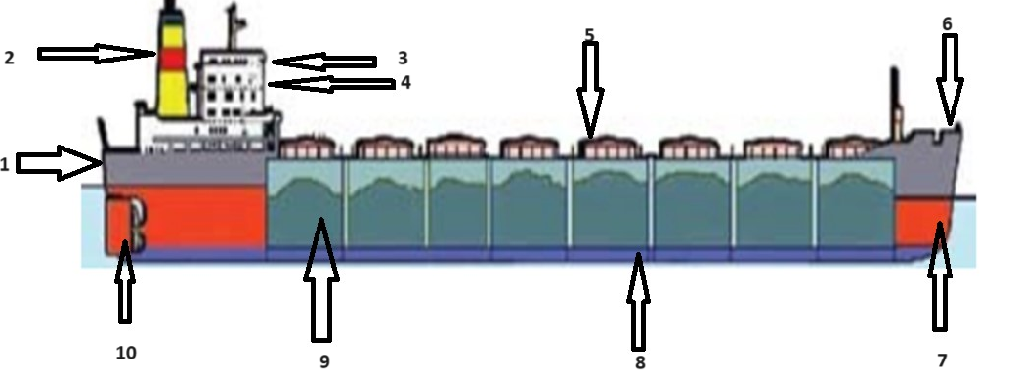
1. S _ _ _ _ 2. F _ _ _ _ _
3. B _ _ _ _ _ 4. A _ _ _ _ _ _ _ _ _ _ _ _
5. H _ _ _ _ cover 6. F _ _ _ _ _ _ _ _ _
7. F _ _ _ P _ _ _ tank 8. Double B _ _ _ _ _ tank
9. H _ _ _ 10. R _ _ _ _ _

Underline the correct answer: (11)
The letters IMO stand for International Marine/ Maritime/ Mariner Organisation.
The letters STCW stand for Standards of teaching, certification and watchkeeping/ Standards of training, competency and watchkeeping/ Standards of training, certification and watchkeeping.
Some ships usually make a speed of 14 routes/ length/ knots.
Tools worked by air under pressure are airing/ pressurized/ pneumatic tools.
You need the oxygen/ air/ breathing apparatus against asphyxia when there is too much smoke in the air.
The superstructure/ engine room/ hull contains the vessel's propulsion plant and is usually at the back of the ship, below the main deck.
The initials ETA mean estimated time of arrival/ expected time of arrival/ expected time of arriving.
In the forecastle we find the windlass/ chain/ capstan for the anchor and it is used for handling the mooring ropes.
The crew members can watch TV with the rest of the crew at the laundry/ derrick/ lounge.
The fire extinguisher/ hose/ kit is used to spray water or powder to a fire to put it out.
The next port of arrival/ call/ coming will be the port of Piraeus.
