Merchant Μarine Αcademy of Macedonia- School of Engineers
Course: Maritime English Academic year:2019-20 Exam period: September
Semester: B Date: Instructors: A. Birbili, E. Xenitidou, M. Tsompanoglou
Student’s name:
Student’s number:
Exam paper grade: Instructor’s signature
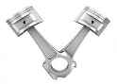

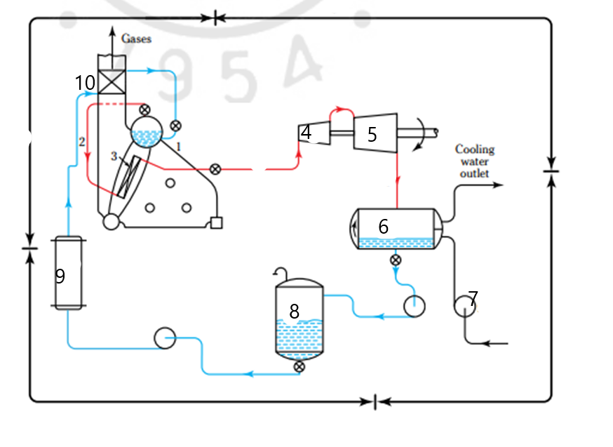
Find the parts that are shown in the diagram- 10

1………………………….
2…………………………..
3…………………………..
4………………………….
5………………………….
6……………………………
7………………………….
8……………………………
9…………………………..
10…………………………

Fill in the gaps with following word. – 15 points
DOWNWARDS | BDC | UPWARDS | INJECTION | POWER
COMRESSION | INDUCTION | SUCTION | COMBUSTION | IGNITED
INLET | RISE | COMPRESSES | TDC | EXHAUST
During the ……………………………………or intake or ……………….. stroke the intake valve is open and the piston is moving…………………….. Air is drawn into the cylinder and when the piston reaches the ………………………….the cylinder is full of air and the ………………………… valve closes.
In the second stroke, the ……………………………stroke the piston is moving …………………….and …………………………..the air. The pressure and the temperature ………………………. All valves are closed when the piston is almost at the …………………..the fuel is sprayed into the cylinder by the fuel ……………………..valve. Ιt is self ………………….. because of the high temperature of the compressed air.
Then fuel is burnt and the …………………………gases push the piston down. This is the ………………………stroke- only this stroke provides power for the propulsion of the ship.
Finally, the last stroke is the ………………………stroke.

Write the name of the auxiliary machinery. You can choose from the following:– 12 points
fin stabilizers |  | heaters | davits | capstans
 | reverse osmosis plants | air compressors | windlasses | sewage treatment plants
incinerators | generators | evaporators | coolers

They are used to burn garbage ........................................................
They are used to lower lifeboats to the sea .............................................................
They reduce the rolling of the ship............................................
They are used to handle the anchor ............................................
They are used to handle the mooring lines .................................................
They are used for reducing the temperature of either oil or water...........................
They are used to increase the temperature of fuel and improve its viscosity ...................................
They produce distilled water .........................................
They are used to pump the water under high pressure through a membrane and filter it ……………………………………………………………..
Human body waste is treated biologically there ...........................................................
They provide the main engine with starting air ..............................................
They supply the ship with electrical power and lighting........................................
Complete the text with an appropriate word from the following. – 10 points
diffuser | stator | casing | pressure | impeller
silencer | vanes | vibration | rotor | shaft
A turbocharger consists of a single turbine wheel, the -----------------of which is mounted on the same ---------------- as with the ------------------ of a centrifugal compressor. Besides the rotor, the turbine assembly has a ---------------too, that is, stationary---------------- which direct the exhaust gases to the rotor. On the compressor’s side there is a -------------------- and a spiral --------------, both of which contribute to the further rising of the --------------------of the compressed air. There is also a -------------- to absorb the noise of the ------------------ of the running components.

Fill in the gaps with the following words. – 10 points
furnace | fire tube | deaerator | economizer | steam drum
condenser | atomizer | superheater | desuperheater | blade
A device by means of which a liquid is reduced to very fine spray is the ………………………
A vessel in which boiler feed water is heated under reduced pressure in order to remove dissolved air is the …………………………….
A device for removing all or part of the superheat from steam by spraying water into it or by use a heat exchanger is a/ an ……………………………..
A device which cools exhaust steam back into water is a/ an ………………………..
A heat exchanger that transfers heat from the gases of combustion to the boiler feedwater is a/ an …………………..
A type of boiler design in which combustion gases flow inside the tubes and water flows outside the tubes is a/ an ……………………….boiler
An enclosed space provided for the combustion of fuel is a/ an ……………………….
The upper drum of a water tube boiler where the separation of water and steam occurs is a /an…………………..
…………………………. is a bank of tubes in the exhaust gas duct after the boiler, used to heat the steam above the saturation temperature.
Α ………………………….…………………………..is one of the flat thin parts that turn around in a turbine

Fill in the gaps with the following words to make phrases- 10 points
water | chamber | proof | tube | valve
end | scavenge | check | indicator | turbine
Bottom …………………..bearing Water …………………….boiler
Fire ……………………………………. Combustion …………………….
Throttle …………………………….. …………………………….box
Feed ………………………valve Steam …………………………..
Water level ……………………….. ……………………………wall

Fill in the gaps with the appropriate type of pump using the following words:
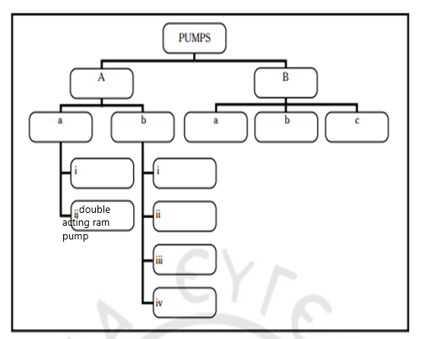
vane, regenerative, rotary, screw, lobe, reciprocating, displacement, centrifugal, volute, single-acting ram pump, gear wheeled, diffuser (12)
Underline the correct word. – 11 points
- 4 stroke Diesel Engines do not have scavenge ports/ inlet valves/ exhaust valves.
- 2 stroke Diesel Engines do not have inlet valves/ scavenge ports/ exhaust ports.
- Water changes into steam in the circulating/ generating/ water tubes.
- The valve seats are housed on the cylinder liner/ cylinder head/ piston crown.
- In a 4 stroke Diesel Engines the piston is connected to the connecting rod with the gudgeon/ crosshead/ crank pin.
- The camshaft opens the valve with the help of the connecting/ push/ tie rod.
- The steam comes out of the nozzles/ ports/ exhausts at a high pressure.
- The piston rod reciprocates into and out of the cylinder liner/ scavenge box/ stuffing box.
- The cylinder block, the frame of the engine and the bedplate are connected together with the frame rods/ connecting rods/ tie rods.
- In a displacement/ centrifugal/ diffuser pump the increase or decrease of the volume of the pump chamber causes the suction or discharge of the liquid.
- Multistage/ Double acting ram / reciprocating pumps are centrifugal pumps.
Fill in the gaps with the following words:(10)
Oil | Transfer | Header | Circulating | Indicator
Lubricating | Chamber | Service | Check | Top- end
general ……………….. pump cooling water …………………….pump fuel oil ……………..pump water wall …………… water level …………………. feed ……………valve …………………… semi- shell combustion …………………….. …………………………… oil system ………………… scraping piston rings

