Merchant marine academy of Macedonia- School of Engineers
Course: Maritime English Academic year:2021-22 Exam period: February
Semester: B Date: Instructors: A. Birbili, E. Xenitidou, M. Tsompanoglou
Student’s name: Student’s number:
Exam paper grade: Instructor’s signature

Complete the text with an appropriate word from the following: (10 )
diffuser, absorb, assembly, vanes, contribute, vibration, components, rotor, impeller, pressure
A turbocharger consists of a single turbine wheel, the ___________of which is mounted on the same shaft as with the _____________ of a centrifugal compressor. Besides the rotor, the turbine ____________ has a stator too, that is, stationary _______________ which direct the exhaust gases to the rotor. On the compressor’s side there is a ______________ and a spiral casing, both of which _____________ to the further rising of the ____________ of the compressed air. There is also a silencer to _____________ the noise of the ____________ of the running ______________.

Fill in the gaps with the appropriate type of pump using the following words:
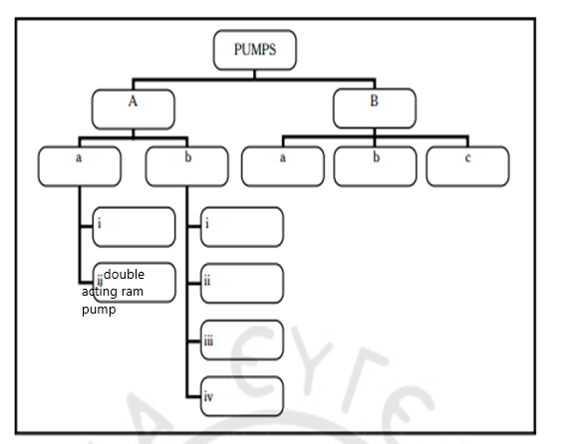
vane, regenerative, rotary, screw, lobe, reciprocating, displacement, centrifugal, volute, single-acting ram pump, gear wheeled, diffuser (12)
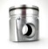 Look at the diagram and write what the numbers show: (10)
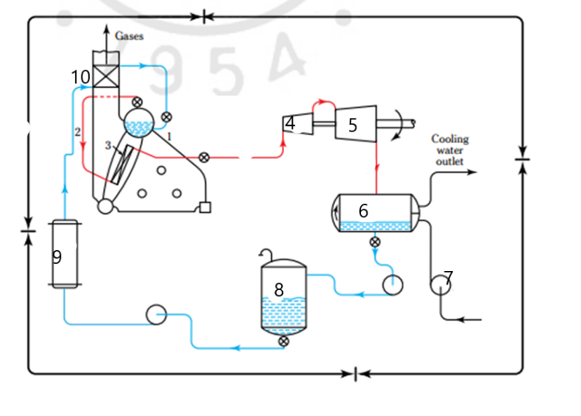
1………………………….
2…………………………..
3…………………………..
4………………………….
5………………………….
6……………………………
7………………………….
8…………………………… 9…………………………..
10…………………………

Match the words to the definitions (10):
- FIREPROOF |  | Reservoir of water
- SALINOMETER |  | Apparatus which decreases the temperature
- DRUM |  | Be in motion, move around
- ATTEMPERATOR |  | Burning
- WATER WALL |  | Not affected by fire
- CIRCULATE |  | Wall made of tubes of water
- COMBUSTION |  | Filled with moisture
- SATURATED |  | Part of the oil burner which sprays the fuel
- ATOMIZER |  | The vapour of water
- STEAM |  | Measures how salty the water is
Fill in the gaps with the words: (10)
combustion | Liner | Drain | Stuffing | Gudgeon
Reciprocating | Level | Burner | Throttle | Casing
Oil ………………………….. ……………………….pin
External …………………………. …………………………..box
Cylinder…………………….. ………………………..cock
…………………………. steam engine Water …………. indicator
……………………………. valve Fire proof ………………………..
Fill in the gaps with following word. – 15 points
DOWNWARDS | BDC | UPWARDS | INJECTION | POWER
COMRESSION | INDUCTION | SUCTION | COMBUSTION | IGNITED
INLET | RISE | COMPRESSES | TDC | EXHAUST
During the ……………………………………or intake or ……………….. stroke the intake valve is open and the piston is moving…………………….. Air is drawn into the cylinder and when the piston reaches the ………………………….the cylinder is full of air and the ………………………… valve closes.
In the second stroke, the ……………………………stroke the piston is moving …………………….and …………………………..the air. The pressure and the temperature ………………………. All valves are closed when the piston is almost at the …………………..the fuel is sprayed into the cylinder by the fuel ……………………..valve. Ιt is self ………………….. because of the high temperature of the compressed air.
Then fuel is burnt and the …………………………gases push the piston down. This is the ………………………stroke- only this stroke provides power for the propulsion of the ship.
Finally, the last stroke is the ………………………stroke.
Fill in the gaps with the following words : (11)
Desuperheater | Deaerator | Furnace | Mounted | Throttle
External | Malfunction | Condenser | Expansion | Impulse
Port
Steam engines are ………………………….. combustion engines.
The ……………………… is a device for removing all or part of the superheat from steam by spraying water into it or by use of a heat exchanger.
The …………………….. is a device which cools exhaust steam back into water.
The rotor is …………………… on a shaft.
…………………….. is an enclosed space provided for the combustion of fuel.
……………………… is a vessel in which boiler feed water is heated under reduced pressure in order to remove dissolved air.
The L.P. turbine is larger due to the ……………….. of the steam.
A kind of turbine is the ………………….
The high pressure steam passes from the H.P. line into the H.P. turbine through a ………………... valve.
Marine boiler plants require adequate control systems to raise steam, maintain design conditions for steady steaming and detect promptly any ………………….and failures.
……………………… is a hole in the cylinder liner.

Choose the correct answer:(10)
With the multistage pumps we can have low/ medium/ high capacities.
The reaction turbine is more efficient/ faster/ less advantageous than the impulse turbine.
A device which cools exhaust steam back into water is a/ an ……………………….. superheater/ deaerator/ condenser.
Water tubes/ Oil burners/ Generating tubes supply the fuel and air to the furnace.
The downcomer tube/ steam drum/ economizer preheats the feeding water.
Four stroke Diesel Engines are medium/ high/ slow speed engines and are used in small/ medium/ big ships.
In a 4 stroke Diesel Engine the piston is connected to the connecting rod with the crank pin/ gudgeon pin/ connection pin.
The connecting rod is connected to the crank shaft with the crank pin/ connection pin/ crosshead pin.
The valve seats are housed on the cylinder liner/ cylinder head/ cylinder crown.

Write the name of the auxiliary machinery. You can choose from the following: (12)
fin stabilizers/ incinerators/ sewage treatment plants/ heaters/ generators/ davits/ capstans/ windlasses/ air compressors/ reverse osmosis plants/ evaporators/ coolers/
They are used to burn garbage ........................................................
They are used to lowering lifeboats to the sea .............................................................
They reduce the rolling of the ship............................................
They are used to handle the anchor ............................................
They are used to handle the mooring lines .................................................
They are used for reducing the temperature of either oil or water...........................
They increase the temperature of fuel and improve its viscosity ...................................
They produce distilled water .........................................
They are used to pump the water under high pressure through a membrane and filter it ……………………………………………………………..
Human body waste is treated biologically with these machines .................................................................
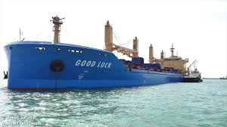
They provide the main engine with starting air ..............................................
They supply the ship with electrical power and lighting...................

