[ Note: All scripts and symbols between brackets, or in red colour are explanatory and must not be used “as is” ]

{Students Names:}

Suzanne Saradone

John Doe

[Title of essay. Use “Title” style]

The story of a shipwrecked sailor

  - Introduction. [Use “Subtitle”style for the word “Introduction”]
[The Styles selection is done from the Home tab of your word processor (see picture below)]

Photo 1 Some of the styles in the "Home"tab of MS Word
[The introduction shall provide a short summary of the main text.]
[Introduce the overall topic on a single paragraph.]

  - Subtitle to Main body text [It is always preferable to have a Subtitle before your
  - The Tragic story of a Shipwrecked Sailor in detail main text. Use “Subtitle”style].
[Type your text with a font size 12 with “Times New Roman”, “Arial” or “Verdana” fonts. Before the beginning of each paragraph leave empty spaces by pressing the “Tab” key. Empty lines between the paragraphs are not required but are preferable, as it is easier to read the text]
[Do not forget to add numbering to your pages. Word processors such as “MS Word” or “LibreOffice Write” automatically carry a word count as you can see on the screenshot below]

Figure a [ Use captions if figures or photos are to be used]
[Add captions on any photos or figures you insert. You will find the “caption” menu item, by right clicking on the inserted picture (see below screenshot).]
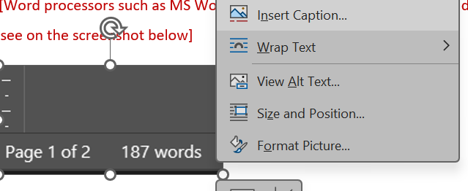
Photo 2 [How to add Caption on a photo]

  - [Add as many paragraphs required for your essay. Do not exceed the maximum word count required]

  - Conclusion. [Use “Subtitle”style for the title].
[Only one paragraph. Write down your conclusion here. Summarize key points from main text paragraphs]

References: [Use “References”style for the title].
[References are always written on a separate page]
[ALL References must be numbered and shall follow the below examples]
[Academic Journal Article Type reference:]
- L. He Shanghai Maritime University, (2024), Challenges and Solutions to COLREGs on MASS Ethical Issues in Vessel Maneuvering Practices.
https://doi.org/10.12716/1001.18.03.11
[Academic Journal Article Type reference:]
- Louise A. Hitchcock, Aren M. Maeir, (2016), Pirates of the Crete-Aegean: migration, mobility, and Post-Palatial realities at the end of the Bronze Age.
https://12iccs.proceedings.gr/uploads/035_%CE%91_Hitchcock-L.-Maier-A_%CF%84.pdf
[Webpage reference]
- Tradewinds News: Oil Brokerage hit with biggest fine yet after unregistered brokers handled US trades Retrieved November 15th 2025 from: https://www.tradewindsnews.com/finance/oil-brokerage-hit-with-biggest-fine-yet-after-unregistered-brokers-handled-us-trades/2-1-1900050
[Newspaper Article reference]
- Κώνστας Γιώργος (6 Νοεμβρίου 2025), Γυναίκες….Ο εύκολος στόχος. Χανιώτικα Νέα. (use Italics on the font for the name of the Newspaper)
https://www.haniotika-nea.gr/gynaikes-o-eykolos-stochos/

