MERCHANT MARINE ACADEMY OF MACEDONIA
SCHOOL OF ENGINEERS

Course: Maritime English
Academic year: 2019 – 2020 Exam period: February 2020
Semester: Α Date: 21/2/20
Name:
Student number:
Instructors: M. Tsompanoglou, E. Xenitidou

FINAL TEST in English

1. Fill in the gaps with the following words (12 p.) weight, rocker, stroke, crown, journal, rod, list, proof, stuffing, wheel, web, oil
primary …………………….. arm
push ……………………….. lever
fly ……………………
diesel ……………..
check……………..
crank …………………………..
………………………….box
water……………
four …………………….. DE
piston ……………………..
fly…………………….
crank ………………………..
2. Name the following life saving equipment. (15)
3. Match the following parts of a diesel engine with their functions. (11 p.)
exhaust, piston, push rod, bedplate, crosshead, piston rod, water jacket, gudgeon pin, cylinder head, crankcase, sump tank

-- It reciprocates in the stuffing box: __________________
-- All the valves are fitted in it: _______________________
-- It supports the whole engine: _____________________
-- The crankshaft rotates in it: ______________________
-- The lub oil is in it: ______________________
-- The gases go out through this valve: ________________ valve
-- It connects the piston rod to the connecting rod: _____________________
-- It compresses the air: ______________________--The camshaft opens the valves with the help of this rod: _______________________
-- It connects the piston to the connecting rod: _____________________
-- It cools the cylinder externally: ________________

4. Name the following tools. (10 p.)

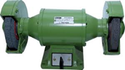  Bench G………………. | 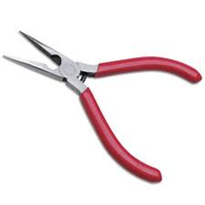P…………….. | 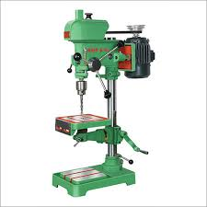  D……………… machine | 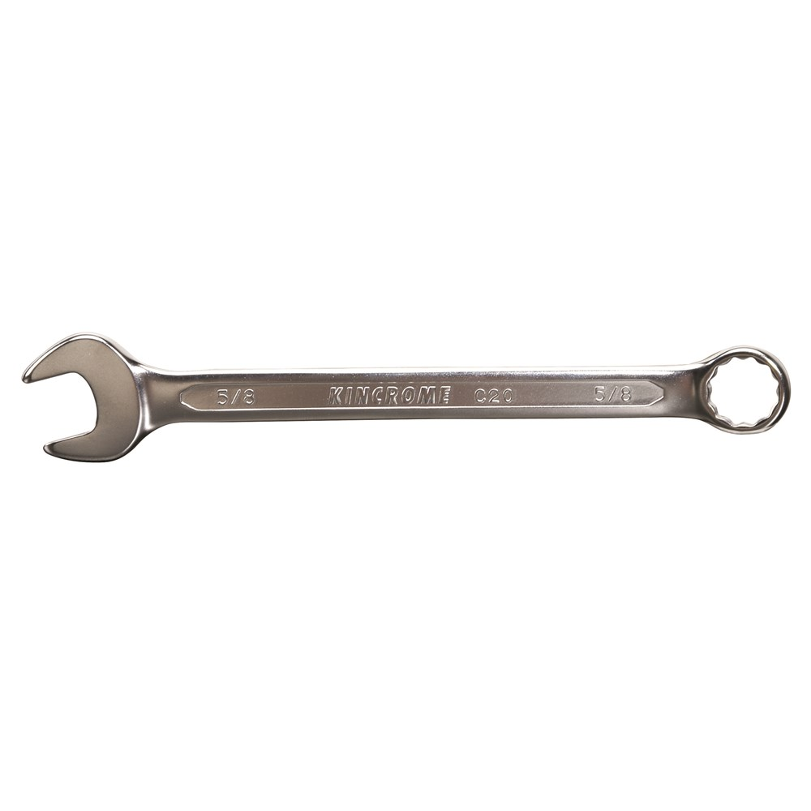  Single German S……………… | 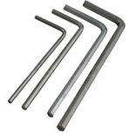  A………………  key
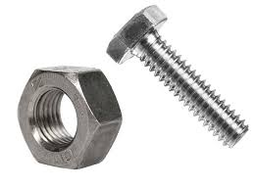  B…………….. and N………….. | 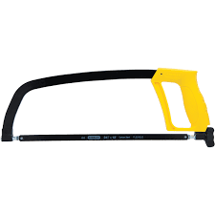H………………… | 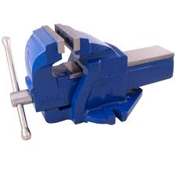  V………………… | 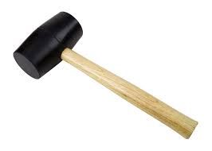  M…………………..

5. Match the duties to the crew members who perform them (10 p)
Master, fitter, oiler, chief engineer, chief officer,
wiper, bosun, 2nd officer, apprentice engineer, cook
-- Is in charge of all deck ratings: _________________
-- Greases parts of the machinery: ___________________
-- Cuts and welds pipes: ____________________
-- Follows commands of the officers in E/R and assists as required: ______________-- Is the head of the Engine Department: _______________
-- Plans and supervises loading: ____________________
-- Prepares food: ___________________
-- Is responsible for cleaning various engine spaces: __________________
-- Representative of the company and responsible for the safety of the crew and the ship: _______________
-- Corrects and updates the charts: ___________________

6. Fill in the gaps with the appropriate word from the list below. (15 p.)

funnel, rudder, poop, cranes, port side, bulkheads, forecastle, hatches, holds, superstructure, messroom, galley, starboard side, laundry, bridge
-- Tool for changing course: ___________________
-- The place where food is cooked: _________________
-- You can wash your clothes there: ___________________
-- The anchor windlass is kept on the: ________________
-- All navigational activities take place in it: __________________
-- The raised “house” containing the bridge and the accommodation: _____________-- They separate the holds from each other: ______________
-- They are used to lift the cargo: ________________

-- The left part of the ship: _________________
-- The place where you can eat: _________________
-- Cargo is stored there: _________________
-- The right part of the ship: ____________________
-- A raised deck aft: ________________ deck
-- The openings on the deck that provide access to the holds: ________________
-- The exhaust gases from the engine room go out into the air from there: __________

7. Find the kinds of vessels that do the following. (12 p.)

lightship, tugboat, LNG, bulk carrier, reefer, container, Paxcar ferry,
Ro-Ro, SAR vessel, icebreaker, clean-product tanker, crude carrier
-- Carries vehicles: __________________
--Carries any type of cargo in “boxes” of standard dimensions: _______________
-- She breaks a way through ice for other ships to sail: _________________
-- Carries passenger and cars: ______________________
--These vessels carry extremely dangerous cargo, explosive gas at freezing temperatures.
-- Tows other vessels: _____________________
-- Carries crude oil: ___________________
-- Carries refrigerated cargo: ___________________
-- Carries dry loose cargo such as grain, iron, ore etc.: __________________
-- Carries refined petroleum products: ___________________
-- Searches and rescues ships in distress: ____________________
-- Serves as a beacon for navigation: ______________________

MERCHANT MARINE ACADEMY OF MACEDONIA
SCHOOL OF ENGINEERS

Course: Maritime English
Academic year: 2021 – 20202 Exam period: March 2022
Semester: Α Date: 14/03/22
Name:
Student number:
Instructors: M. Tsompanoglou, E. Xenitidou

FINAL TEST in English

1. Fill in the gaps with the following words (12 p.) weight, rocker, stroke, crown, journal, rod, list, proof, stuffing, wheel, web, oil
diesel ……………..
check……………..
fly…………………….
fly ……………………
water……………
primary …………………….. arm
push ……………………….. lever
four …………………….. DE
piston ……………………..
crank ………………………..
crank …………………………..
………………………….box
2. Name the following life saving equipment. (15)
3. Match the following parts of a diesel engine with their functions. (11 p.)
exhaust, piston, push rod, bedplate, crosshead, piston rod, water jacket, gudgeon pin, cylinder head, crankcase, sump tank
-- It connects the piston rod to the connecting rod: _____________________
-- It compresses the air: ______________________
-- The crankshaft rotates in it: ______________________
-- The lub oil is in it: ______________________
-- The gases go out through this valve: ________________ valve
--The camshaft opens the valves with the help of this rod: _______________________
-- It connects the piston to the connecting rod: _____________________
-- All the valves are fitted in it: _______________________
-- It supports the whole engine: _____________________
-- It cools the cylinder externally: ________________
-- It reciprocates in the stuffing box: __________________

4. Name the following tools. (10 p.)

Bench G………………. | P…………….. | D……………… machine | Single German S……………… | A………………  key
B…………….. and N………….. | H………………… | V………………… | M…………………..

5. Match the duties to the crew members who perform them (10 p)
Master, fitter, oiler, chief engineer, chief officer,
wiper, bosun, 2nd officer, apprentice engineer, cook
-- Representative of the company and responsible for the safety of the crew and the ship: _______________
-- Corrects and updates the charts: ___________________
-- Is the head of the Engine Department: _______________
-- Plans and supervises loading: ____________________
-- Is in charge of all deck ratings: _________________
-- Greases parts of the machinery: ___________________
-- Cuts and welds pipes: ____________________
-- Follows commands of the officers in E/R and assists as required: ______________
-- Prepares food: ___________________
-- Is responsible for cleaning various engine spaces: __________________

6. Fill in the gaps with the appropriate word from the list below. (15 p.)

funnel, rudder, poop, cranes, port side, bulkheads, forecastle, hatches, holds, superstructure, messroom, galley, starboard side, laundry, bridge
-- The right part of the ship: ____________________
-- The left part of the ship: _________________
-- The place where you can eat: _________________
-- The place where food is cooked: _________________
-- You can wash your clothes there: ___________________
-- The anchor windlass is kept on the: ________________
-- They separate the holds from each other: ______________
-- They are used to lift the cargo: ________________
-- Cargo is stored there: _________________
-- A raised deck aft: ________________ deck
-- The openings on the deck that provide access to the holds: ________________
-- The exhaust gases from the engine room go out into the air from there: __________
-- Tool for changing course: ___________________
-- All navigational activities take place in it: __________________
-- The raised “house” containing the bridge and the accommodation: _____________

7. Find the kinds of vessels that do the following. (12 p.)

lightship, tugboat, LNG, bulk carrier, reefer, container, Paxcar ferry,
Ro-Ro, SAR vessel, icebreaker, clean-product tanker, crude carrier
-- Carries refrigerated cargo: ___________________
-- Carries dry loose cargo such as grain, iron, ore etc.: __________________
-- Carries vehicles: __________________
-- Tows other vessels: _____________________
-- Carries crude oil: ___________________
-- Carries refined petroleum products: ___________________
-- Searches and rescues ships in distress: ____________________
-- Serves as a beacon for navigation: ______________________
--Carries any type of cargo in “boxes” of standard dimensions: _______________
-- She breaks a way through ice for other ships to sail: _________________
-- Carries passenger and cars: ______________________
--These vessels carry extremely dangerous cargo, explosive gas at freezing temperatures.

8. Name the parts in the following diagram of a 4-stroke diesel engine. (15 p.)

