PARTS OF THE SHIP
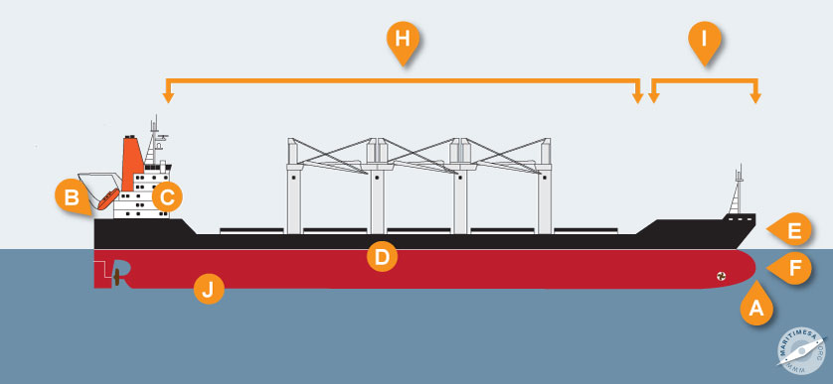
A Bow The front of the ship (This ship has a bulbous bow, a term for the shape of this bow with a protruding part that helps with the hydrodynamics of the ship.)
B Stern The back of the ship
C Accommodation (or superstructure) This where the crew live and operate the ship.
D Hull The part of the ship that is partly in the water. The cargo is kept in holds (or in tanks) in the hull.
E Freeboard The part of the hull that is above the water. Freeboard is usually given in metres (e.g. 6 metres, or 10 metres, which means that 6 metres of the hull or 10 metres of the hull is above the water.) The more cargo the ship is carrying, the less will be her freeboard (e.g. a ship with little cargo may have a freeboard of 15 metres, but the same ship with a full cargo may have a freeboard of 6 metres.)
F Draught The part of the hull that is below the water. Draught is usually given in metres (e.g. 5.6 metres or 17.3 metres which means that 5.6 metres of the hull is below the water, or 17.3 metres of the hull is below the water.) The more cargo the ship is carrying, the greater will be the draught. (e.g. a ship with little cargo may have a draugth of 6 metres, but the same ship with a full cargo may have a draught of 12 metres.)
G Afterdeck The deck aft (on the stern side) of the accommodation
H Foredeck The deck of a ship from the accommodation to the forecastle. (See forecastle below)
I Forecastle (pronounced fowksil and often spelled fo’c’sle) A raised part of the foredeck near the bow
J Keel The bottom of the ship
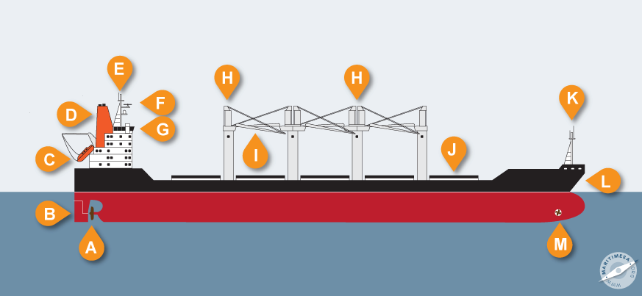
A Propeller A propeller is usually made of a metal compound, and has blades. When the ship’s engine turns the propeller shaft, the propeller turns and drives the ship ahead (forwards). On some ships, the propeller shaft and therefore the propeller can turn in the opposite direction, causing the ship to go astern (backwards). In other ships, the propeller keeps turning in the same direction, but if the ship should need to go astern, the angle of the blades can be altered to change the propulsion, causing the ship to go astern. This is called a variable-pitch propeller. NB There are other forms of propulsion that are used in some ships :
- Multi-directional propulsion such as the Voith-Schneider system.
- Azipods, sometimes linked to a dynamic positioning system. (This will be explained in the Grade 12 work.)
B Rudder When the ship needs to turn, the rudder turns to port (to the left) or to starboard (to the right in response to the ship’s steering mechanism. The ship then turns in that direction. Note : A ship is navigated from the wheelhouse (G), and steering is usually done by an automatic system, unless the ship is approaching a harbour, in narrow waters or manouevering in harbour when she is hand-steered.
C Lifeboat Used in an emergency when the crew have to abandon ship.
D Funnel The exhaust gasses pass from the engines and generators through pipes in the funnel. Shipowners usually paint the funnel of their ships in the company’s colours and some put the company logo on the funnel.
E Main mast The mast carries important lights for night-time navigation and some electronic equipment (such as the radar scanner) is mounted on the mast.
F Radar scanners These turn, sending out impulses that reflect off objects and the reflections are picked up by the scanner. The impulses are transferred to a radar screen in the wheelhouse (see G) so that the officer on watch can see the object as a spot on the radar screen.
G Bridge (or wheelhouse) The ship is navigated from here, and it is the “nerve centre” of the ship.
H Crane Used to lift cargo. You will see that there are two sets of cranes close together. These are designed to work either on their own, or the two cranes can work together – we call this system of cranes working in tandem. The lifting capacity nearly doubles if cranes are working in tandem. (Some older ships have derricks to lift cargo.)
I Crane jib
J Hatch cover The “lid” over the hold to ensure that water does not enter the hold. On this ship, containers or other deck cargo can be stowed atop (on top of) the hatch covers
K Foremast This mast that is located towards the bow of the ship. It usually has a special light that is shown at night, as well as the ship’s foghorn which is blown during poor visibility to warn other ships of this ship’s presence.
L Anchor Sometimes, a ship may have to wait outside a harbour. She then has to anchor in a suitable place. When the anchor is lowered (or dropped) to the seabed, the anchor holds the long chain attached to it in place, while the weight of the chain and its resistance on the seabed hold the ship in place.
M Bowthruster This is a small propeller that, when required, can shoot water to the starboard side (right side) or to the port side (left side), swinging the bow in the opposite direction.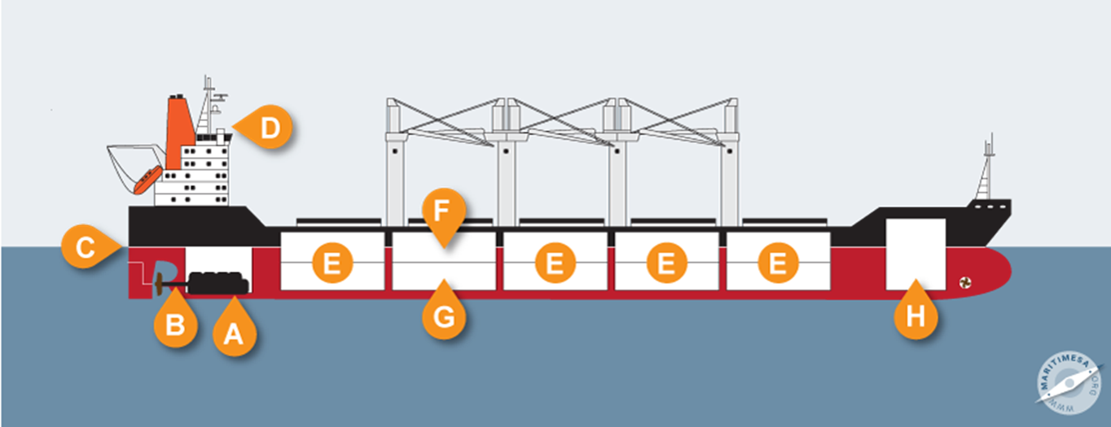
A Engine room The ship’s engine(s), generators and other machinery are located here. The engine(s) turn(s) a steel shaft (B – Propeller shaft) to which the propeller is attached. The generators generate electricity that is used for lighting, air-conditioning, electronics systems, cranes, pumps, refrigeration, and a number of other uses. In some ships, there is no main engine, but several powerful generators – the electricity generated is used to drive the propeller shaft and therefore the propeller.
B Propeller shaft A steel shaft to which the propeller is fixed.
C Loadline A special mark on the side of the ship indicating the level to which the ship may be loaded. (See diagram below.)
D Monkey Island Deck atop (above) the wheelhouse
E Hold The place where cargo is kept on the ship. This ship has five holds in which cargo can be stowed (placed). In ships that carry liquid cargoes, the “holds” are tanks in which the liquid cargo is carried. Therefore we call ships that carry liquid cargoes tankers.
F Tweendeck A deck inside the hold where cargo can be stowed.
G Lower hold The lower part of the hold where cargo can be stowed.
H Forepeak Tank Used to stow liquid cargo or fresh water or ballast water. (Ballast water is sea water that is used to trim [level] the ship.)

Information taken from https://maritimesa.org/grade-10/terminology-parts-of-ships-and-equipment-aboard-ships/
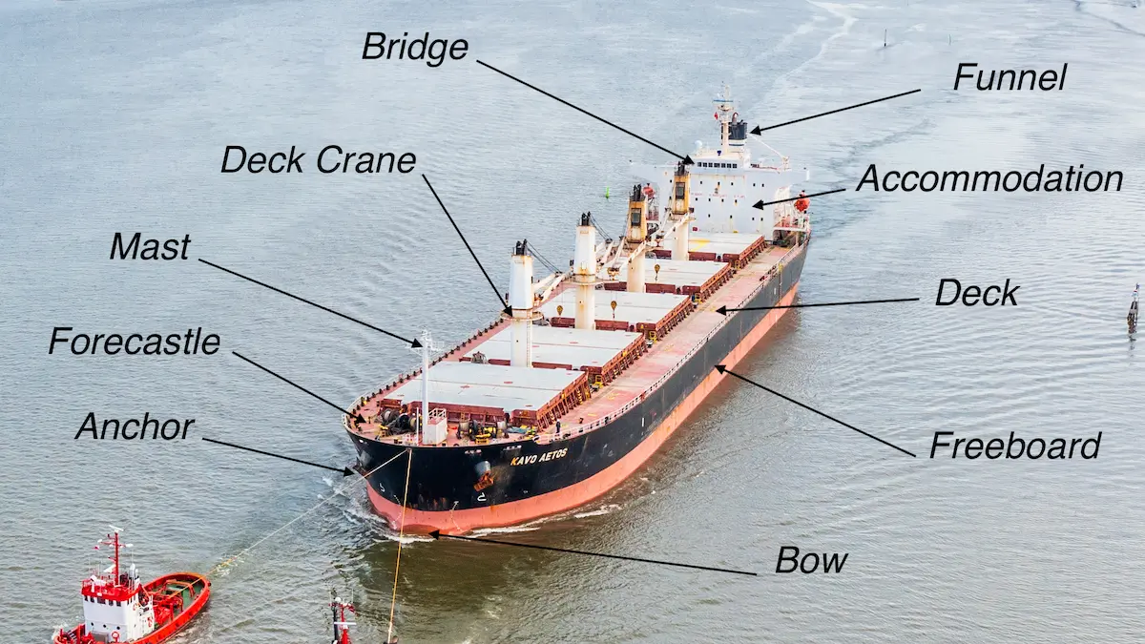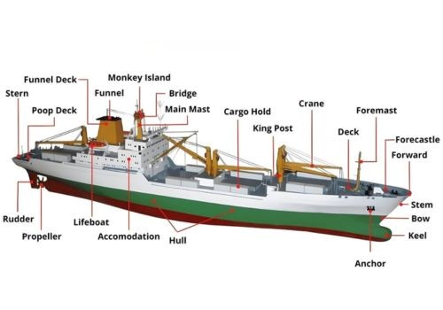
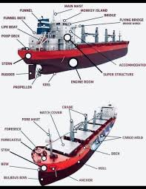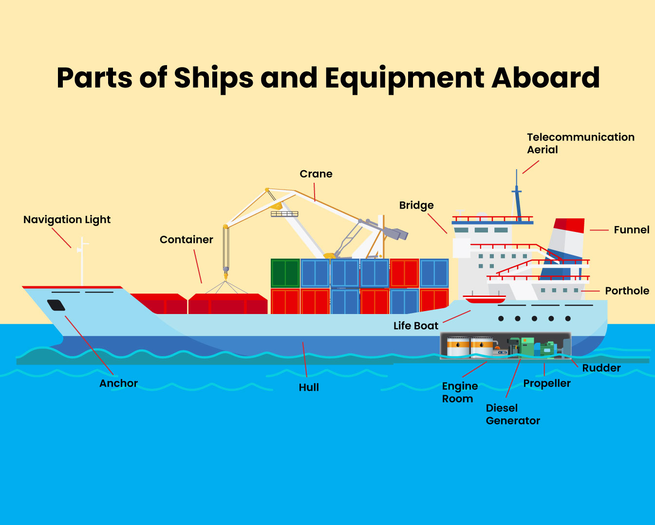
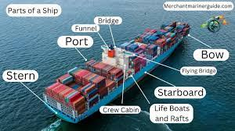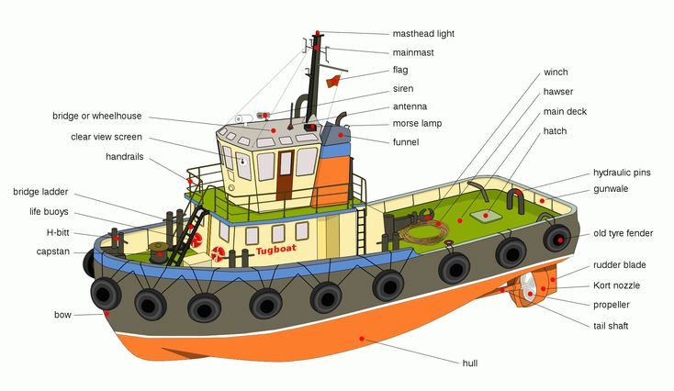
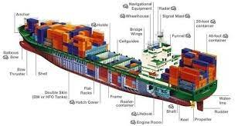
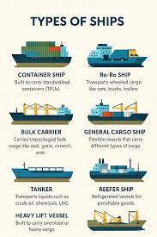
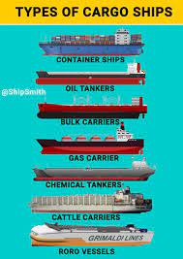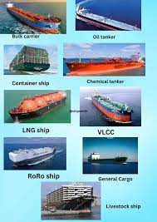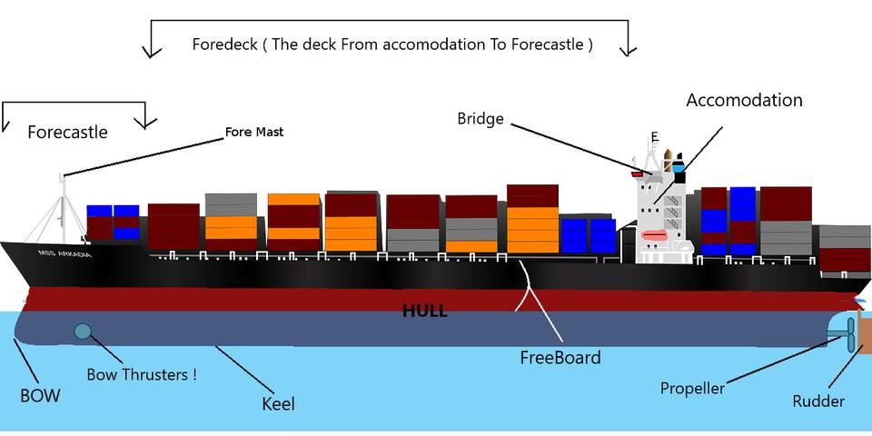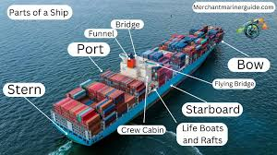
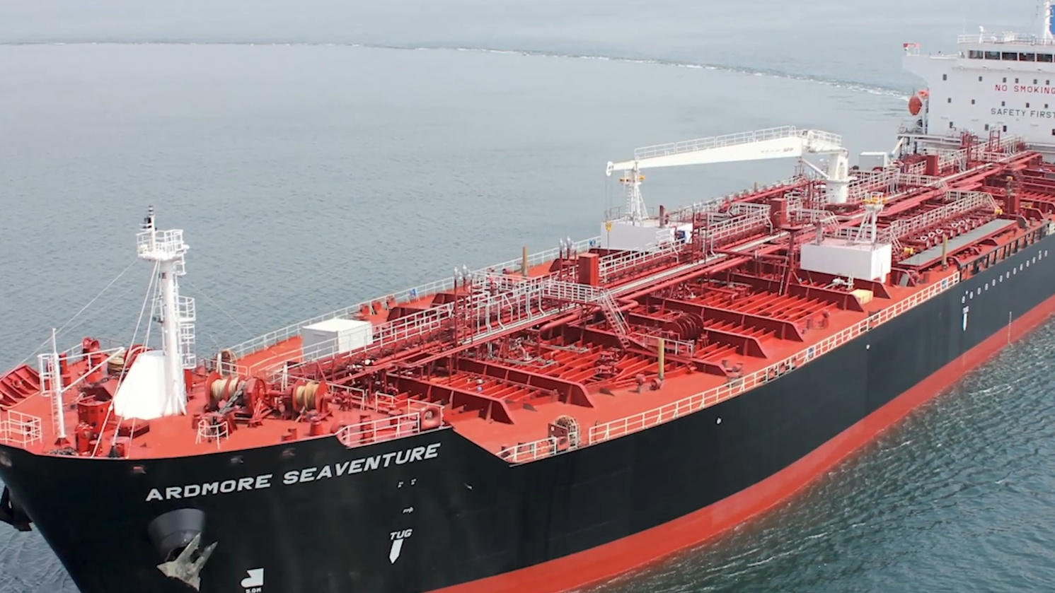
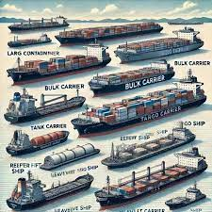

Also video at https://mascotmaritime.com/different-parts-of-a-ship/