Types of Ships in the Maritime Industry
The maritime industry plays a vital role in global trade, transportation, energy supply, and defense. Different types of ships are designed according to their purpose, cargo, operating area, and technical requirements. Below are twenty major types of vessels used in modern shipping, along with detailed descriptions of their characteristics, functions, and importance.

1. Container Ship
Container ships are designed to transport standardized containers (TEUs – Twenty-foot Equivalent Units). They operate on fixed routes and schedules, mainly between major ports worldwide. These vessels are equipped with cellular guides in their holds to secure containers and often carry thousands of containers on deck. Container ships are essential for global trade, transporting consumer goods, electronics, clothing, and industrial products efficiently.
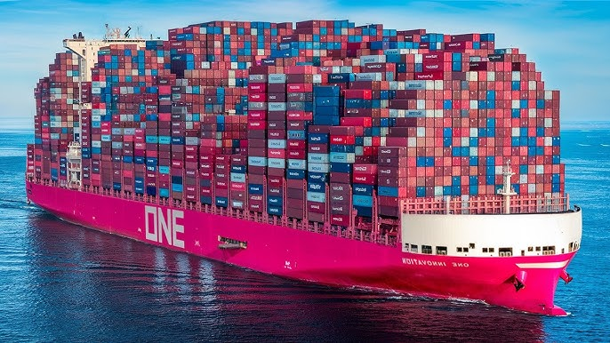

2. Bulk Carrier
Bulk carriers transport unpackaged dry bulk cargo such as coal, iron ore, grain, bauxite, and cement. They have large cargo holds with reinforced structures to handle heavy loads. Bulk carriers are categorized into Handysize, Panamax, Capesize, and Very Large Bulk Carriers depending on their size. They are crucial for supplying raw materials to industries worldwide.
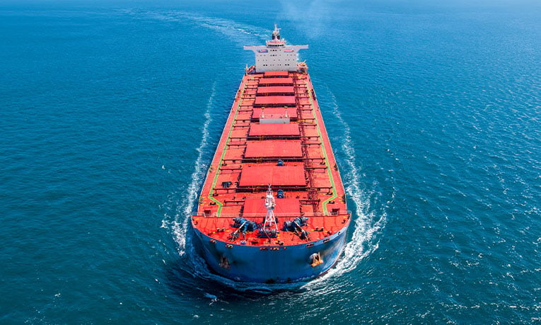

3. Oil Tanker
Oil tankers are designed to carry crude oil and petroleum products. They have multiple segregated tanks to prevent contamination and improve safety. Modern tankers are equipped with double hulls to reduce the risk of oil spills. Oil tankers are divided into crude oil tankers and product tankers, playing a key role in the global energy supply chain.
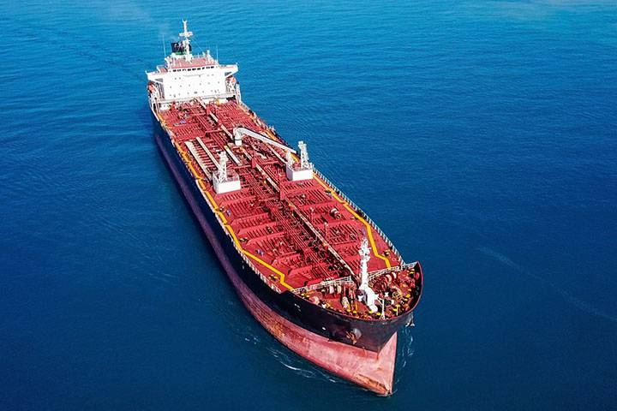

4. Chemical Tanker
Chemical tankers transport liquid chemicals in bulk, such as acids, alcohols, and solvents. Their cargo tanks are made of stainless steel or coated with special materials to resist corrosion. These vessels require highly trained crews due to the hazardous nature of the cargo. Strict international regulations govern their operation.
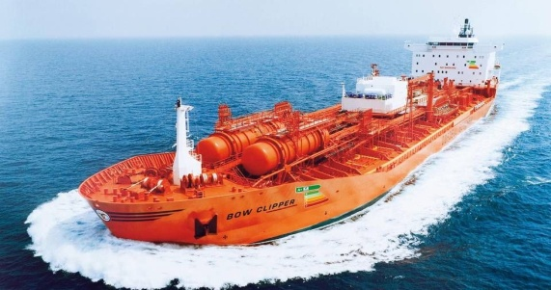

5. Liquefied Natural Gas (LNG) Carrier
LNG carriers transport natural gas in liquefied form at extremely low temperatures (-162°C). They use advanced insulation systems and specialized containment tanks, such as Moss-type or membrane tanks. LNG carriers are technologically advanced vessels and play a growing role in cleaner energy transportation.
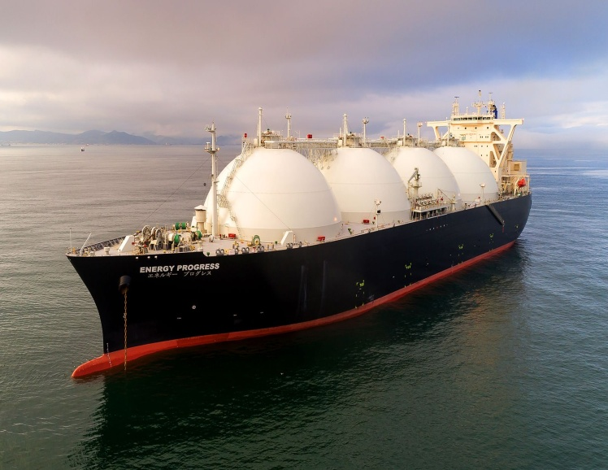

6. Liquefied Petroleum Gas (LPG) Carrier
LPG carriers transport propane, butane, and other liquefied gases under pressure or refrigeration. They are smaller than LNG carriers but still require sophisticated safety systems. LPG carriers are widely used for both domestic and industrial energy needs.
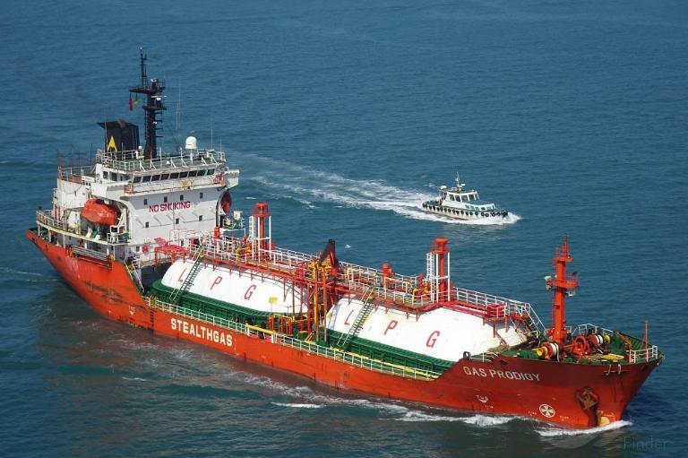

7. Ro-Ro Ship (Roll-on/Roll-off)
Ro-Ro ships transport wheeled cargo such as cars, trucks, trailers, and railway wagons. Cargo is loaded and unloaded via ramps, allowing fast turnaround times in ports. These ships are commonly used in short-sea shipping and ferry services.
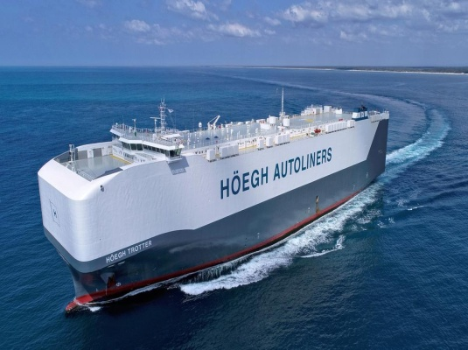

8. Car Carrier (PCC / PCTC)
Car carriers are specialized Ro-Ro vessels designed to transport large numbers of vehicles. They have multiple enclosed decks and advanced ventilation systems to protect vehicles from damage. They are essential for the global automotive industry.
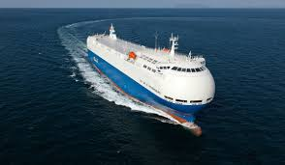

9. General Cargo Ship
General cargo ships carry various types of cargo, including packaged goods, pallets, bags, and crates. They are flexible vessels often used in smaller ports where specialized ships cannot operate. Although their use has declined due to containerization, they remain important in certain trades.
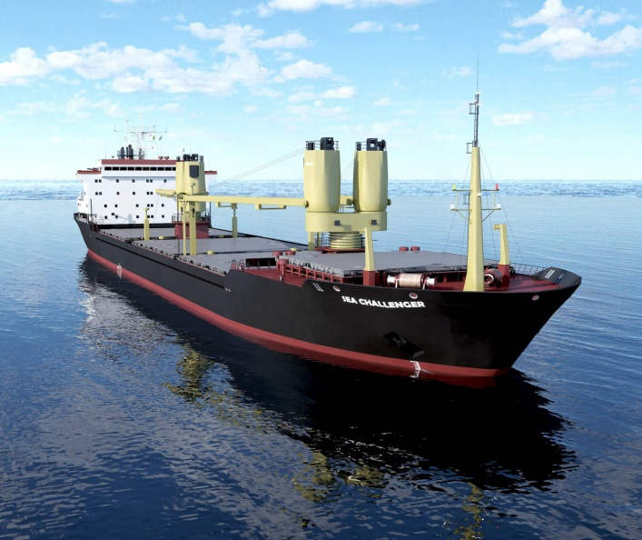

10. Passenger Ship
Passenger ships transport people rather than cargo. They include ocean liners and coastal passenger vessels. Safety, comfort, and accommodation are key design factors. Passenger ships must comply with strict international safety regulations such as SOLAS.
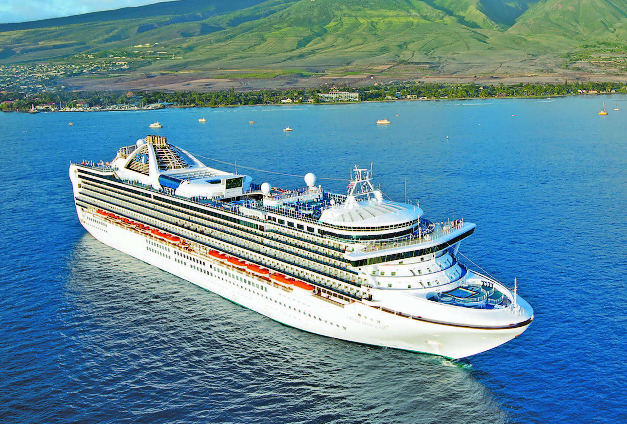

11. Cruise Ship
Cruise ships are luxury passenger vessels designed for leisure travel. They offer accommodation, entertainment, restaurants, and recreational facilities. Cruise ships operate on specific routes and destinations and focus on passenger experience rather than transportation.
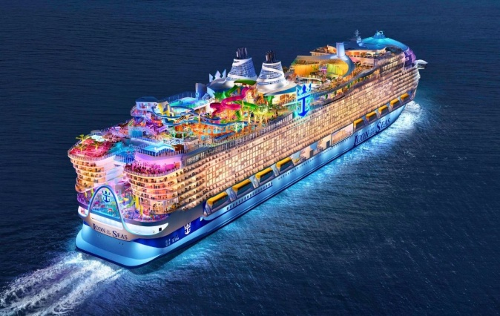

12. Ferry
Ferries transport passengers, vehicles, and cargo over short distances, often across rivers, bays, or narrow seas. They operate on regular schedules and are vital for local transportation networks. Ferries can be Ro-Ro or passenger-only vessels.
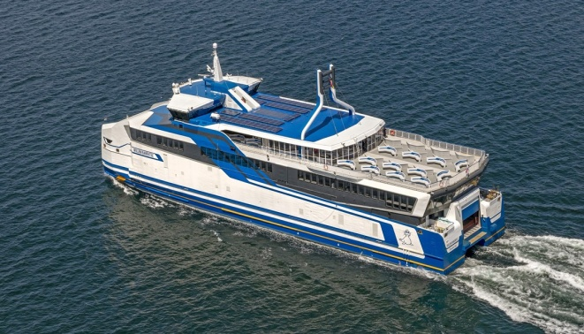

13. Fishing Vessel
Fishing vessels are used for catching fish and other seafood. Types include trawlers, longliners, purse seiners, and factory ships. Some fishing vessels are equipped with processing and freezing facilities, allowing them to stay at sea for extended periods.
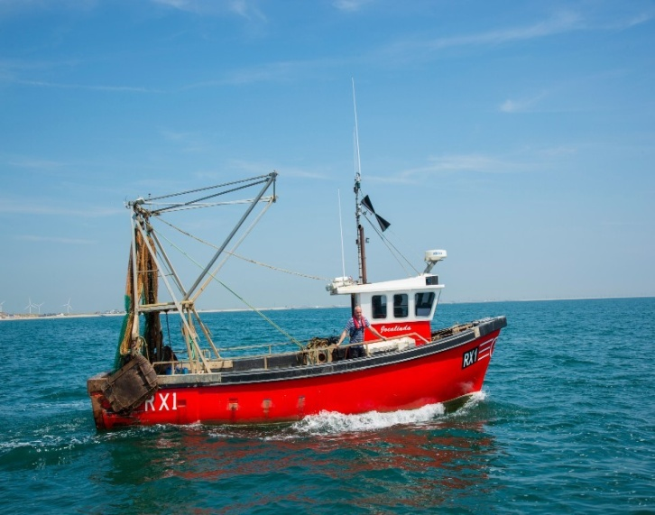

14. Offshore Support Vessel (OSV)
OSVs support offshore oil and gas operations. They transport supplies, equipment, and personnel to offshore platforms. Common types include Platform Supply Vessels (PSVs) and Anchor Handling Tug Supply vessels (AHTS).
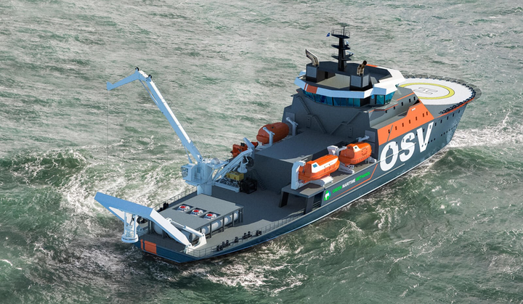

15. Tugboat
Tugboats are powerful vessels used to maneuver larger ships in ports, narrow channels, and confined waters. They provide towing, pushing, and escort services. Tugboats are equipped with strong engines and towing equipment.
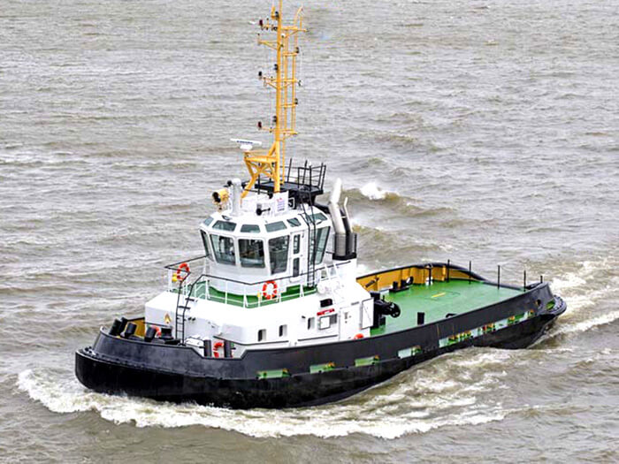

16. Dredger
Dredgers are used to remove sediment from the seabed to maintain or deepen navigation channels and ports. Types include cutter suction dredgers and trailing suction hopper dredgers. Dredging is essential for safe maritime navigation.
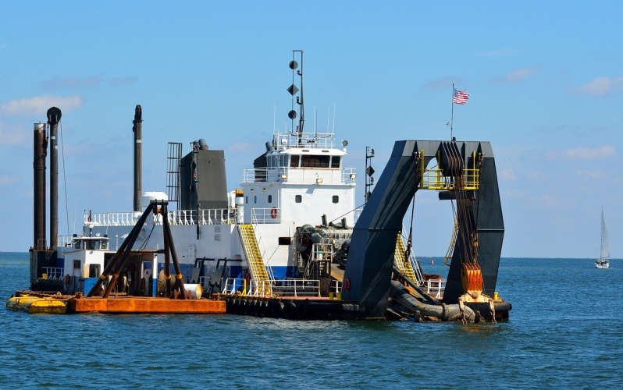

17. Naval Warship
Naval warships are military vessels designed for combat and defense operations. They include destroyers, frigates, aircraft carriers, and submarines. Warships are equipped with advanced weapons, radar systems, and communication technology.
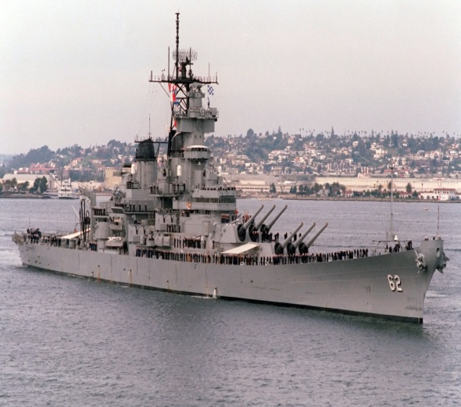

18. Research Vessel
Research vessels are used for scientific exploration of oceans and seas. They support marine biology, oceanography, and climate research. These vessels are equipped with laboratories, sonar systems, and specialized instruments.
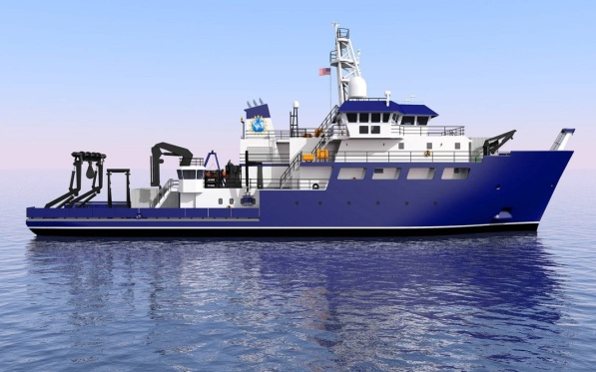

19. Icebreaker
Icebreakers are designed to operate in frozen waters by breaking ice with their reinforced hulls. They are essential for navigation in polar regions and icy seas. Icebreakers support commercial shipping, research, and national security.
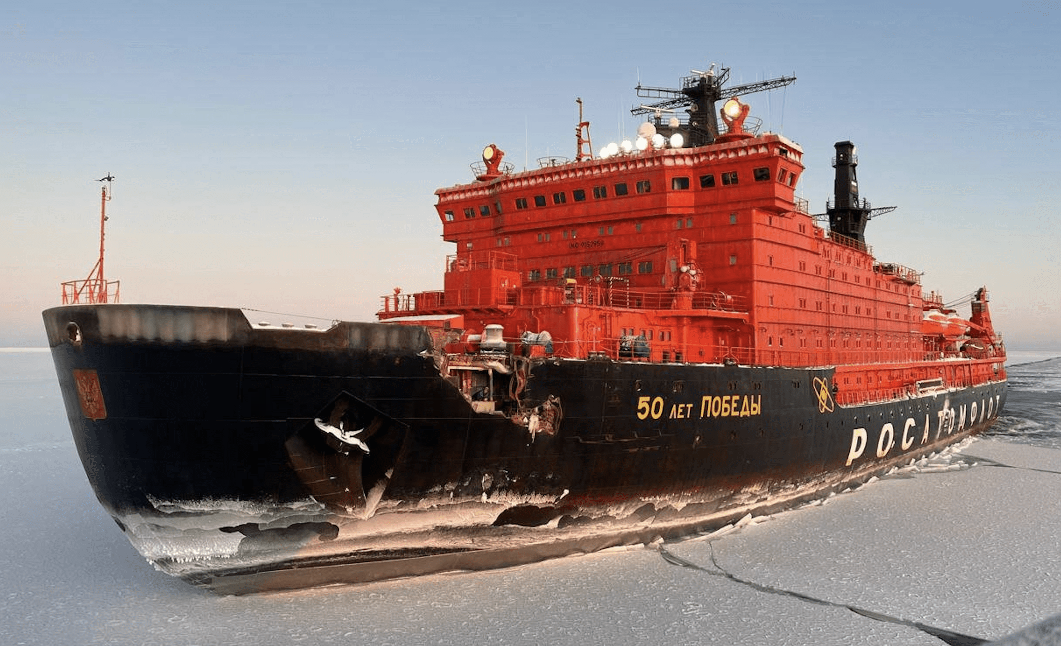

20. Heavy Lift Vessel
Heavy lift vessels transport extremely heavy and oversized cargo such as offshore platforms, wind turbine components, and industrial machinery. They are equipped with powerful cranes or semi-submersible decks. These ships are vital for offshore construction projects.
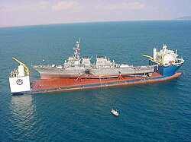

Conclusion
Each type of ship plays a specific and essential role in the maritime industry. From transporting raw materials and energy to supporting offshore operations and passenger travel, ships are the backbone of global commerce. Understanding different vessel types is fundamental for students and professionals in maritime studies.

