Commercial Shipping Vessels – Types and Characteristics
A comprehensive overview of 20 modern merchant ships
Introduction
Commercial shipping is one of the most essential pillars of global trade, responsible for transporting more than 90% of the world’s goods. Modern merchant vessels are highly specialized, each designed to carry specific types of cargo efficiently and safely across long distances. This assignment presents 20 major types of commercial ships, describing their purpose, characteristics, and role in international maritime transport.

- Container Ship
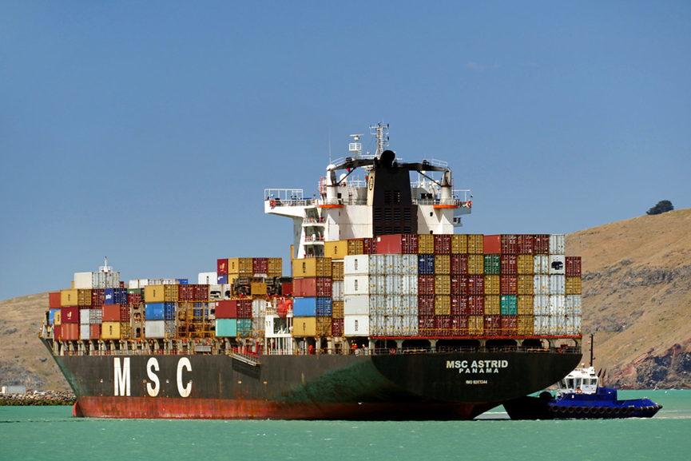
A container ship is designed to carry standardized cargo containers (TEUs and FEUs). These vessels are the backbone of global trade, transporting manufactured goods, electronics, clothing, and machinery. They feature large open decks and deep holds where containers are stacked and secured. Modern container ships can carry more than 20,000 containers on a single voyage.
- Bulk Carrier 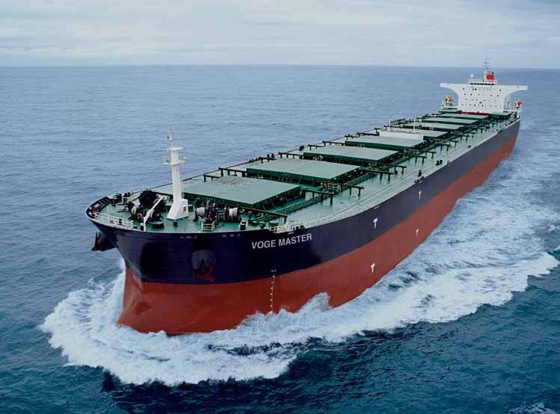
Αυτή η φωτογραφία από Άγνωστος συντάκτης με άδεια χρήσης CC BY-NC
Bulk carriers transport unpackaged bulk cargo such as coal, grain, iron ore, and cement. They have large cargo holds and strong hatch covers to protect the cargo. Their design focuses on maximizing cargo volume and ensuring safe loading and unloading operations. Bulk carriers are essential for supplying raw materials to industries worldwide.
- Oil Tanker
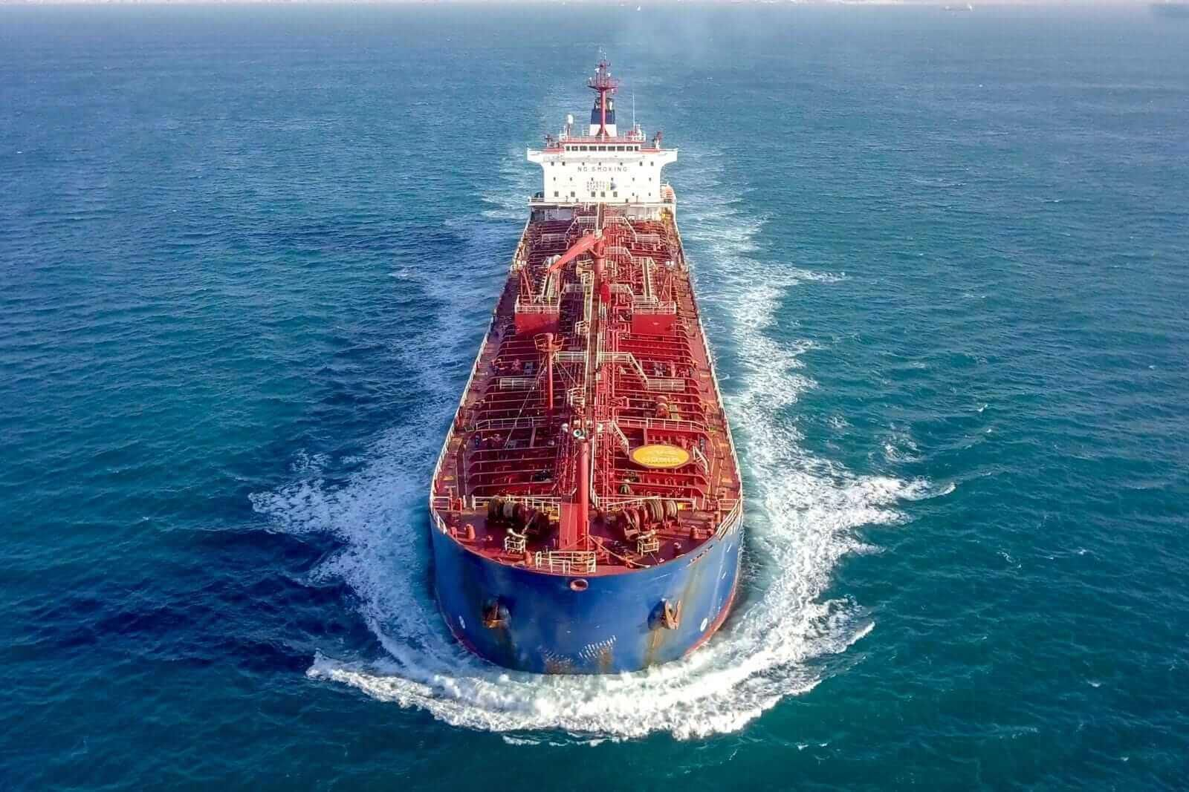
Oil tankers are specialized vessels used to transport crude oil or refined petroleum products. They are built with multiple segregated tanks and advanced safety systems to prevent spills. Very Large Crude Carriers (VLCCs) and Ultra Large Crude Carriers (ULCCs) are among the largest ships ever built. They play a vital role in the global energy supply chain.
- LNG Carrier 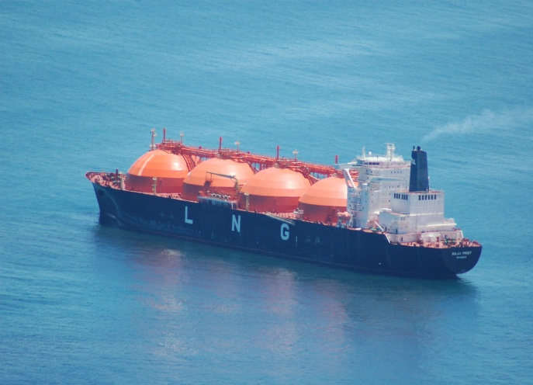
Αυτή η φωτογραφία από Άγνωστος συντάκτης με άδεια χρήσης CC BY-NC-ND
Liquefied Natural Gas (LNG) carriers transport natural gas cooled to –162°C, reducing its volume for efficient shipping. These vessels have spherical or membrane-type insulated tanks. LNG carriers require advanced technology and strict safety standards due to the cryogenic nature of the cargo.
- LPG Carrier
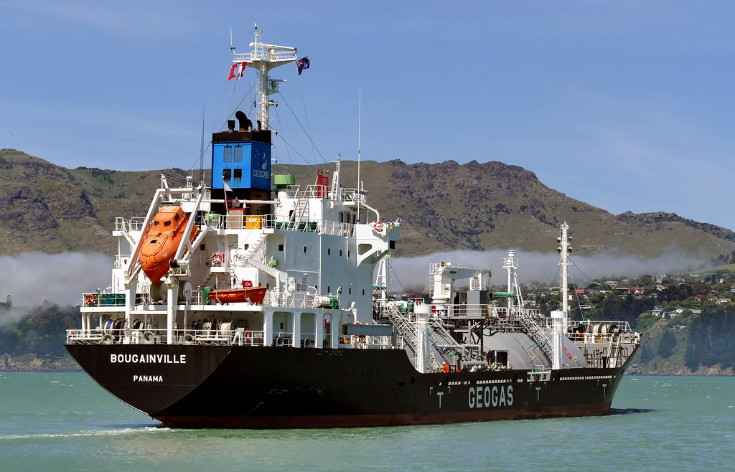
Liquefied Petroleum Gas (LPG) carriers transport propane, butane, and other liquefied gases. Their tanks are designed to withstand high pressure or low temperatures. LPG carriers support the global chemical and energy industries by transporting gas products safely and efficiently.

- Ro-Ro Ship
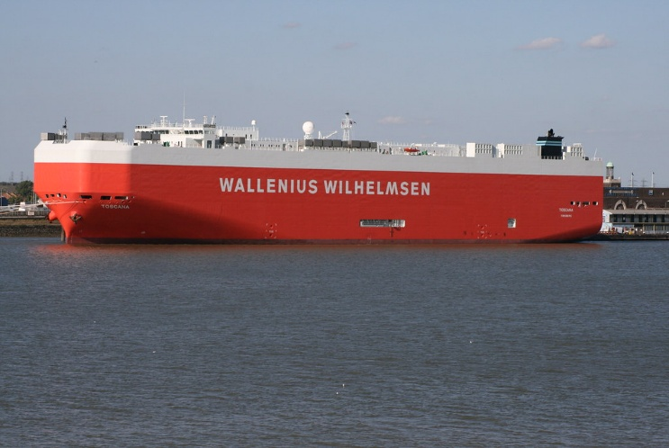
Αυτή η φωτογραφία από Άγνωστος συντάκτης με άδεια χρήσης CC BY
Roll-on/Roll-off (Ro-Ro) ships are designed for wheeled cargo such as trucks, trailers, and cars. They feature built-in ramps that allow vehicles to drive directly on and off the vessel. Ro-Ro ships are widely used in short-sea shipping and international vehicle transport.
- Car Carrier (PCTC)
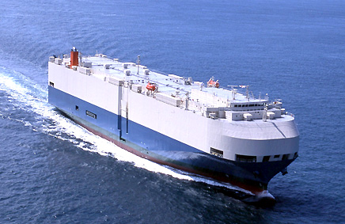
Αυτή η φωτογραφία από Άγνωστος συντάκτης με άδεια χρήσης CC BY-NC
Pure Car and Truck Carriers (PCTCs) are a type of Ro-Ro ship specialized in transporting thousands of cars at once. They have multiple decks, adjustable ramps, and climate-controlled spaces. These vessels are essential for the global automotive industry.

- General Cargo Ship

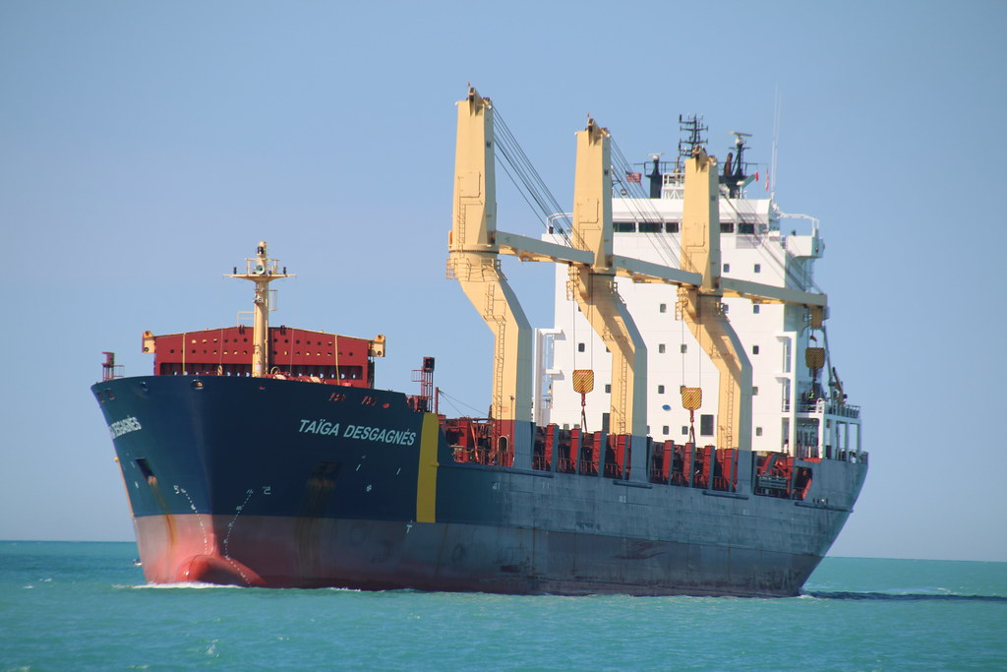
Αυτή η φωτογραφία από Άγνωστος συντάκτης με άδεια χρήσης CC BY-SA-NC
General cargo ships carry a wide variety of goods that cannot be containerized, such as machinery, steel products, and packaged items. They often have onboard cranes for loading and unloading in ports without infrastructure. Their flexibility makes them valuable for regional and specialized trade routes.
- Reefer Ship
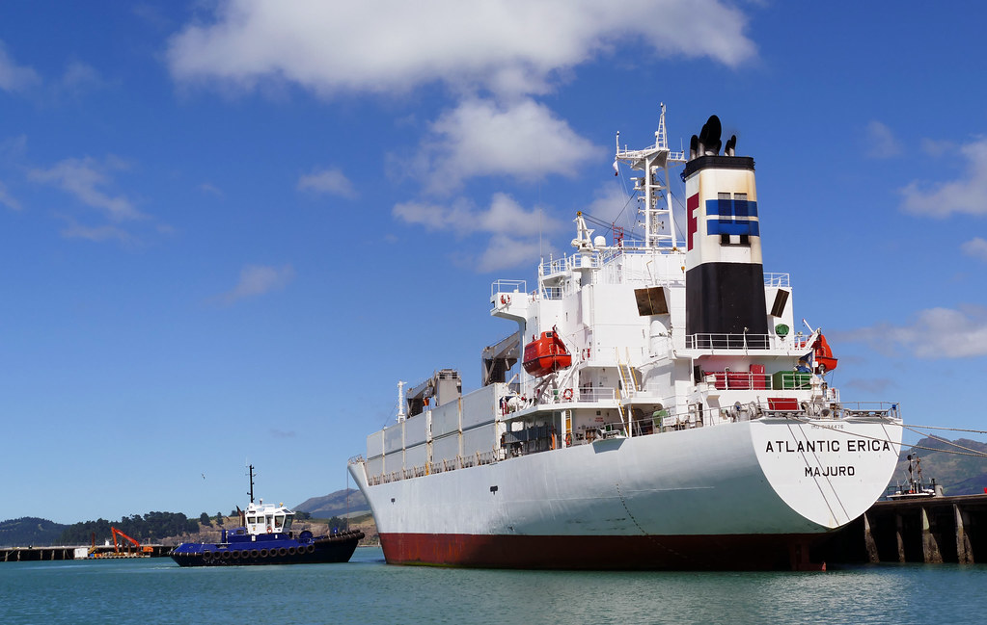
Reefer ships transport perishable goods such as fruits, vegetables, meat, and pharmaceuticals. They are equipped with advanced refrigeration systems to maintain stable temperatures. These vessels ensure that sensitive products remain fresh during long-distance transport.

- Heavy Lift Vessel
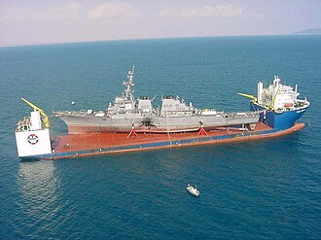
Αυτή η φωτογραφία από Άγνωστος συντάκτης με άδεια χρήσης CC BY-SA
Heavy lift vessels are designed to transport oversized or extremely heavy cargo, such as wind turbine parts, industrial machinery, and offshore equipment. They feature powerful cranes and reinforced decks. Some heavy lift ships can partially submerge to load floating structures.
- Offshore Supply Vessel (OSV)
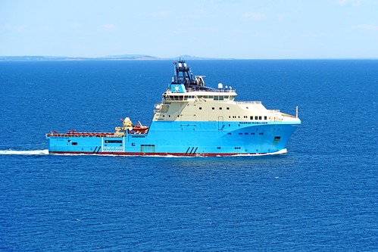
Αυτή η φωτογραφία από Άγνωστος συντάκτης με άδεια χρήσης CC BY-SA
OSVs support offshore oil and gas platforms by transporting equipment, fuel, water, and supplies. They are built with dynamic positioning systems to maintain stability near offshore installations. OSVs are essential for energy exploration and production.

- Tugboat
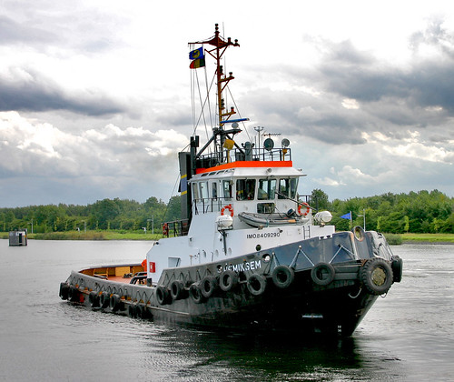
Αυτή η φωτογραφία από Άγνωστος συντάκτης με άδεια χρήσης CC BY
Tugboats are small but powerful vessels used to maneuver larger ships in ports, canals, and narrow waterways. They provide towing, pushing, and escort services. Tugboats are crucial for port safety and efficient ship handling.
- Dredger
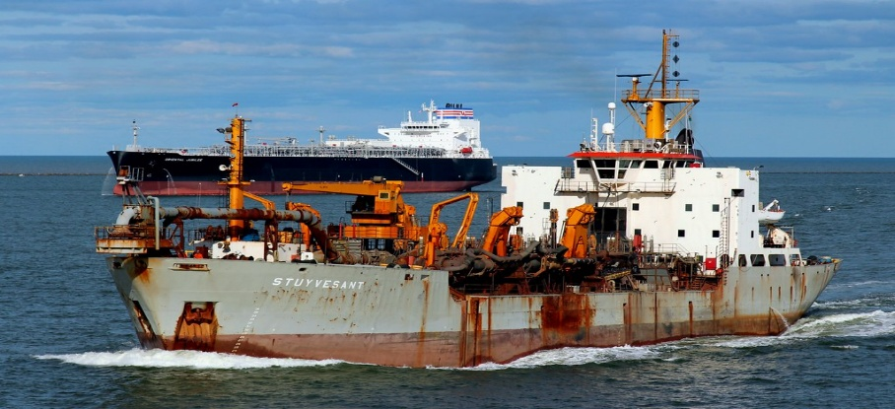
Αυτή η φωτογραφία από Άγνωστος συντάκτης με άδεια χρήσης CC BY
Dredgers remove sediment from the seabed to maintain navigable waterways, deepen ports, and support construction projects. They come in various types, such as cutter suction dredgers and trailing suction hopper dredgers. Dredging is vital for global maritime infrastructure.

- Barge
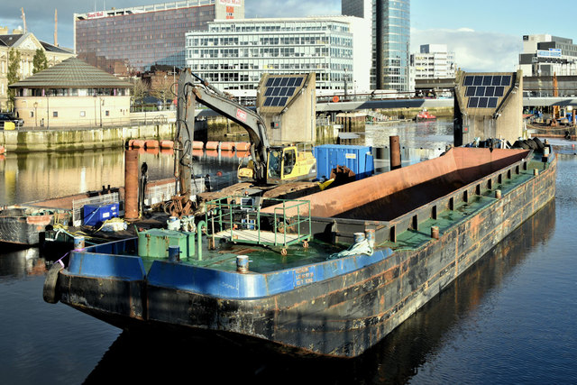
Αυτή η φωτογραφία από Άγνωστος συντάκτης με άδεια χρήσης CC BY-SA
Barges are flat-bottomed vessels used to transport cargo on rivers, canals, and coastal waters. They are often pushed or pulled by tugboats. Barges are efficient for transporting bulk goods, construction materials, and containers over short distances.
- Feeder Ship
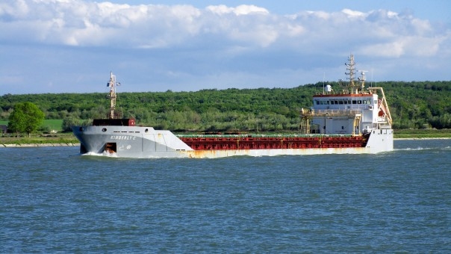
Feeder ships transport containers between smaller regional ports and major international hubs. They play a key role in the container shipping network by connecting local markets to global trade routes. Feeder ships are smaller than mainline container vessels.

- Passenger Ferry
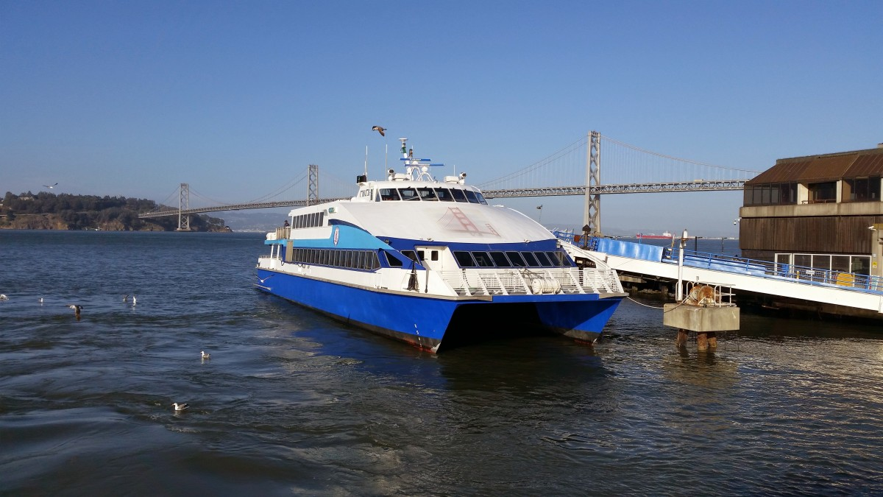
Passenger ferries transport people, vehicles, and goods across short or medium distances. They operate on fixed schedules and are essential for connecting islands, coastal cities, and river crossings. Modern ferries may include restaurants, lounges, and cabins.
- Cruise Ship
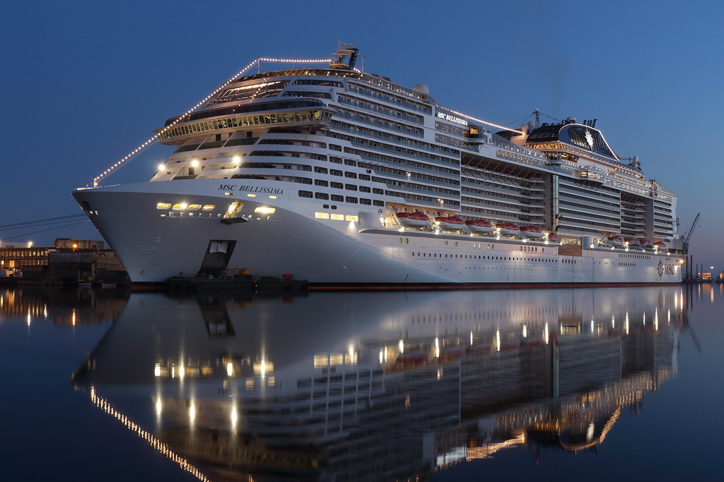
Cruise ships are large passenger vessels designed for leisure travel. They offer accommodations, entertainment, dining, and recreational facilities. Cruise ships operate on planned itineraries and contribute significantly to the tourism industry.

- Research Vessel
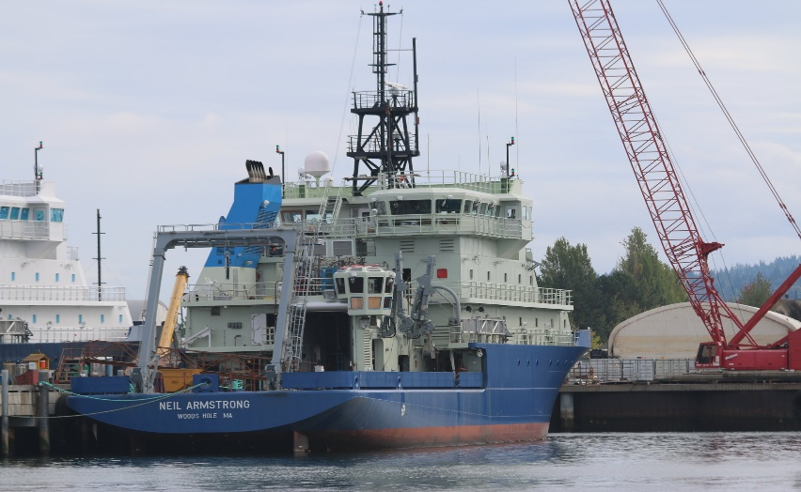
Αυτή η φωτογραφία από Άγνωστος συντάκτης με άδεια χρήσης CC BY-SA-NC
Research vessels support scientific missions such as oceanography, marine biology, and climate studies. They are equipped with laboratories, sonar systems, and sampling equipment. These ships help scientists explore and understand the world’s oceans.
- Cable-Laying Ship
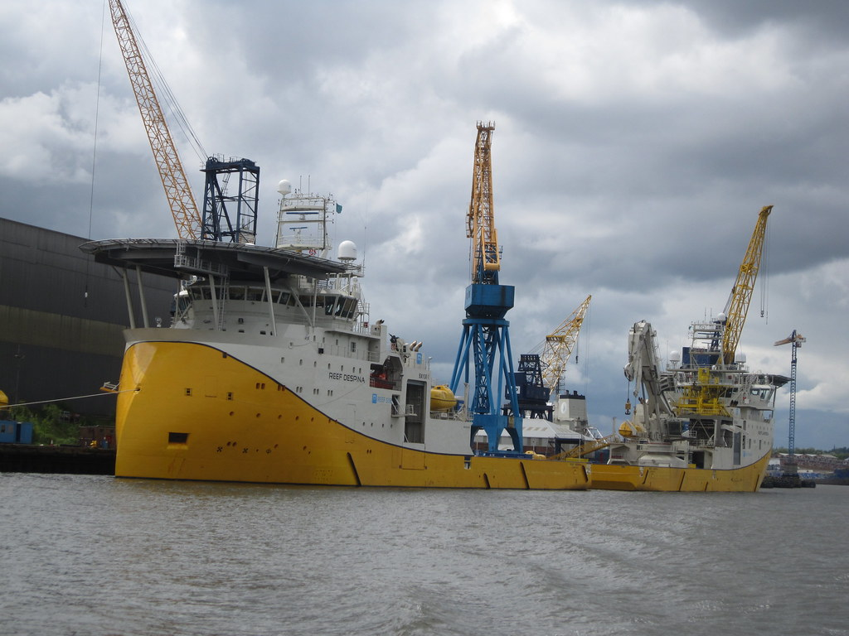
Αυτή η φωτογραφία από Άγνωστος συντάκτης με άδεια χρήσης CC BY-NC
Cable-laying ships install and repair underwater communication and power cables. They have specialized equipment for storing, deploying, and burying cables on the seabed. These vessels are essential for global internet and electrical infrastructure.

- Icebreaker (Commercial)
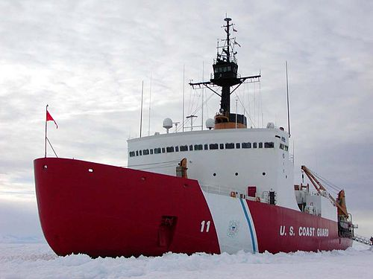
Αυτή η φωτογραφία από Άγνωστος συντάκτης με άδεια χρήσης CC BY-SA
Commercial icebreakers are designed to navigate and clear paths through ice-covered waters. They support shipping routes in polar regions and assist other vessels by breaking thick ice. Their reinforced hulls and powerful engines allow safe passage in extreme conditions.

Conclusion
Modern commercial shipping relies on a diverse fleet of specialized vessels, each designed to meet the demands of global trade. From container ships that carry manufactured goods to tankers that transport energy resources, every type of ship plays a vital role in the world economy. Understanding these vessel types highlights the complexity and importance of maritime transport in connecting nations and supporting international commerce.

I HOPE YOU LIKE IT!!!!!!!!

