Δημήτρης Τομάζος Α.Μ. 8019

20 Different Types of Ships
Ναυτικα αγγλικα α εξαμηνο 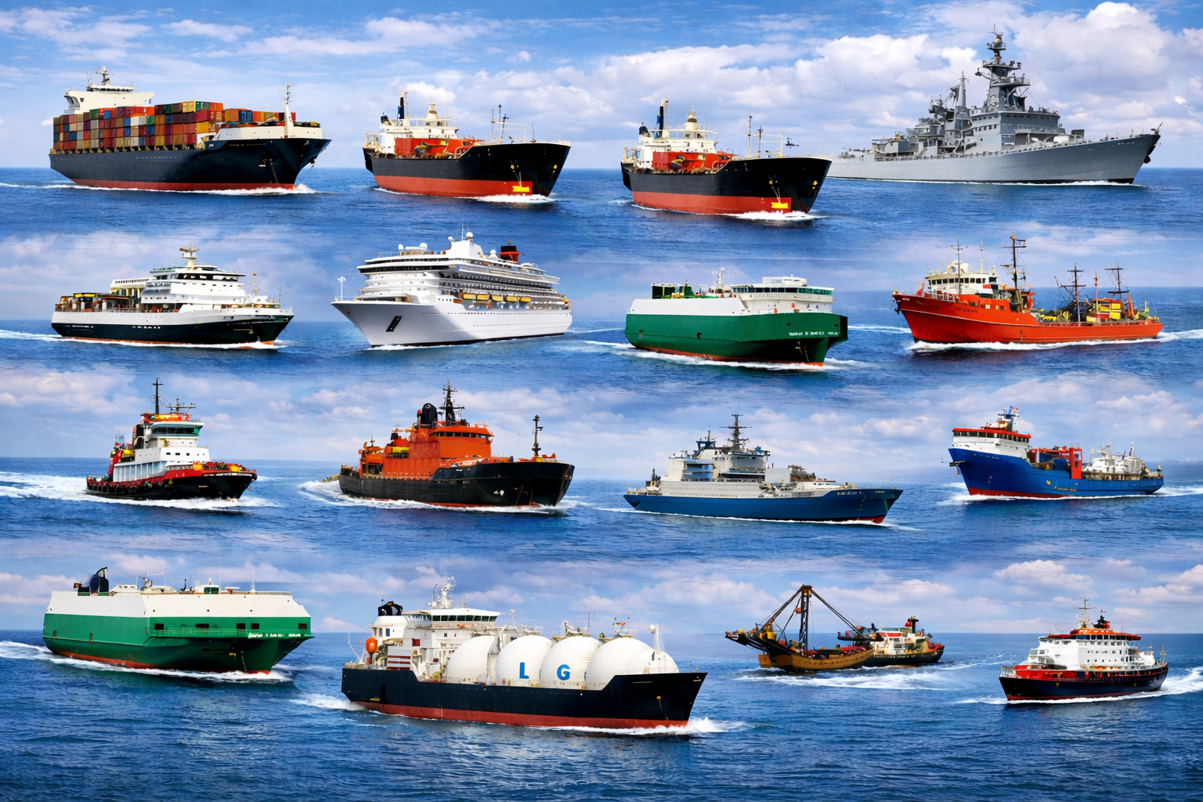

Πίνακας περιεχομένων
Introduction 1
1. Container Ship 1
2. Bulk Carrier 2
3. Tanker 3
4. Passenger Ship 4
5. Cruise Ship 5
6. Ro-Ro Ship 6
7. Fishing Vessel 7
8. Naval Ship 8
9. Tugboat 9
10. Supply Vessel 10
11. Research Vessel 11
12. Icebreaker 12
13. Car Carrier 13
14. Livestock Carrier 14
15. Chemical Tanker 15
16. Gas Carrier 16
17. Dredger 17
18. Cable Laying Ship 18
19. Pilot Boat 19
20. Training Ship 20
Conclusion 21

Introduction
This assignment is about different types of ships.
These ships work at sea for different jobs.

1. Container Ship
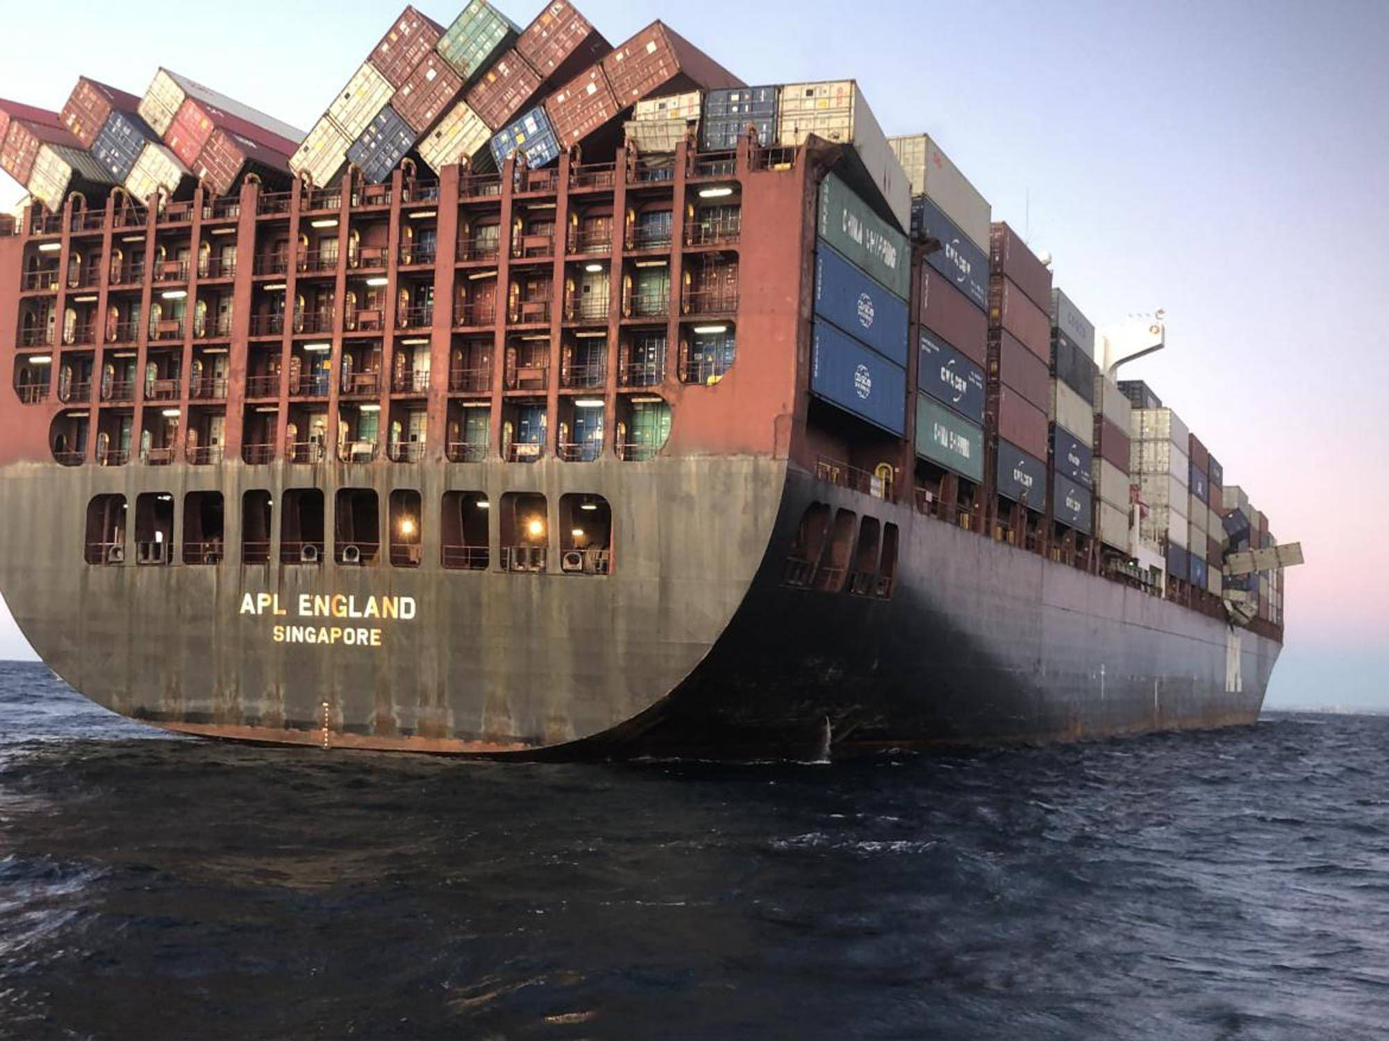
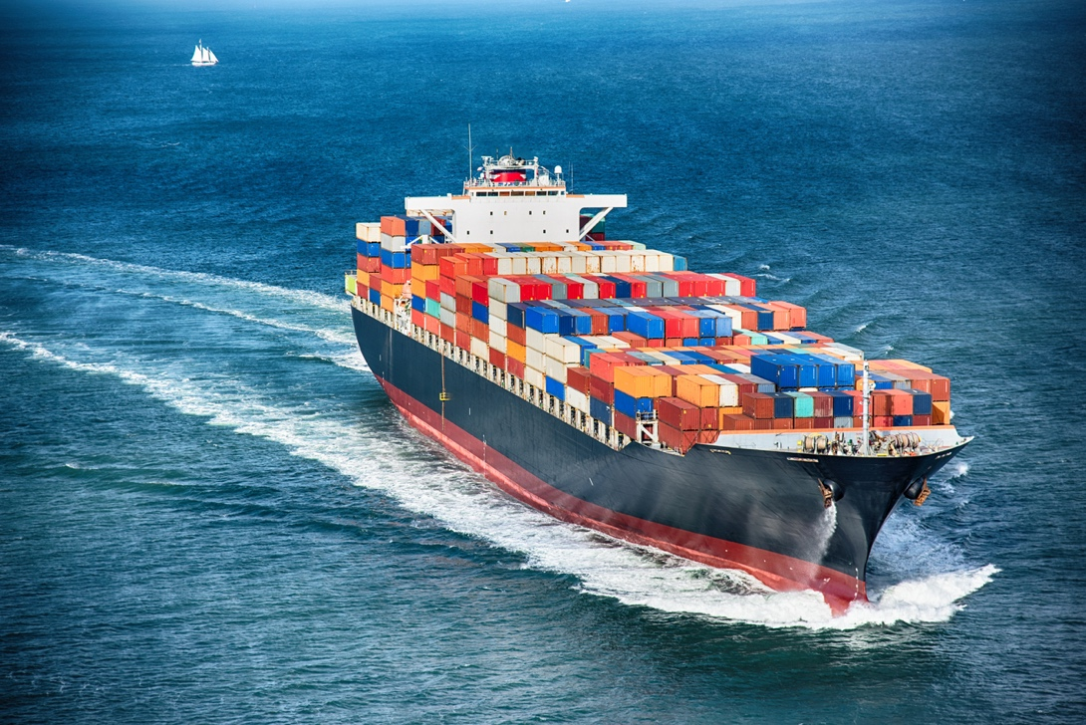
This ship carries containers.
It works all over the world.
It is very important for trade.

2. Bulk Carrier
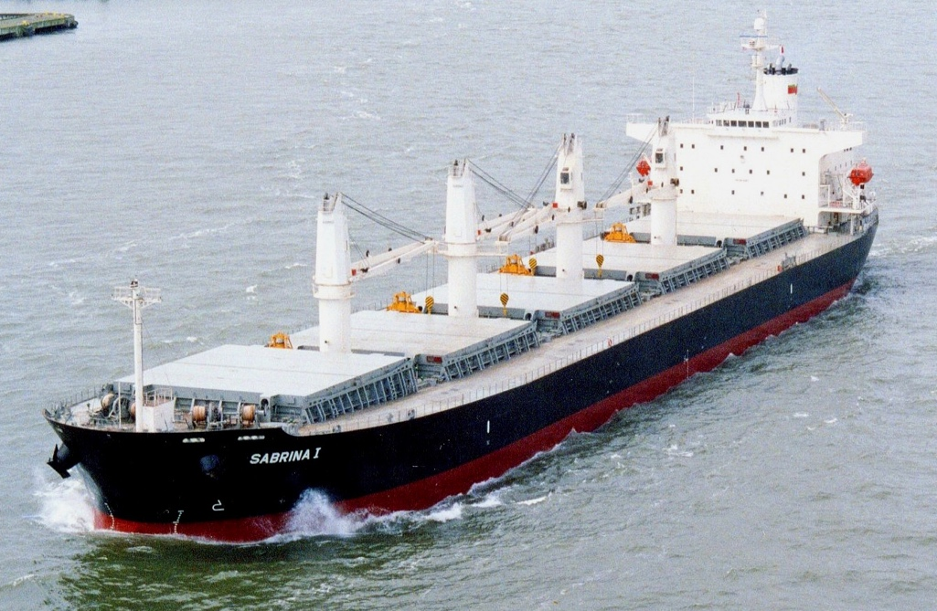
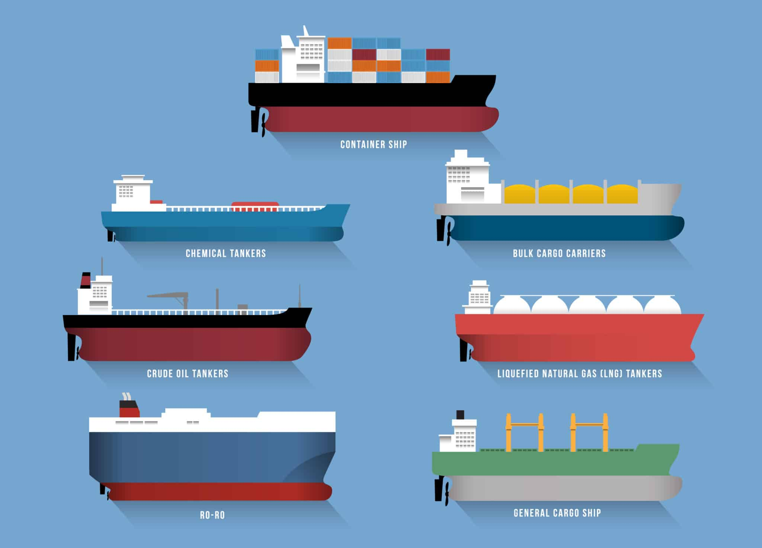
This ship carries bulk cargo.
It carries coal, grain, or ore.
The cargo is not in containers.

3. Tanker
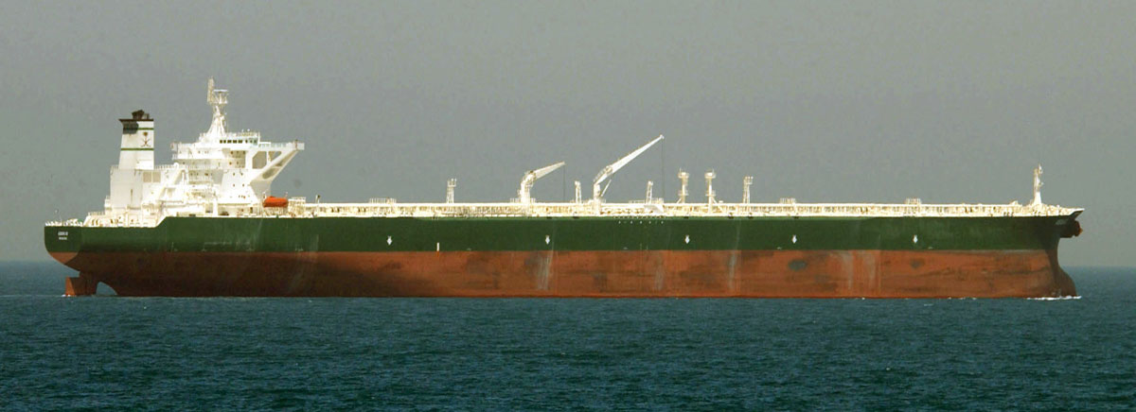
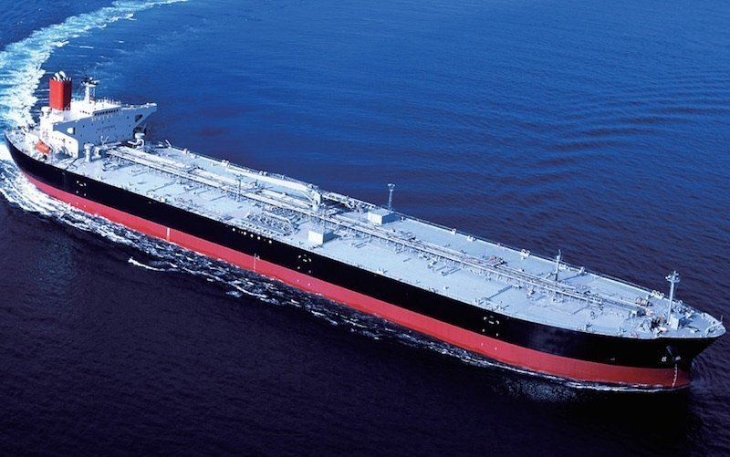
This ship carries liquid cargo.
It carries oil or fuel.
Safety is very important on this ship.

4. Passenger Ship
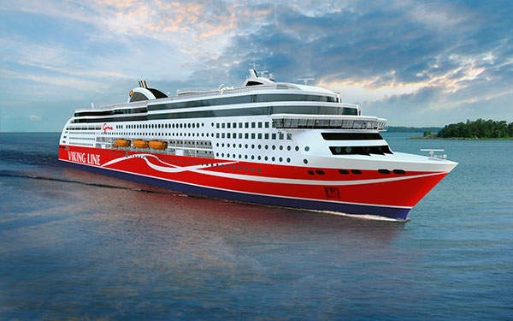
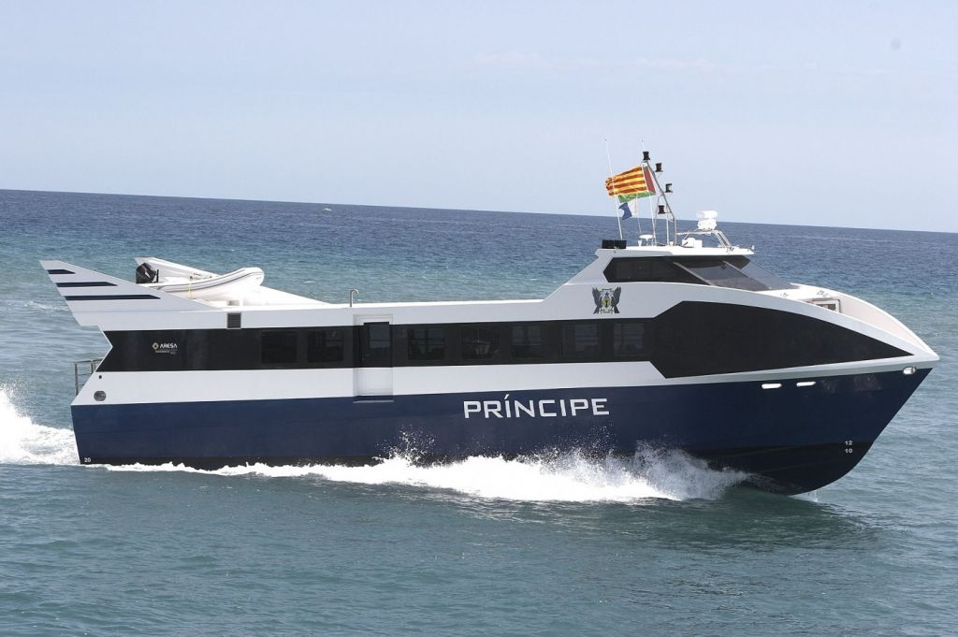
This ship carries passengers.
It travels between ports.
Many people use this ship.

5. Cruise Ship
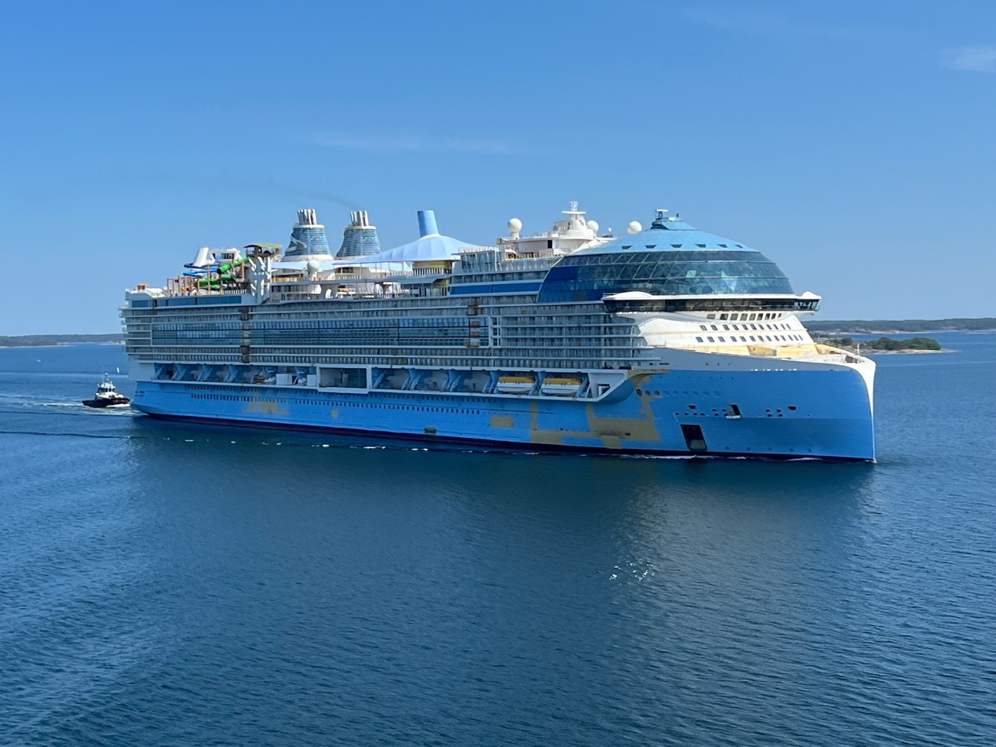
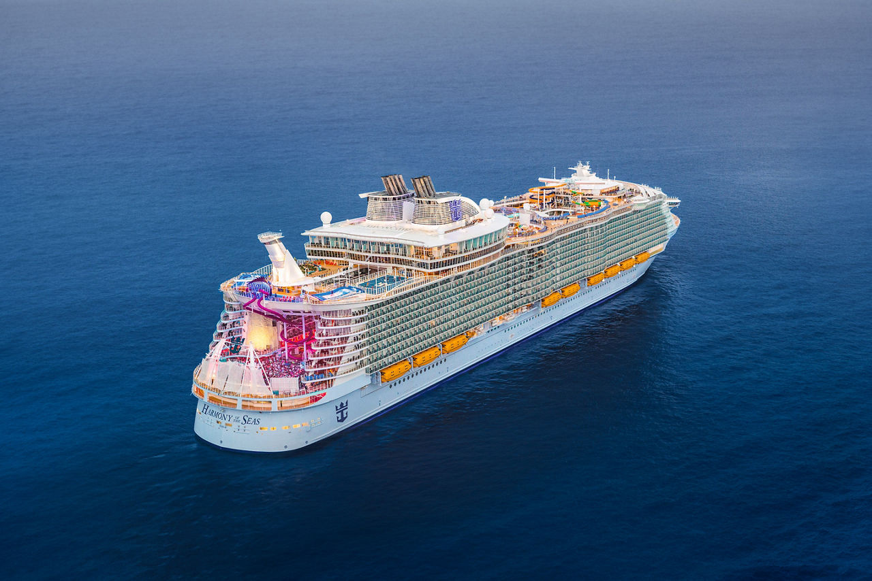
This ship is for holidays.
Passengers sleep and eat on board.
It travels to many countries.

6. Ro-Ro Ship
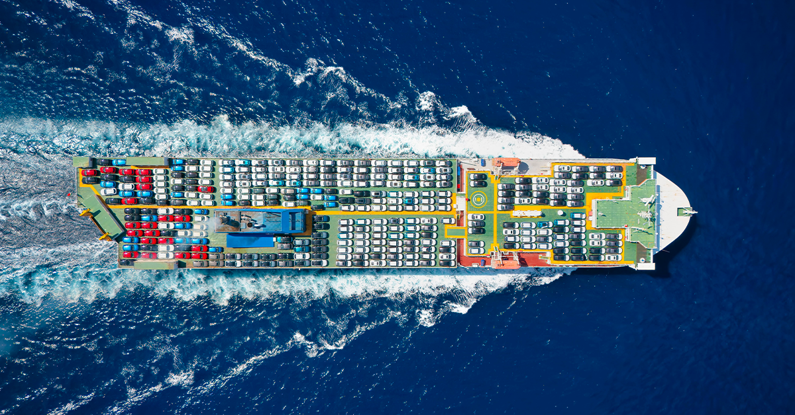
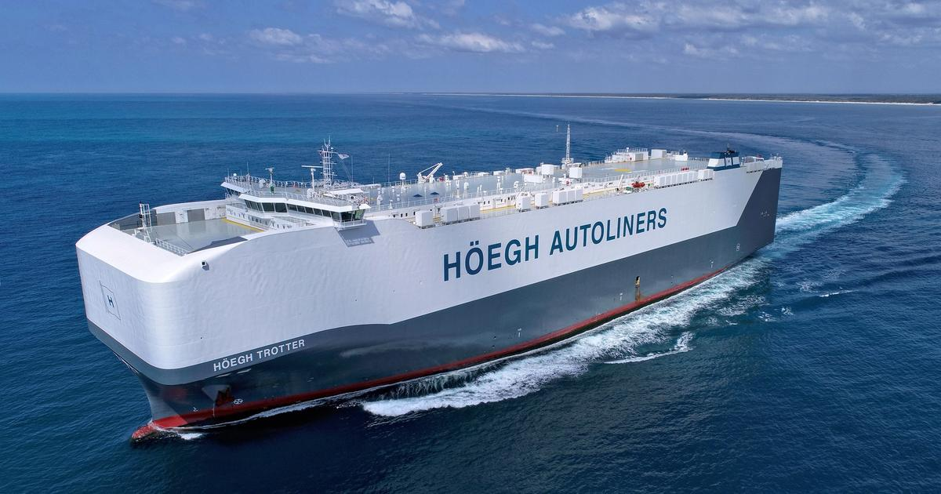
This ship carries vehicles.
Cars drive on and off the ship.
Loading is very fast.

7. Fishing Vessel
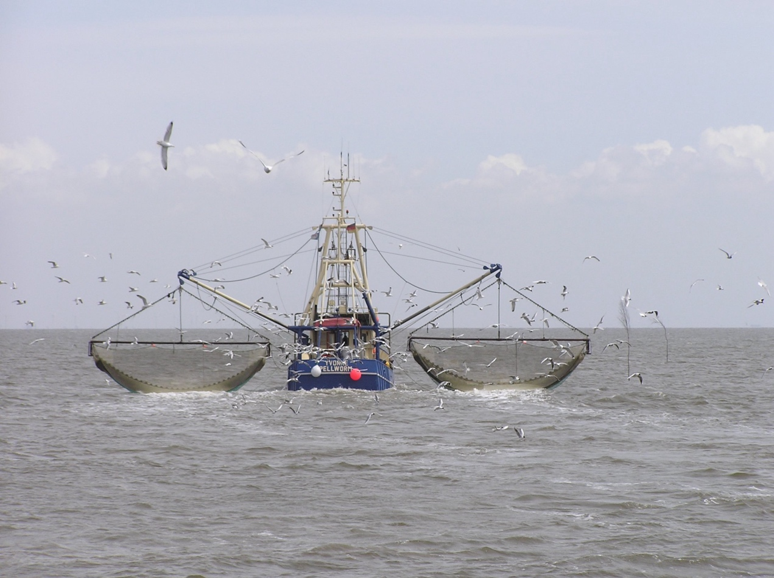
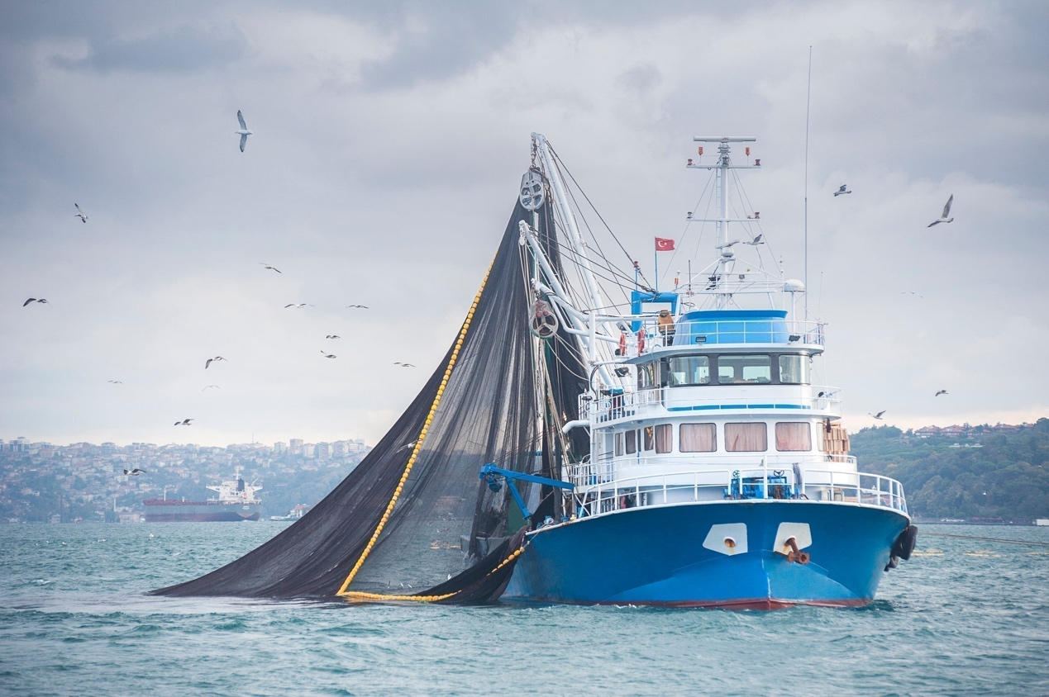
This ship is used for fishing.
It has fishing nets.
It works near the coast or at sea.

8. Naval Ship
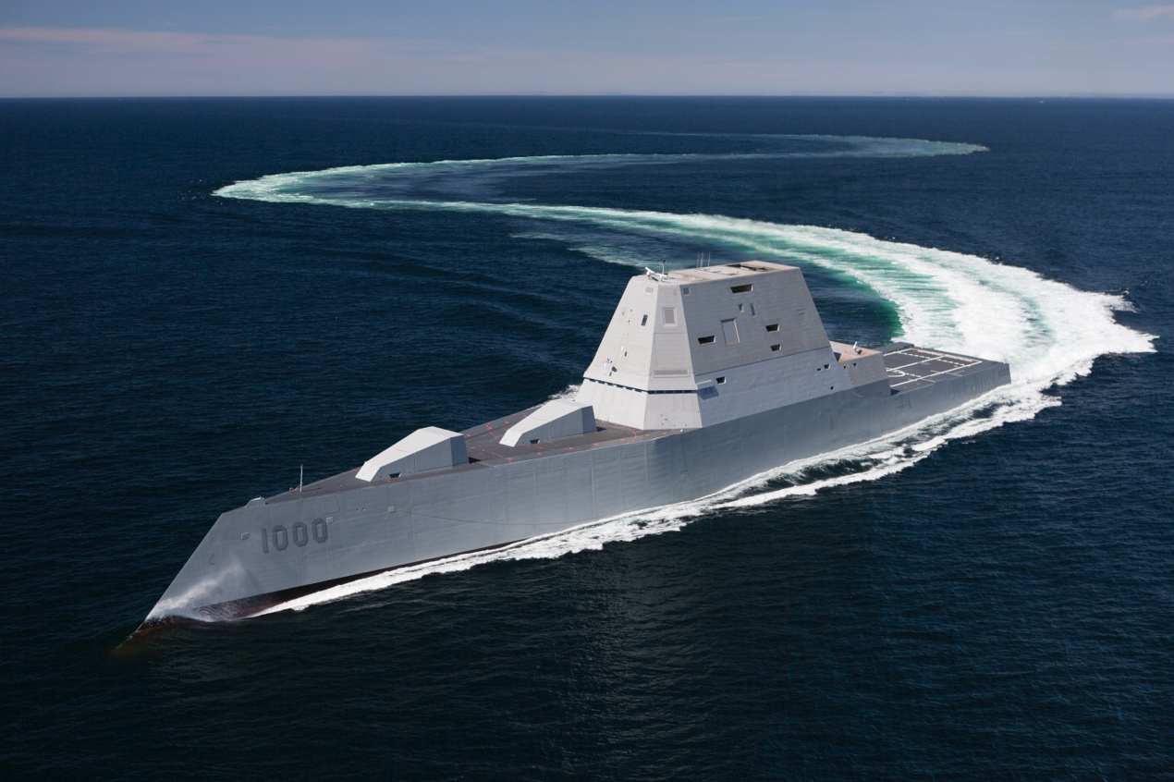
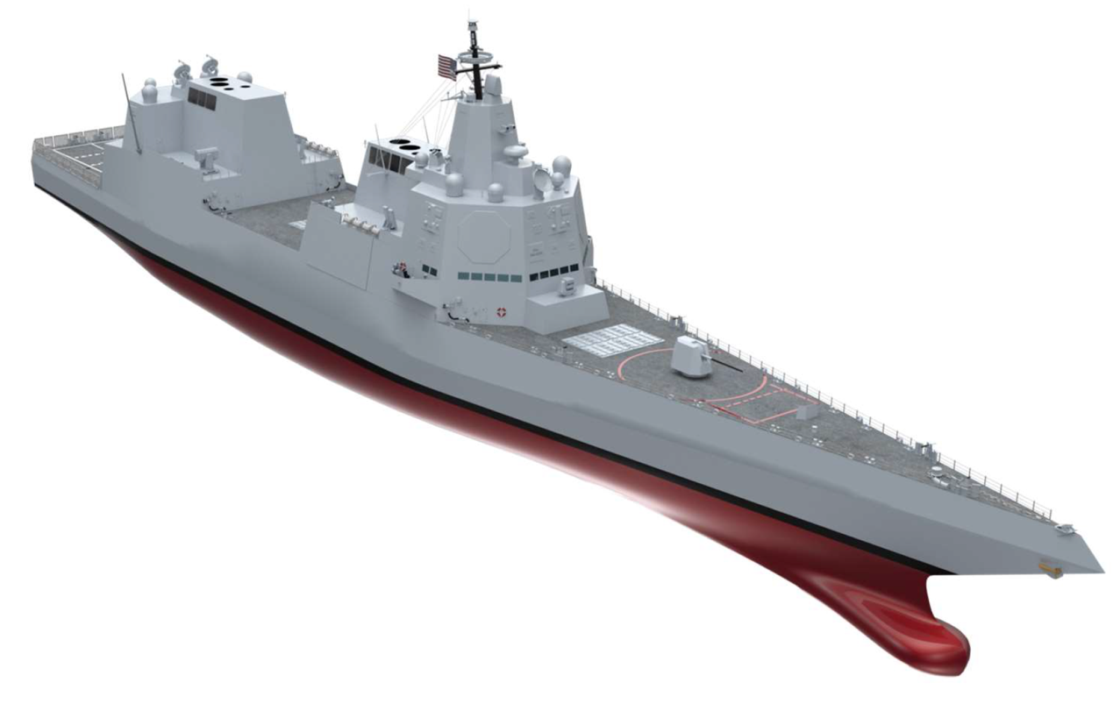
This ship belongs to the navy.
It is used for defence.
It has weapons on board.

9. Tugboat
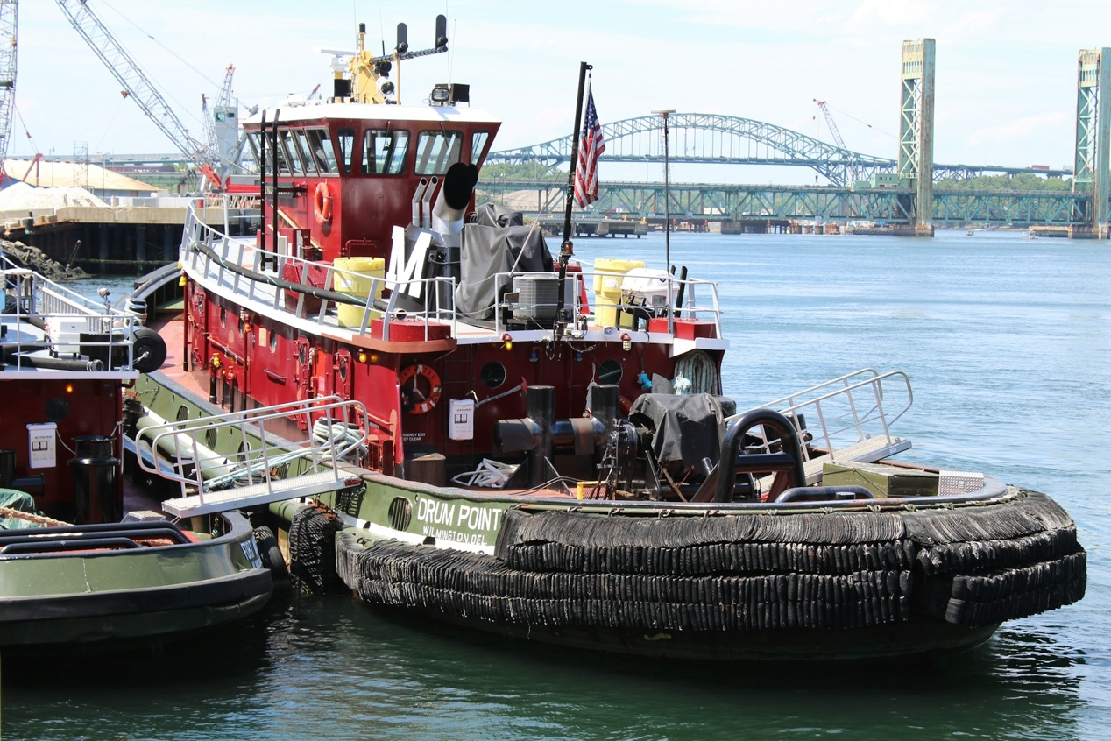
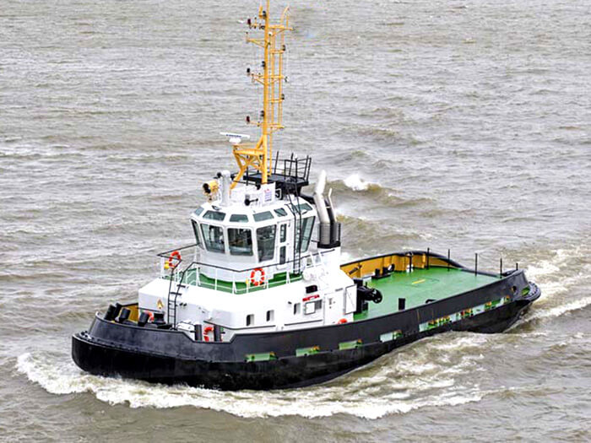
This ship helps big ships.
It works in ports.
It is small but very strong.

10. Supply Vessel
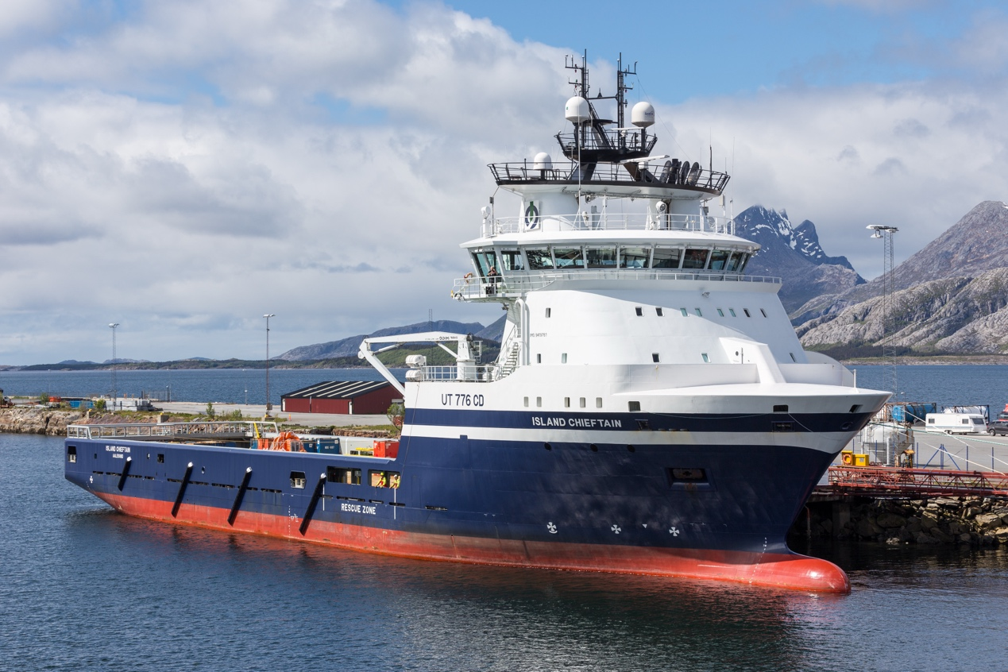
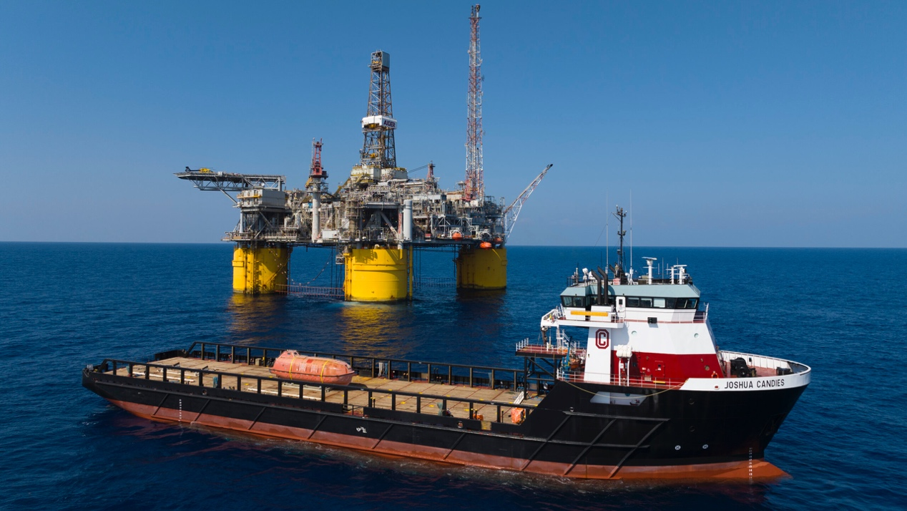
This ship supports oil platforms.
It carries supplies and equipment.
It works in open sea.

11. Research Vessel
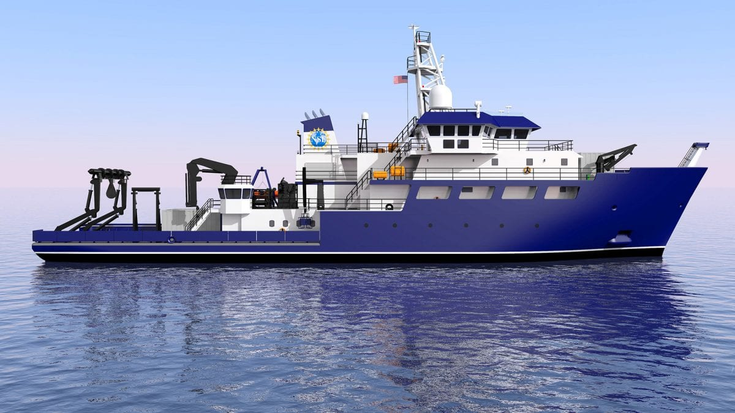
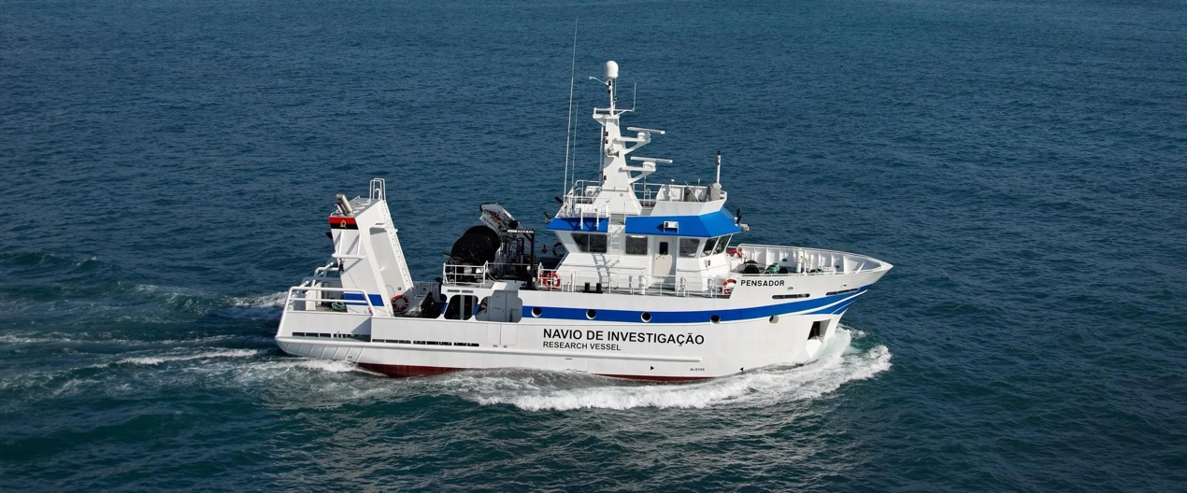
This ship is used for research.
Scientists work on this ship.
It studies the sea.

12. Icebreaker
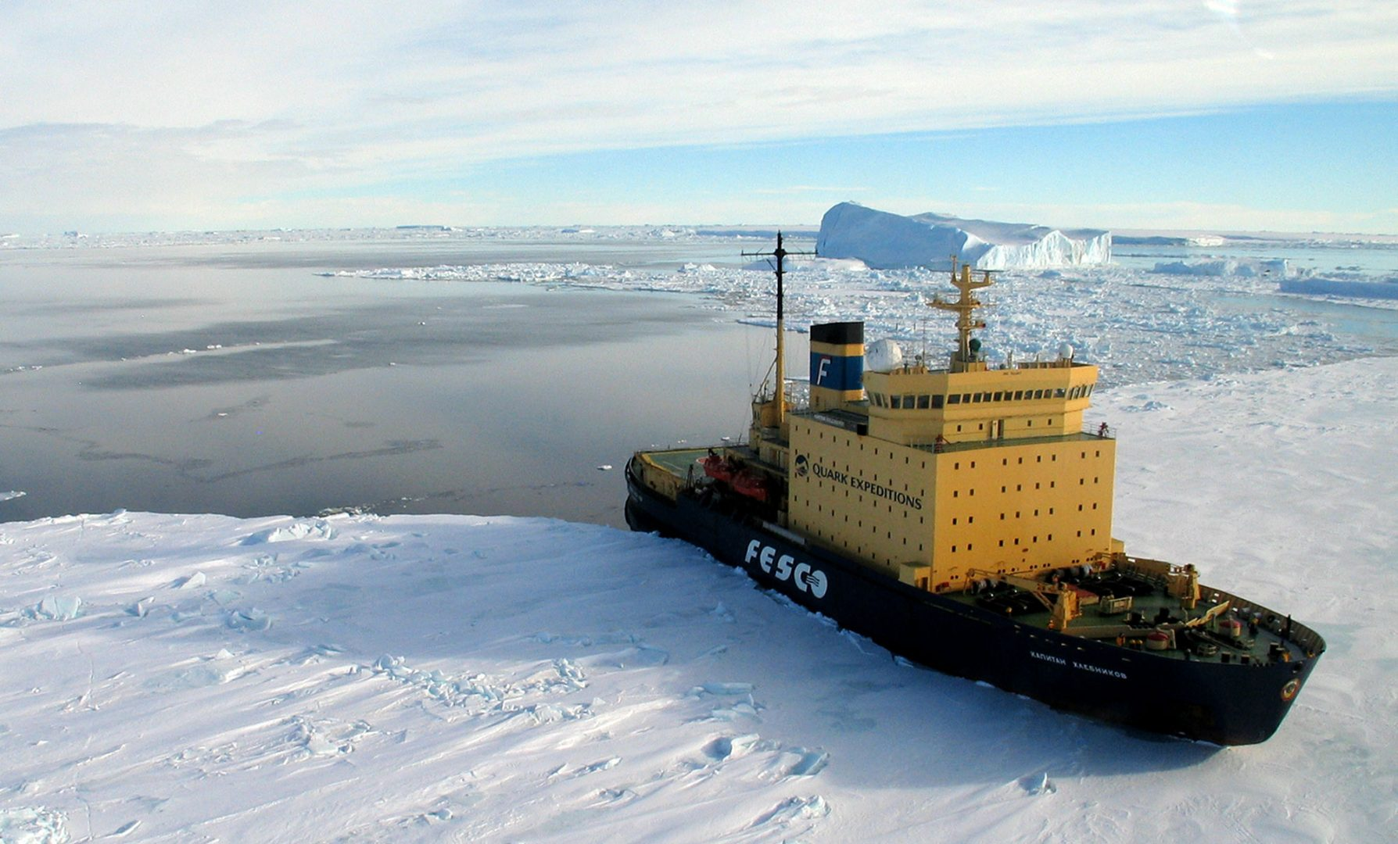
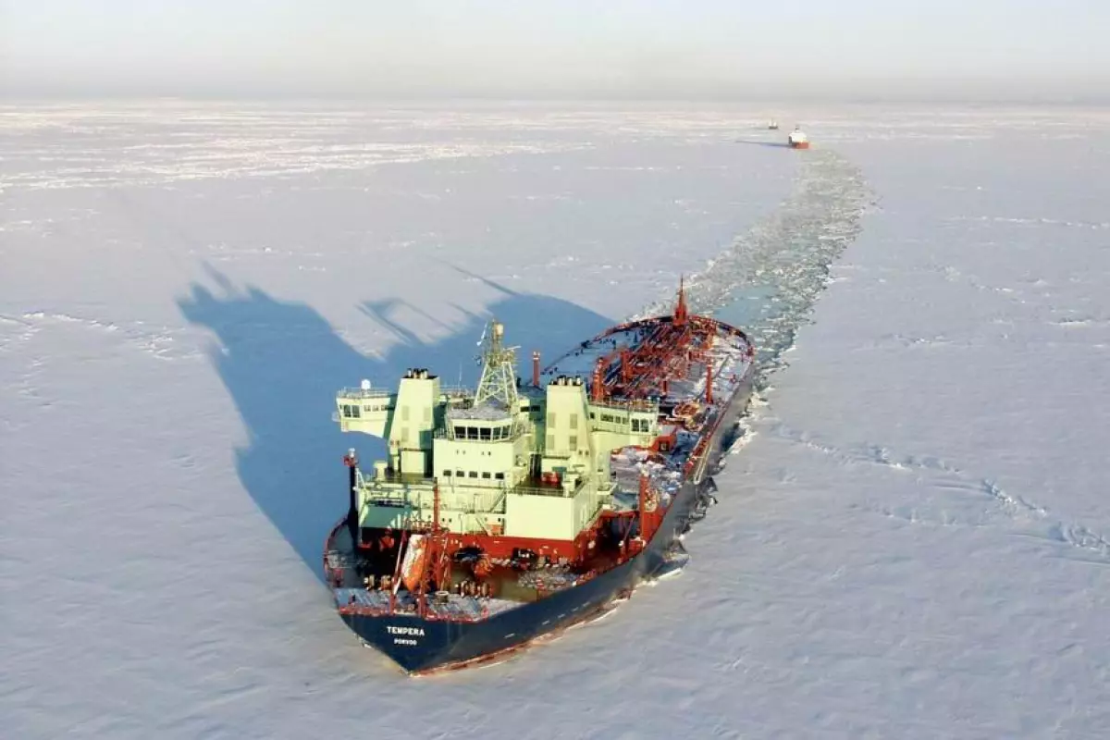
This ship works in icy waters.
It breaks the ice.
It has a strong hull.

13. Car Carrier
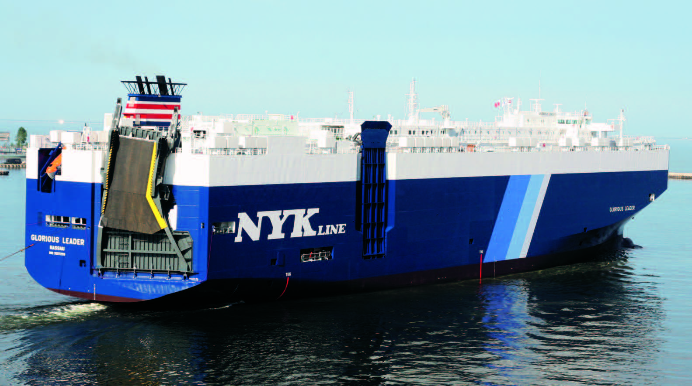
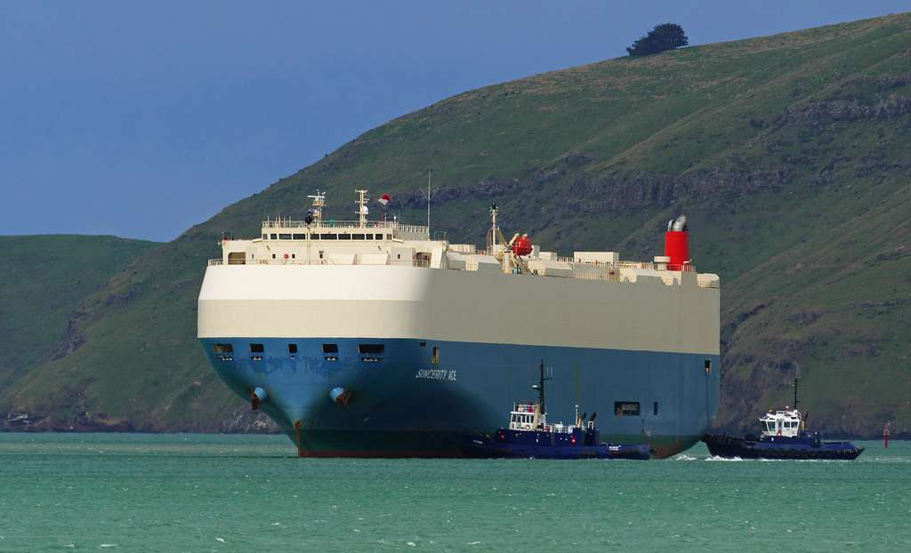
This ship carries cars.
It has many decks.
Cars are safe inside.

14. Livestock Carrier
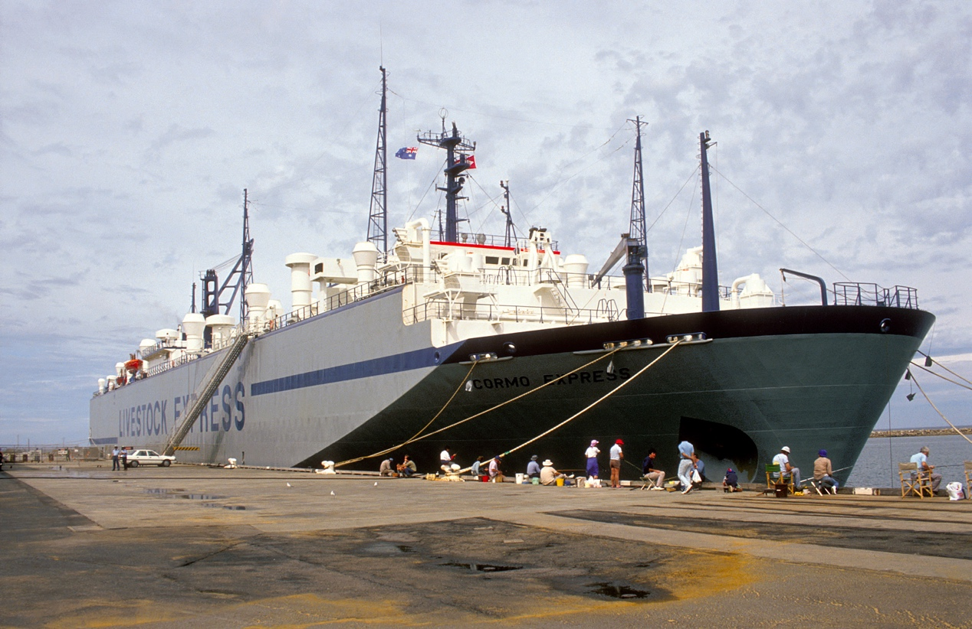
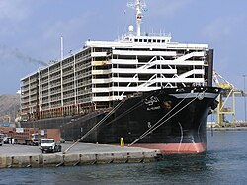
This ship carries live animals.
It has good ventilation.
Animals are cared for on board.

15. Chemical Tanker
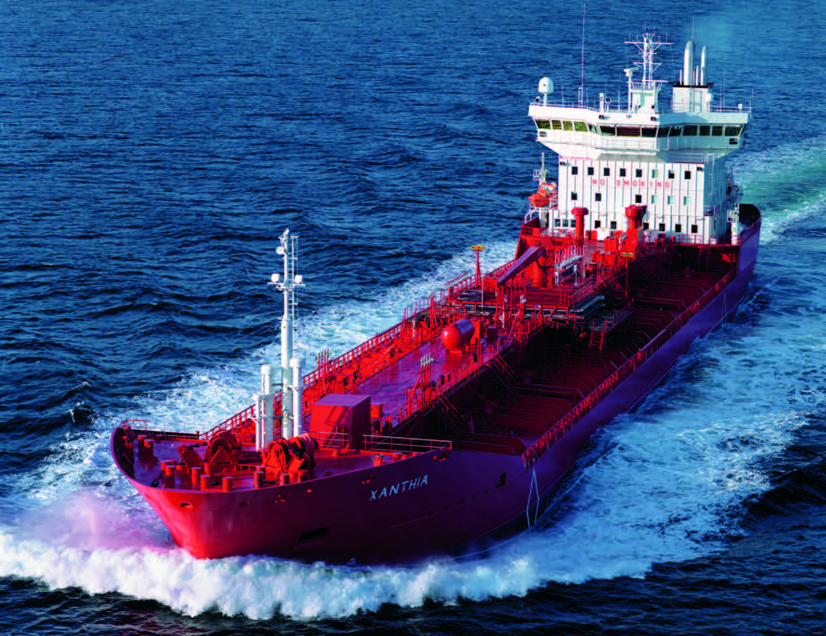
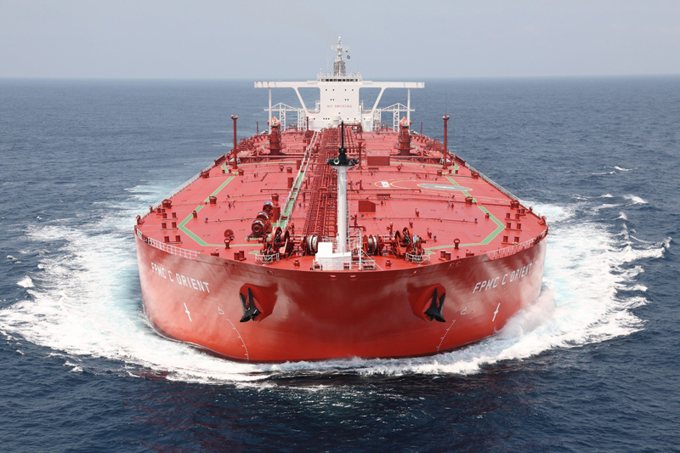
This ship carries chemicals.
It has special tanks.
Safety rules are very strict.

16. Gas Carrier
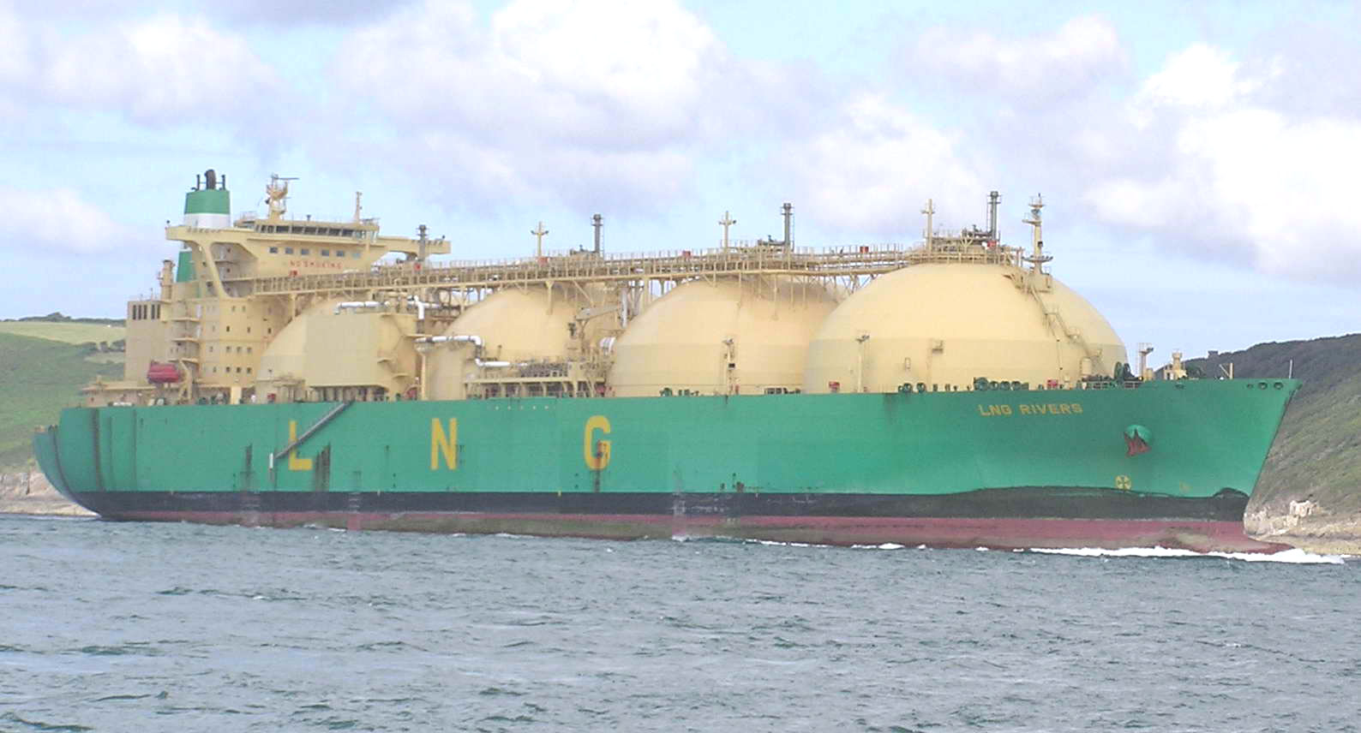
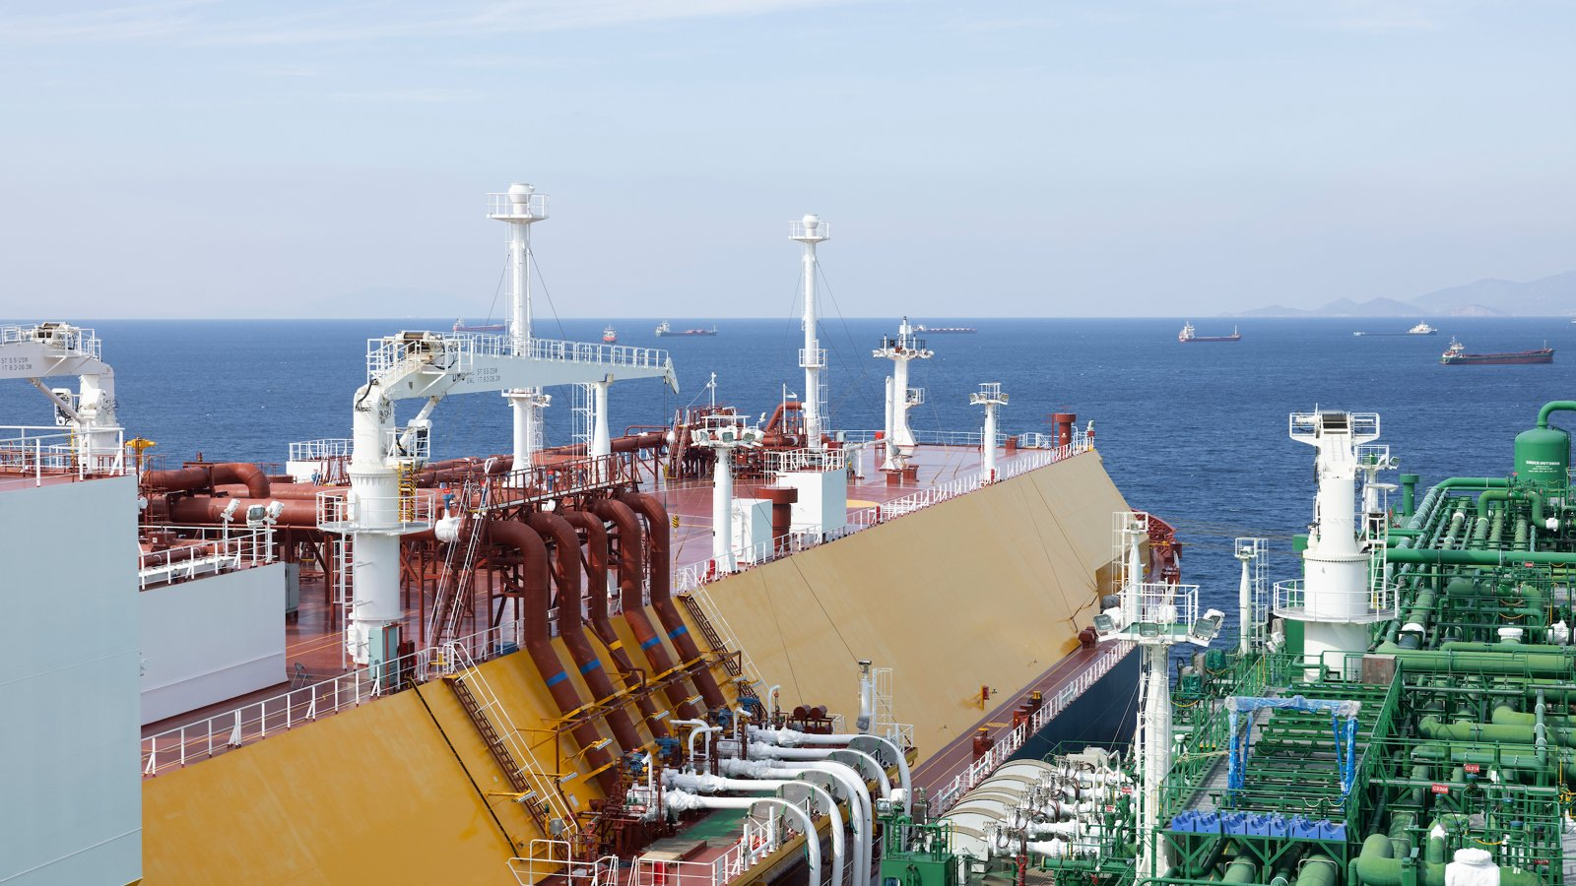
This ship carries gas.
It carries LNG or LPG.
The tanks are very safe.

17. Dredger
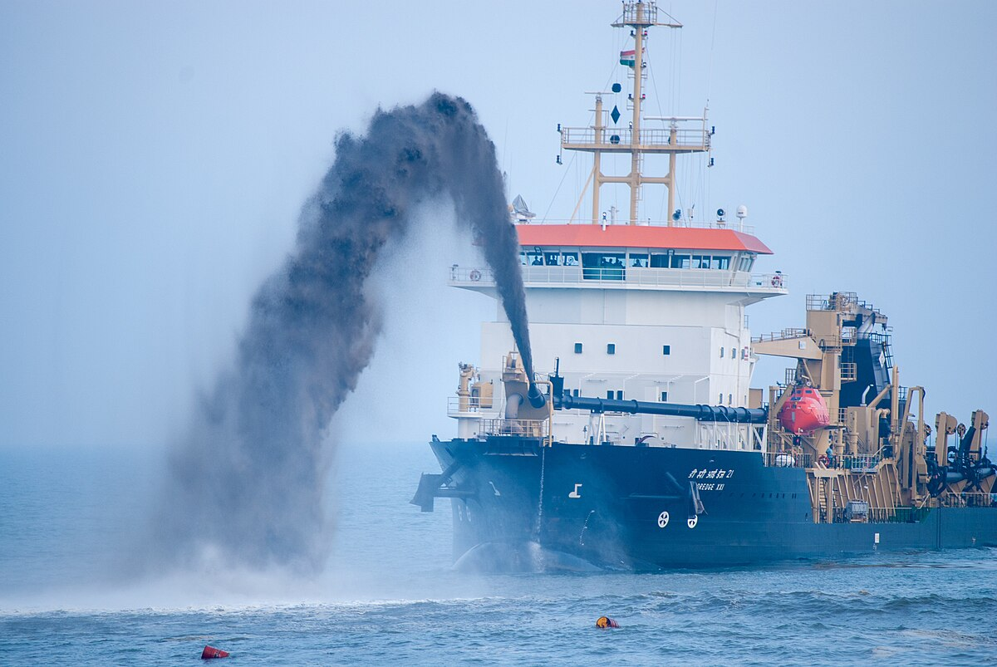
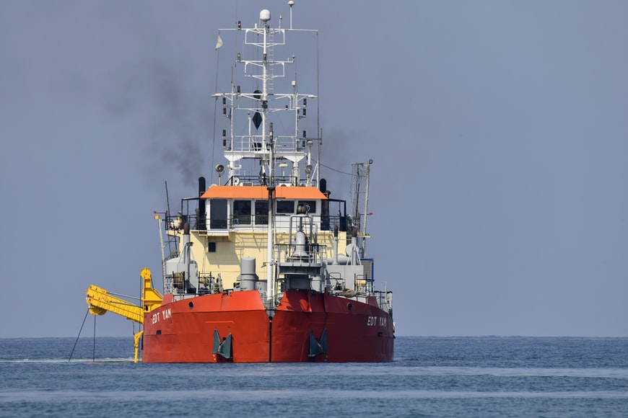
This ship cleans the seabed.
It removes sand and mud.
It helps ports stay open.

18. Cable Laying Ship
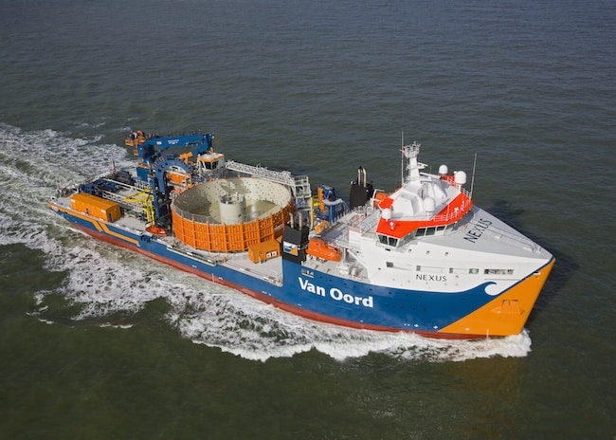
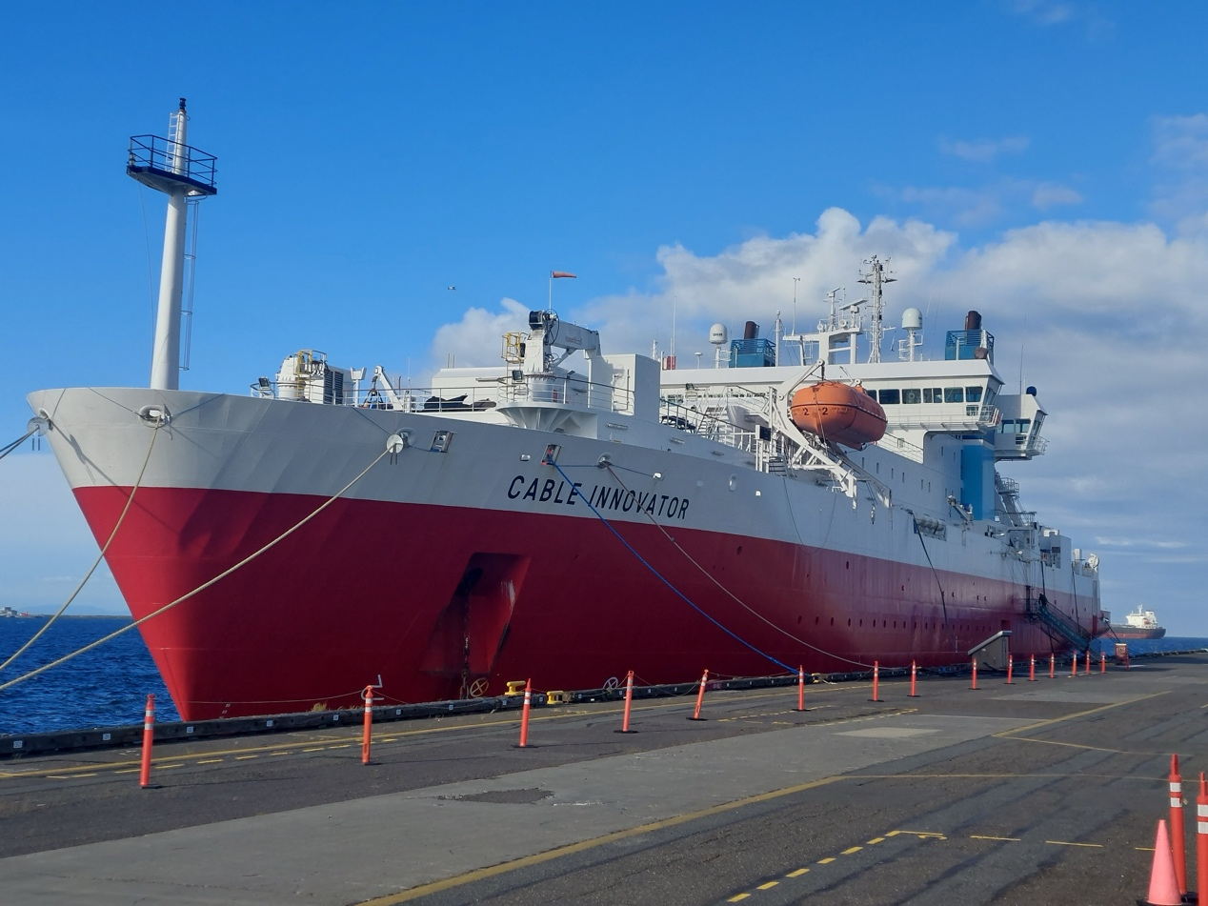
This ship lays sea cables.
It is used for communication.
It works very carefully.

19. Pilot Boat
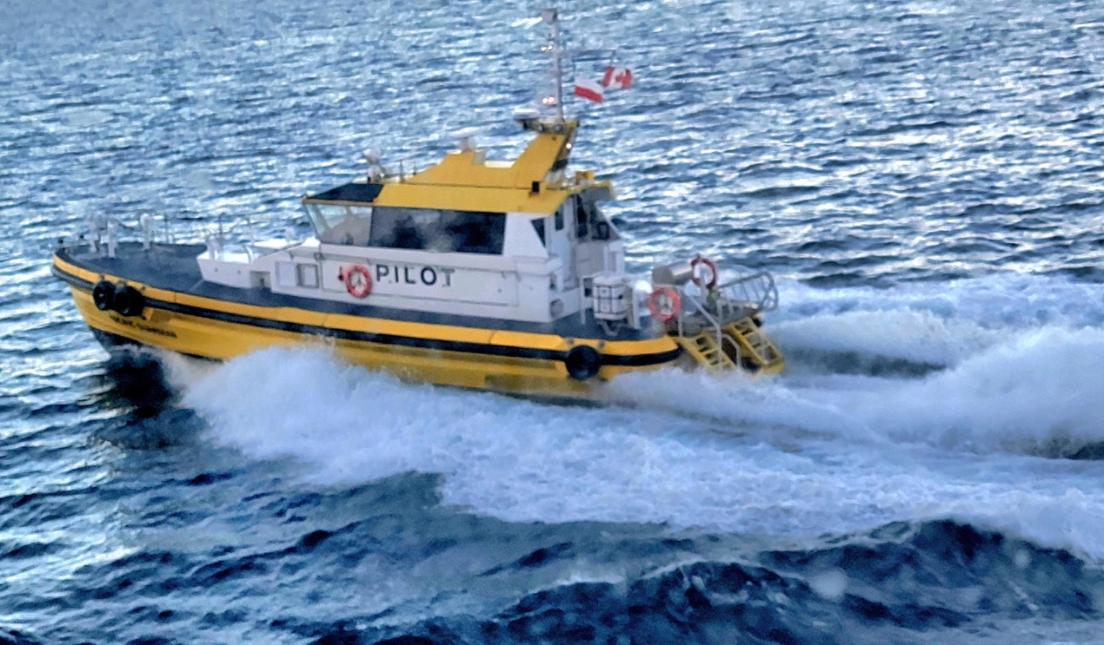
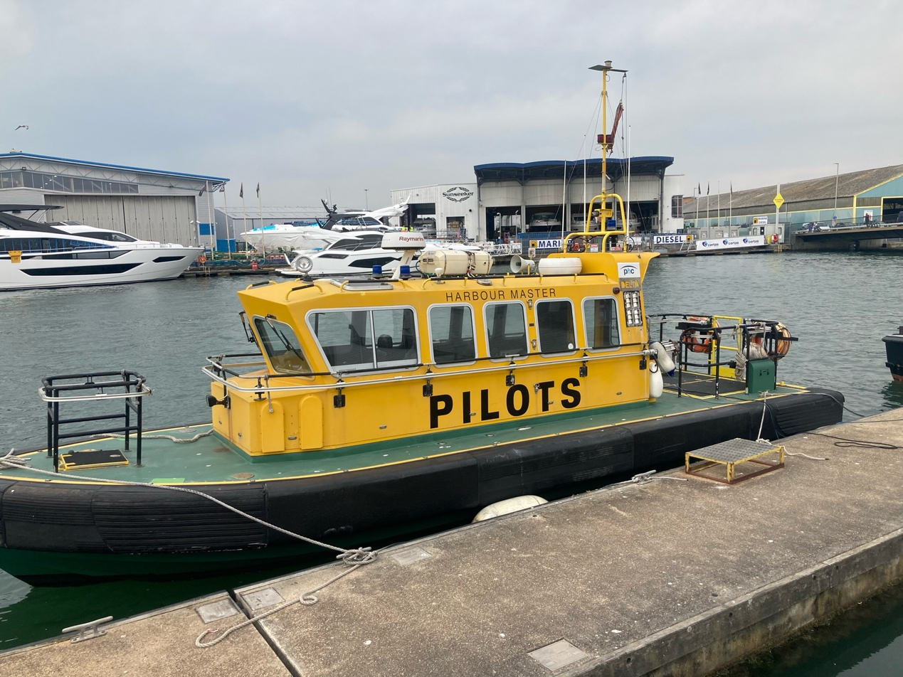
This ship carries pilots.
It is small and fast.
It works near ports.

20. Training Ship
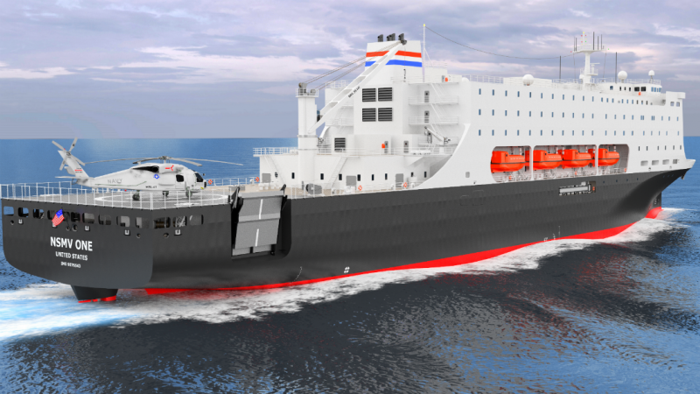
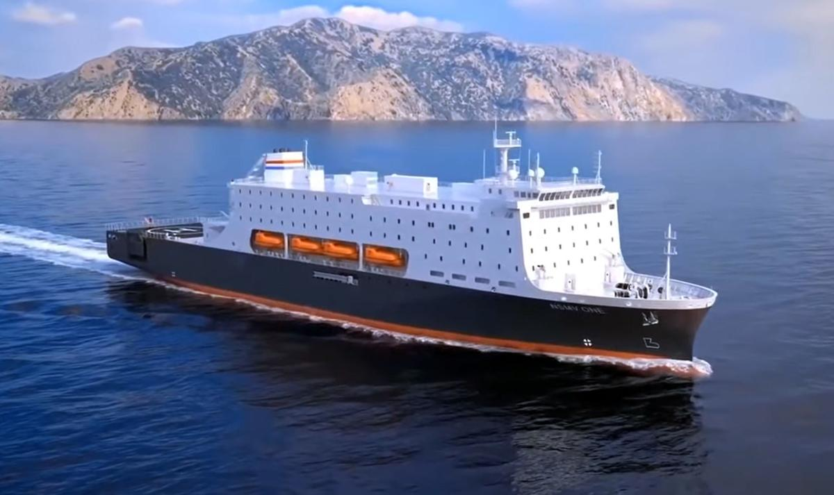
This ship is for education.
Students learn on board.
It prepares future sailors.

Conclusion
All these ships are important. They help transport and work at sea.

