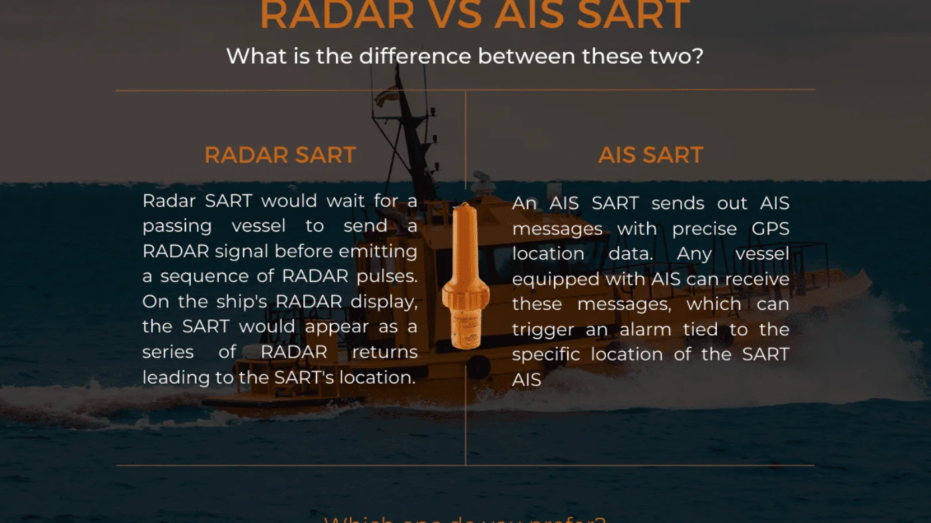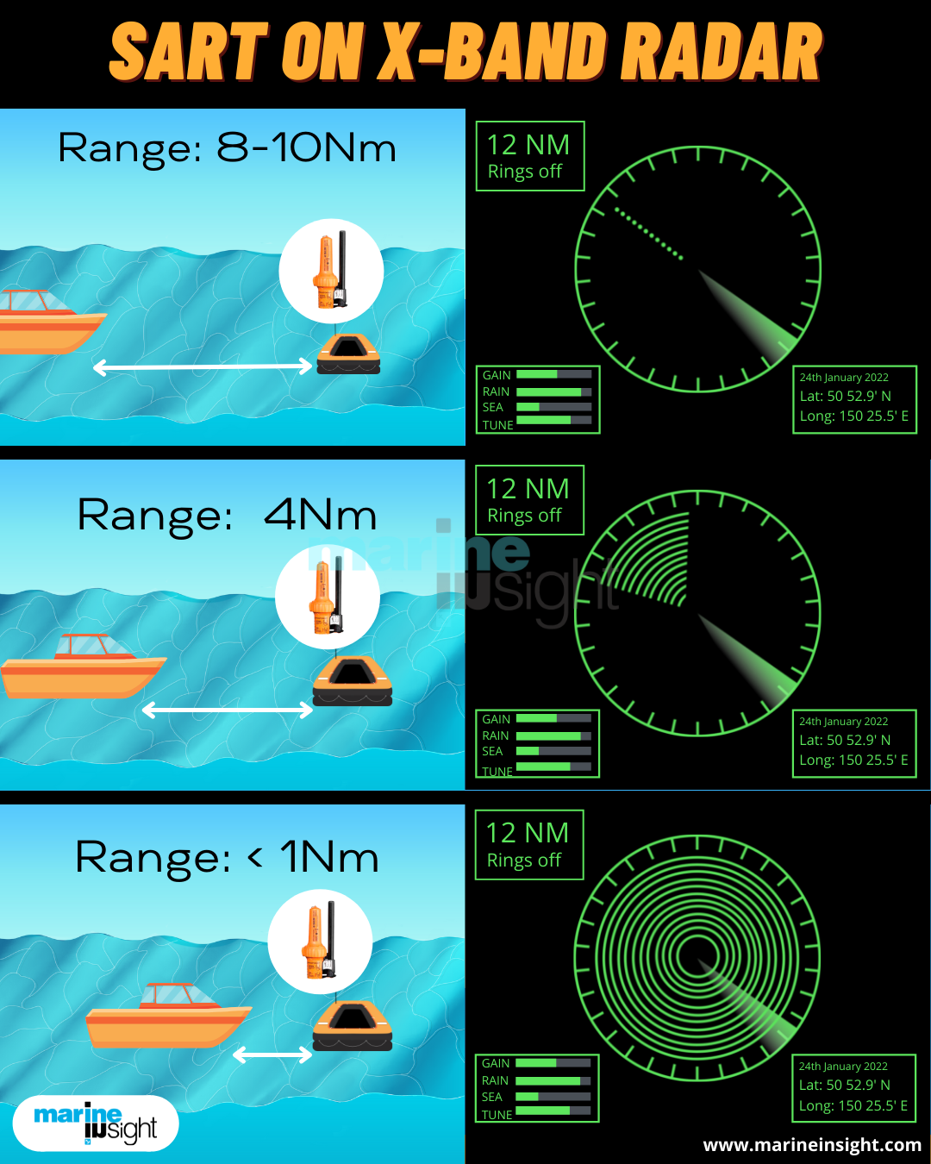
A Search and Rescue Transponder (SART) is a self-contained, waterproof transponder intended for emergency use at sea.
The radar-SART is used to locate a survival craft or distressed vessel by creating a series of dots on a rescuing ship’s radar display. A SART will only respond to a 9 GHz X-band (3 cm) Radar.
Check out our post to find out how SART looks on the X-BAND RADAR as per its range.

