MERCHANT MARINE ACADEMY OF MACEDONIA
SCHOOL OF ENGINEERS
Course: Maritime English
Academic year: 2021 – 2022 Exam period: September 2022
Semester: B Date: 6/9/22
Name:
Student number:
Instructors: M. Tsompanoglou, E. Xenitidou

Final Test
Exercise 1. (10 p.)
Circle the correct choice about diesel engines.

-- In a 2-stroke Diesel Engine the piston rod is connected to the connecting rod with the connection pin/ crosshead pin/ crank pin.
-- The camshaft actuates the valves with the help of the push / piston / connecting rod .
-- The upper part of the piston is the piston crown/ skirt/ pin.
-- In a 2-stroke DE the cycle of operation is completed in two strokes of the piston and one/ two/ three
revolution(s) of the crankshaft.
-- The conventional 2-stroke Diesel Engine does not have an injection/exhaust/inlet valve. It has scavenge ports/ valves/ boxes.
-- The inlet, exhaust and fuel injection valves are fitted in the cylinder block / liner / head.
-- The connecting rod is connected to the crankshaft with the crank pin/ connection pin/ crosshead pin.
-- In a 4-stroke Diesel Engine the piston is connected to the connecting rod with the crosshead pin/ gudgeon pin/ connection pin.
-- The cylinder block, the frame of the engine and the bedplate are all three connected together with
tie rods / connecting rods / frame rods.

Exercise 2. (13 p.)
Underline the correct choice of the following sentences about boilers and steam engines.

-- The heater/ steam drum/ water drum is the upper drum of a water tube boiler, where the separation of water and steam takes place.
-- The water level / check/ indicator/ control shows the level of water in the boiler.
-- In the boiler, the water pipe/ tube/ drum serves as a reservoir of water.
-- The steam drum/ main stop valve/ feed check valve controls the passage of the steam to the engines.
-- The steam turbine consists of a rotor that has a set of curved blades/ stators/ tubes.
--There two types of steam engines: the reciprocating steam engines and the steam turbines/ rotors/ vanes.
-- The steam which is collected in the steam drum of the boiler is dry/ saturated/ superheated.
--When the temperature of the steam falls below permissible limits, evaporation/ condensation/ concentration takes place.
-- Boiler indicators/ mountings/ tubes are usually valves and gauges that are attached directly to the pressure parts of the boiler.
-- Depending on the case, in the boiler, there may be a/ an superheater/ water wall header/ attemperator to decrease the temperature.
-- In the reaction turbine the steam passes first through the stationary/ reciprocating/ rotating blades, where it condenses / expands/ decreases.
-- The LP turbine is larger due to the extension/ expansion/ exhaust of steam.

Exercise 3. (15 p.)
Describe the following strokes of a 4-stroke diesel engine using the words given below.
DOWNWARDS | BDC | UPWARDS | INJECTION | POWER
COMRESSION | INDUCTION | SUCTION | COMBUSTION | IGNITED
INLET | RISE | COMPRESSES | TDC | EXHAUST
During the ……………………………………or intake or ……………….. stroke, the intake valve is opened and the piston is moving……………………... . Air is drawn into the cylinder, and when the piston reaches the …………………………., the cylinder is full of air and the ………………………… valve closes.
In the second stroke, which is the …………………………… stroke, the piston is moving …………………….and …………………………..the air. Pressure and temperature ………………………. . All valves are closed, and when the piston is almost at the ………………….., the fuel is sprayed into the cylinder by the fuel …………………….. valve. Ιt is self -………………….. because of the high temperature of the compressed air.
Then, the fuel is burnt and the ………………………… gases push the piston down. This is the ……………………… stroke - only this stroke provides power for the propulsion of the ship.
Finally, the last stroke is the ……………………… stroke.
Exercise 4. (15 p.)
Fill in the gaps with an appropriate term of boilers. The first letter is given.
-- The s…………. has a great number of small tubes and is used to heat the wet steam before it enters the main steam pipe.
-- The w…………. drum serves as a reservoir of water.
-- The a…………. reduces the temperature of the superheated steam.
-- The s…………. measures the salinity of water.
-- B…………. are used for producing steam.
-- The furnace is the place where f…………. is burnt.
-- The e…………. preheats the feeding water.
-- The b…………. may be placed either at the top of the boiler or at the bottom.
-- Water t…………. are pipes which connect the steam drum with the water drum.
-- The f…………. check valve can stop or start the flow of water into the boiler.
Exercise 5. (10 p.)
Match the following auxiliary machinery with their functions below.

incinerator, steering gear, windlass, launching gear, electric motor,
sewage treatment plant, evaporator, separator, capstan, fin stabilizer

-- It is used to handle mooring lines:
-- It is used to drive another machine:
-- It is used to produce distilled water:
-- It is used to manoeuvre the ship:
-- Fuel is cleaned in it:
-- It is used to burn garbage:
-- Human body waste is treated biologically there:
-- It is used to lower lifeboats to the sea:
-- It is used to reduce the rolling of the ship:
-- It is used to handle the anchor:

Exercise 6. (10 p.)
Match the following words with their synonyms below.

fireproof, port, convert, condenser, reciprocate, malfunction,
attemperator, astern, saturated, salinometer
-- filled with a little moisture:
-- change:
-- irregular or abnormal function:
-- not affected by fire:
-- move back and forth:
-- an apparatus that changes steam into water by cooling it:
-- apparatus which decreases the temperature:
-- the opposite of ahead:
-- measures the salinity of water:
-- a hole in the cylinder liner:

Exercise 7. (12 p.)
Fill in the gaps with the appropriate type of pump using the following words:
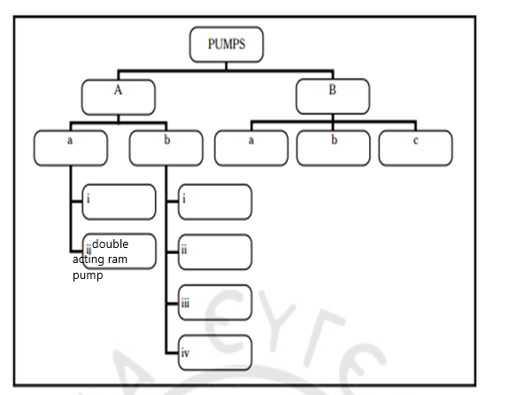
vane, regenerative, rotary, screw, lobe, reciprocating, displacement, centrifugal, volute, single-acting ram pump, gear wheeled, diffuser

Exercise 8. (15 p.)
Complete the following diagram with the correct terms.
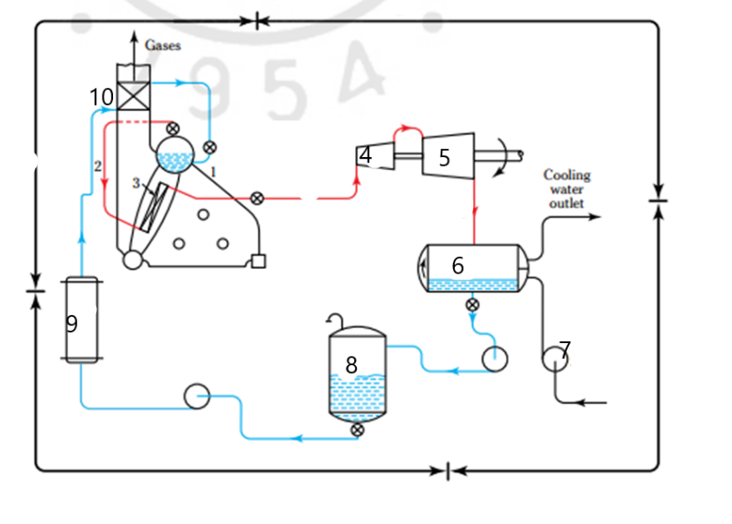

1…………………………. 2………………………….. 3………………………….. 4…………………………. 5………………………….
6………………………… 7…………………………. 8…………………… 9…………………………..10…………………………

Good Luck!

