World maps, history – evolution

1. Cartography's Foundation: Ptolemy's Geography (150 AD)
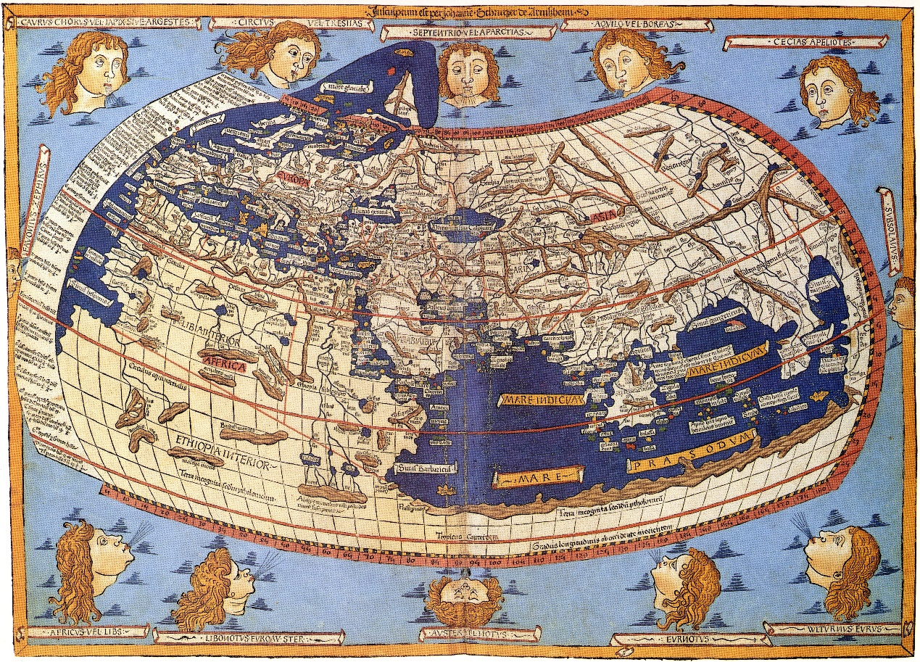
A 15th-century reconstruction based on Ptolemy's projections of the world (Wikimedia Commons)
The Alexandria-based Greek scholar Claudius Ptolemy was the first to use math and geometry to develop a manual for how to map the planet using a rectangle and intersecting lines—one that resurfaced in 13th-century Byzantium and was used until the early 17th century. Ptolemy described the latitude and longitude of more than 8,000 locations in Europe, Asia, and Africa, projecting a north-oriented, Mediterranean-focused world that was missing the Americas, Australasia, southern Africa (you can see Africa skirting the bottom of the map and then blending into Asia), the Far East, the Pacific Ocean, and most of the Atlantic Ocean. Ptolemy's Geography was a "book with a 1,500-year legacy," Brotton says.

2. Cultural Exchange: Al-Idrisi's World Map (1154)
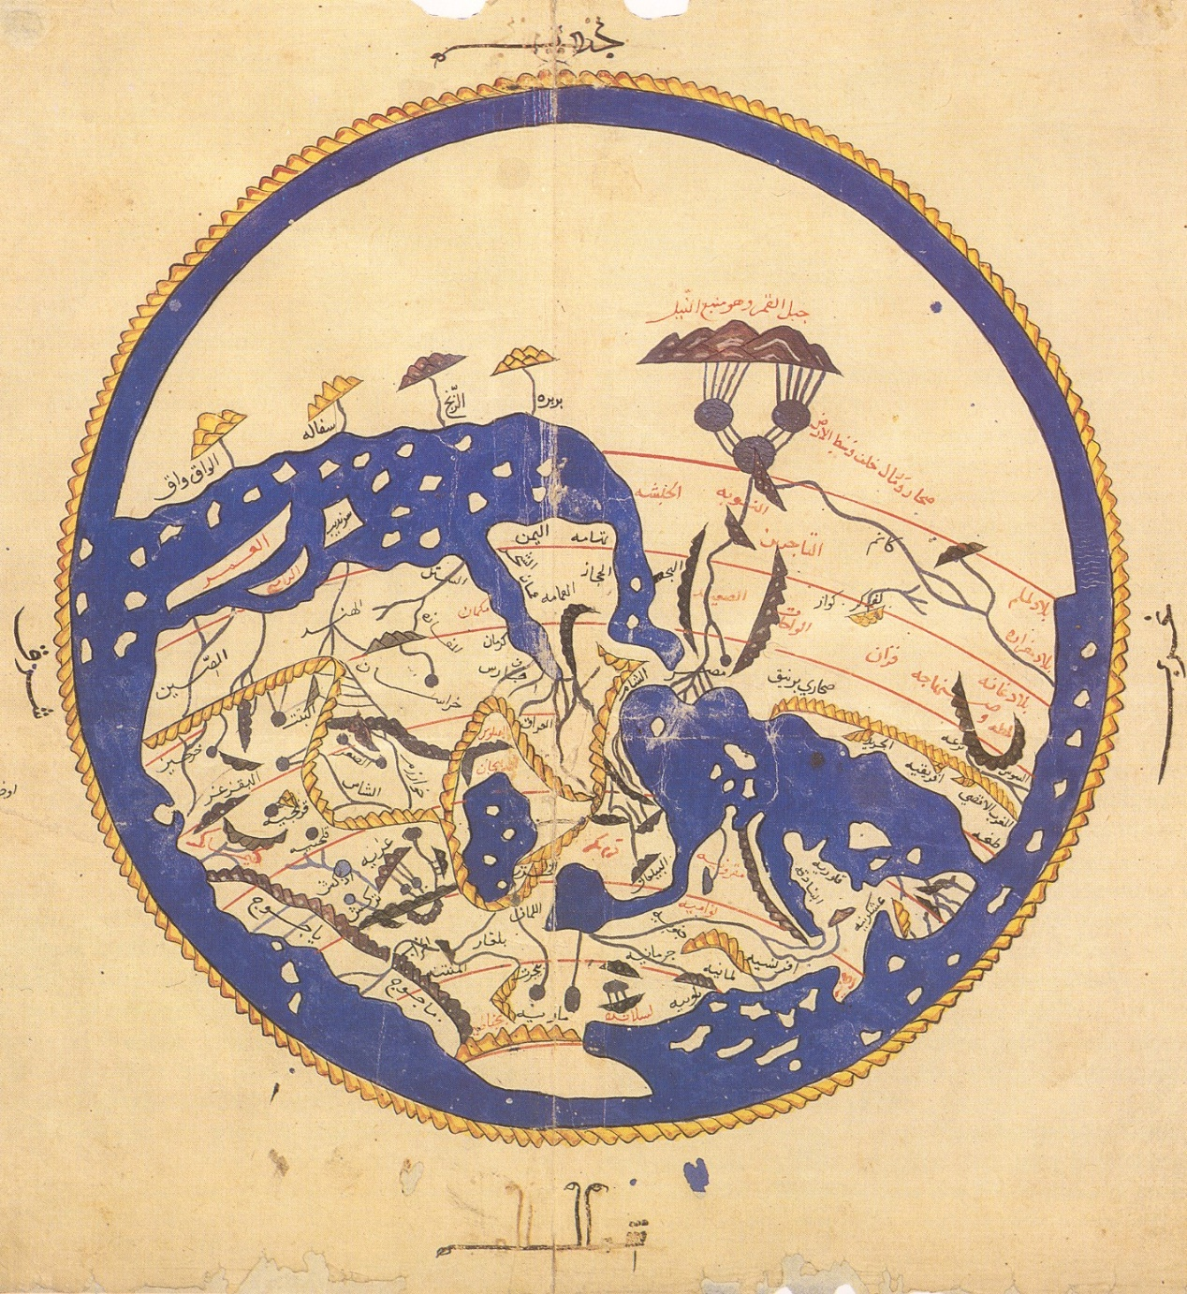
Al-Sharif al-Idrisi, a Muslim from Al-Andalus, traveled to Sicily to work for the Norman King Roger II, producing an Arabic-language geography guide that drew on Jewish, Greek, Christian, and Islamic traditions. Unlike east-oriented Christian world maps at the time, al-Idrisi's map puts south at top in the tradition of Muslim mapmakers, who considered Mecca due south (Africa is the crescent-shaped landmass at top, and the Arabian Peninsula is in the center). Unlike Ptolemy, al-Idrisi depicted a circumnavigable Africa—blue sea surrounds the globe.

3. Christian Faith: Hereford's Mappa Mundi (1300)
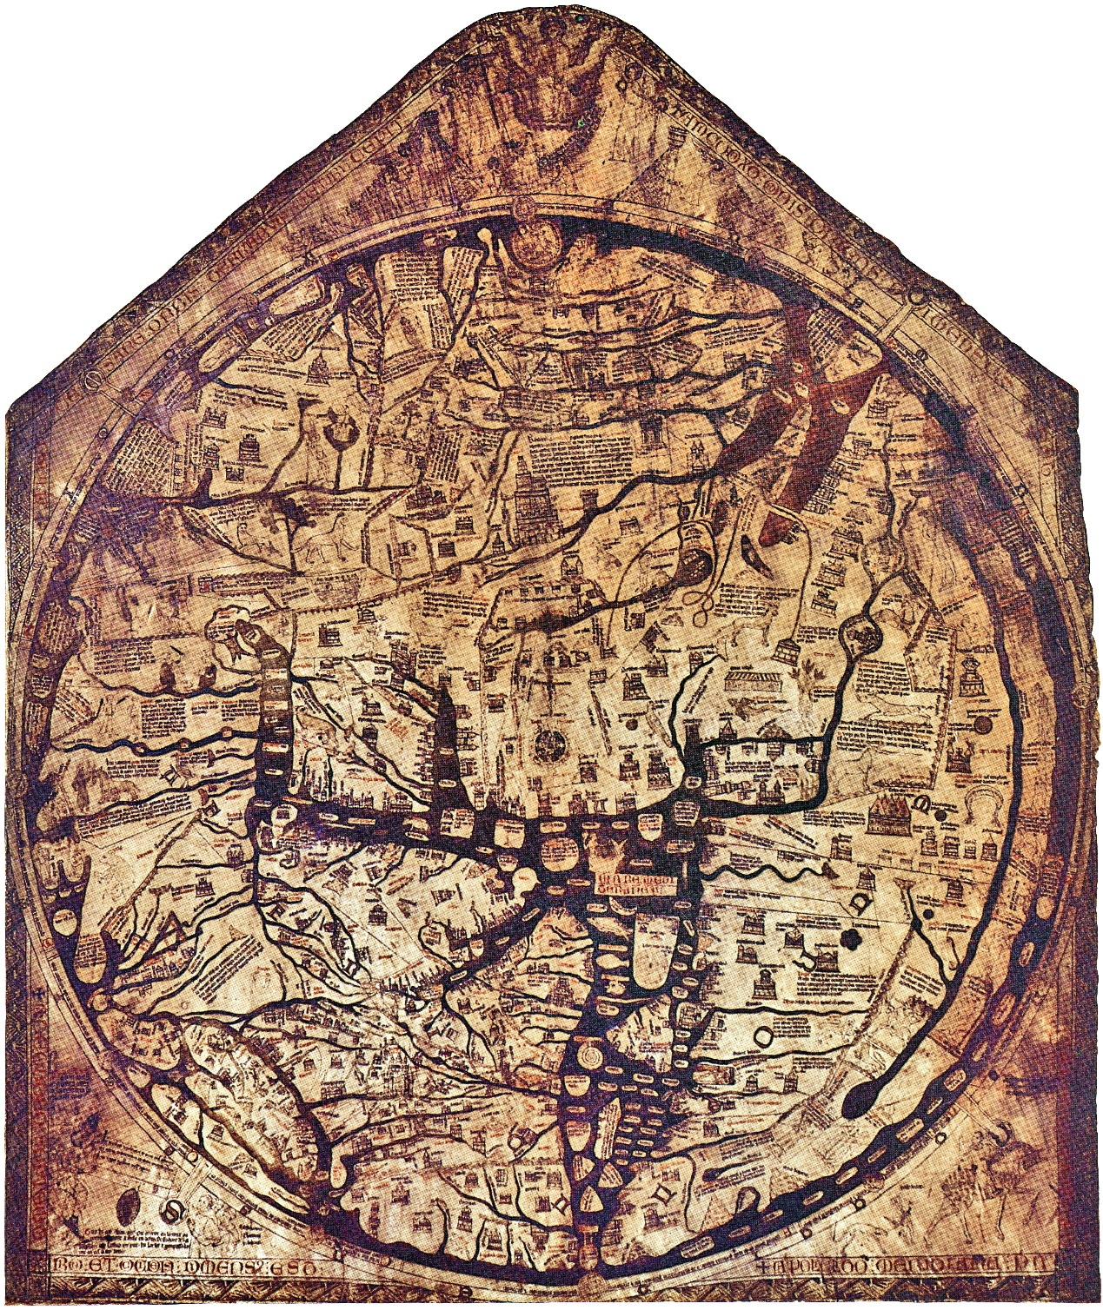
This map from England's Hereford Cathedral depicts "what the world looked like to medieval Christians," Brotton says. The organizing principle in the east-oriented map is time, not space, and specifically biblical time; with Christ looming over the globe, the viewer travels spiritually from the Garden of Eden at top down to the Pillars of Hercules near the Strait of Gibralter at bottom (for a more detailed tour, check out this handy guide to the map's landmarks). At the center is Jerusalem, marked with a crucifix, and to the right is Africa, whose coast is dotted with grotesque monsters in the margins. "Once you get to the edges of what you know, those are dangerous places," Brotton explains.

4. Imperial Politics: Kwon Kun's Kangnido Map (1402)
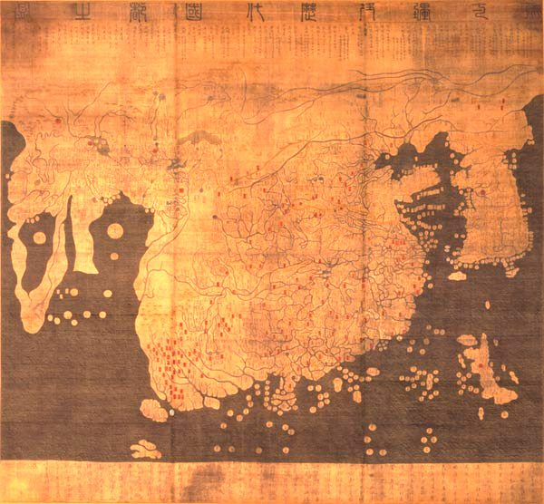
What's most striking about this Korean map, designed by a team of royal astronomers led by Kwon Kun, is that north is at top. "It's strange because the first map that looks recognizable to us as a Western map is a map from Korea in 1402," Brotton notes. He chalks this up to power politics in the region at the time. "In South Asian and Chinese imperial ideology, you look up northwards in respect to the emperor, and the emperor looks south to his subjects," Brotton explains. Europe is a "tiny, barbaric speck" in the upper left, with a circumnavigable Africa below (it's unclear whether the dark shading in the middle of Africa represents a lake or a desert). The Arabian Peninsula is to Africa's right, and India is barely visible. China is the gigantic blob at the center of the map, with Korea, looking disproportionately large, to its right and the island of Japan in the bottom right.

5. Territorial Exploration: Waldseemuller's Universalis Cosmographia (1507)
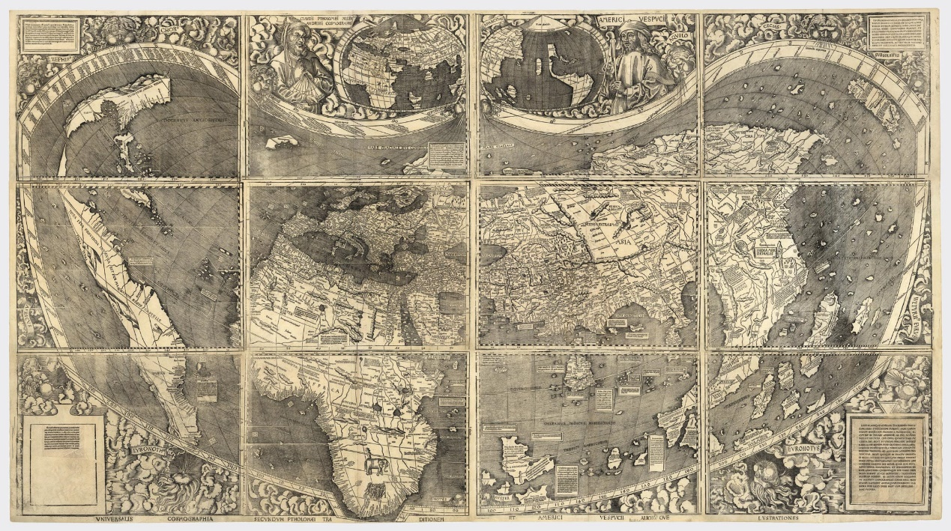
This work by the German cartographer Martin Waldseemuller is considered the most expensive map in the world because, as Brotton notes, it is "America's birth certificate"—a distinction that prompted the Library of Congress to buy it from a German prince for $10 million. It is the first map to recognize the Pacific Ocean and the separate continent of "America," which Waldseemuller named in honor of the then-still-living Amerigo Vespucci, who identified the Americas as a distinct landmass (Vespucci and Ptolemy appear at the top of the map). The map consists of 12 woodcuts and incorporates many of the latest discoveries by European explorers (you get the sense that the woodcutter was asked at the last minute to make room for the Cape of Good Hope). "This is the moment when the world goes bang, and all these discoveries are made over a short period of time," Brotton says.

6. Territorial Navigation: Mercator's World Map (1569)
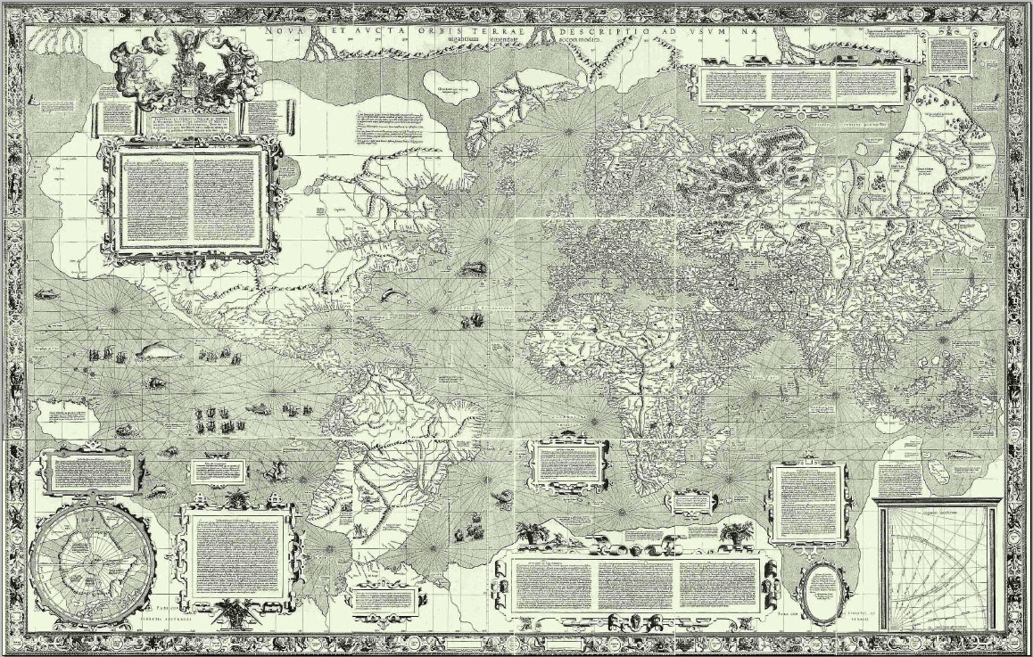
Next to Ptolemy, Brotton says, Gerardus Mercator is the most influential figure in the history of mapmaking. The Flemish-German cartographer tried "on a flat piece of paper to mimic the curvature of the earth’s surface," permitting "him to draw a straight line from, say, Lisbon to the West Coast of the States and maintain an active line of bearing." Mercator, who was imprisoned by Catholic authorities for alleged Lutheran heresy, designed his map for European navigators. But Brotton thinks it had a higher purpose as well. "I think it’s a map about stoicism and transcendence," he says. "If you look at the world from several thousands miles up, at all these conflicts in religious and political life, you’re like ants running around." Mercator has been accused of Eurocentrism, since his projection, which is still occasionally used today, increasingly distorts territory as you go further north and south from the equator. Brotton dismisses this view, arguing that Europe isn't even at the center of the map.

7. Geopolitics: Mackinder's 'Geographical Pivot of History' (1904)
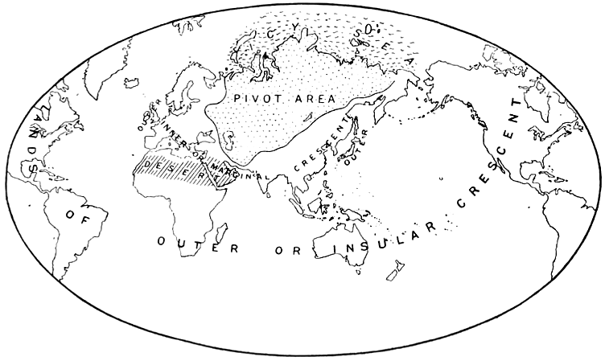
Don't let the modesty of this "little line drawing" fool you, Brotton says: It "basically created the whole notion that politics is driven to some extent by geographic issues." The English geographer and imperialist Halford Mackinder included the drawing in a paper arguing that Russia and Central Asia constituted "the pivot of the world's politics." Brotton believes this idea—that control of certain pivotal regions can translate into international hegemony—has influenced figures ranging from the Nazis to George Orwell to Henry Kissinger.

8. Geopolitics: U.S.A. bases
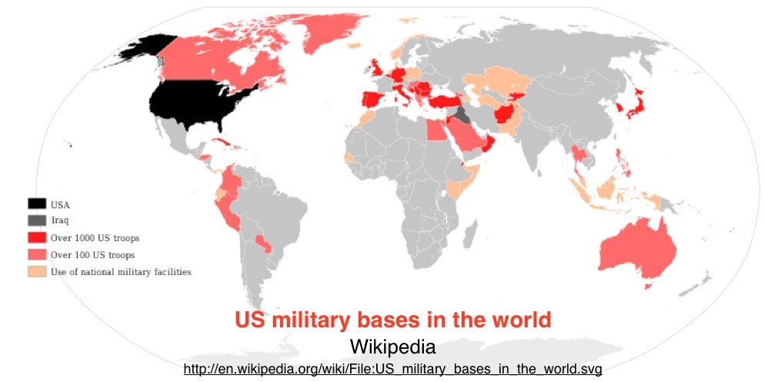

9. Geopolitics & Geoeconomics: Chinese ‘One Belt and One Road’
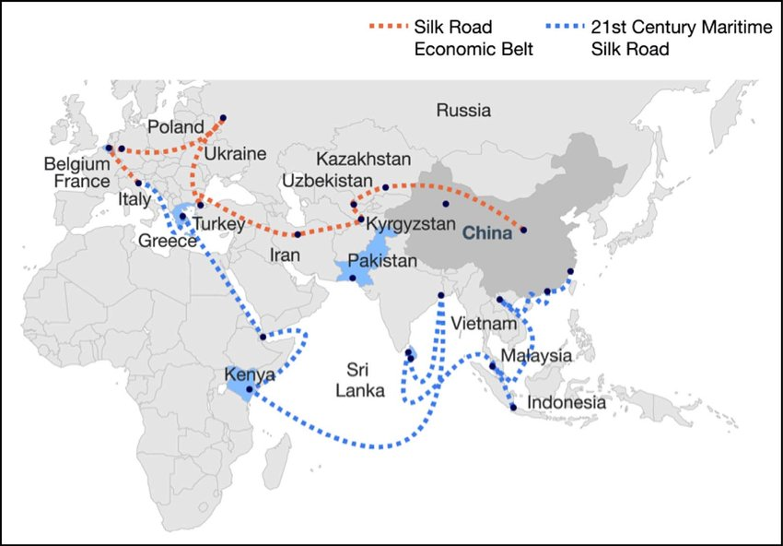
The map of One Belt and One Road initiative. Source: McKinsey Company.

10. Geopolitics & Geoeconomics: Chinese ‘Belt and Road’ II
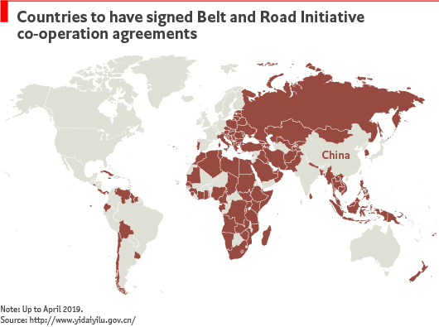

11. World map: Religions
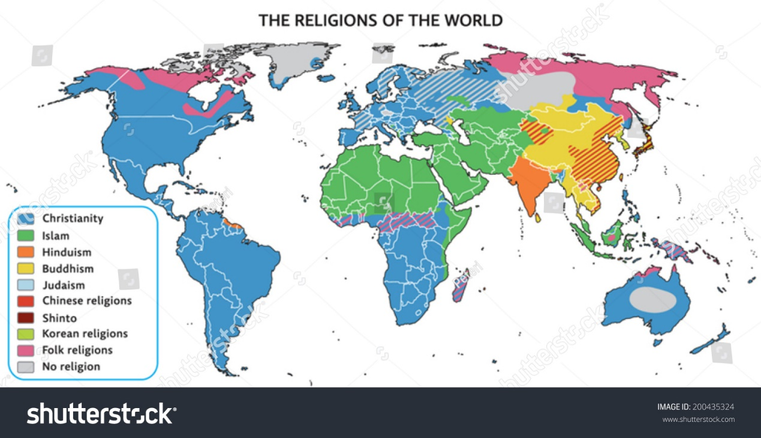

11. World map: Religions, an ‘artist’s view’
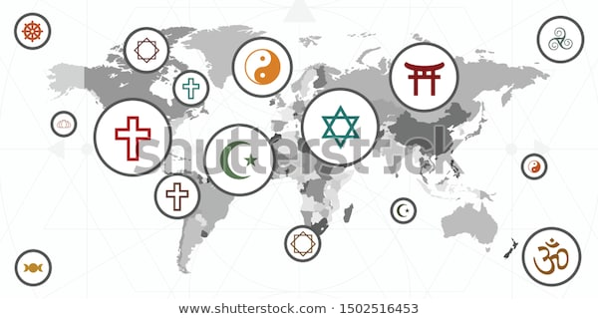

12. Virtual Mapping: Google Earth (2005)
